

Year 9 Recipe Book

2025-2026

|  |  |  |
| --- | --- | --- |
| Pg | Product | Skills demonstrated. |
| 3 | Fajitas & salsa or guacamole | *Bridge and claw, using the hob, safe meat handling,* |
| 4 | Curry & Naan bread, | *Using yeast as a raising agent, using the grill, reduction sauce, safe meat handling,* |
| 5 | Fruit pie & Ice cream | *Making shortcrust pastry, using the oven, separating eggs, whisking method, setting using the freezer.* |
| 6 | Rough puff pastry product, | *Making rough puff pastry, shaping, using the oven,* |
| 7 | Profiteroles | *Making choux pastry, using steam as a raising agent* |
| 8 | Focaccia – bread art. | *Using yeast as a raising agent,* |
| 9 | Mini pavlovas with lemon curd | *Making a foam, using an electric whisk, piping, thickened sauce using cornflour.* |
| 10 | Quiche/ Egg Custard Tart | *Making shortcrust pastry, baking blind,* |
| 11 | Cheesecake homemade biscuits | *Making, shaping and baking biscuits, setting using the fridge, using an electric whisk.* |

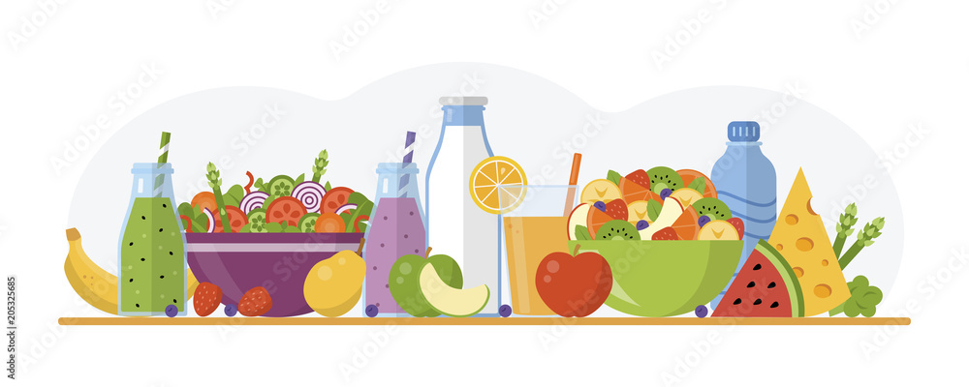

Name _________________________ Technology group ___________ Teacher ____________________

Note to parents/carer’s:

This recipe book contains all the recipes needed for the GCSE Foundation Food and Nutrition. In Year 9, students will have a 2 hour lesson a fortnight, with one half being theory and the other half applying the knowledge with the practical product. Students will need to bring this recipe book to every lesson along with ingredients and a container to take their products home in. Students will be given at least a weeks notice for ingredients, if there are any problems in getting ingredients please make a note in your child’s planner, in advance of the lesson please, so we can ensure ingredients are available and your child does not miss out on vital practical lessons.

Recipes can be added to or changed with ingredients at home you may have closer to the date. Recipes can be cut into single portions if necessary. Ingredients must be weighed out at home before the lesson and stored in their Food Technology room before registration.

Please only place highlighted ingredients in the fridge, named.

Fajitas & salsa or guacamole

Don’t forget…a container to take home in.

Ingredients:

Method:

1. Slice the chicken on a board with a sharp knife, then put in a large bowl. Grate in the lime zest and squeeze in the juice. Crush the garlic, then add to the chicken with the ground coriander, chilli powder (if using) and seasoning to taste. Stir well.
2. Heat the oil in a wok or large frying pan. Add the pepper, then stir, continuously, over a high heat for 2 mins. Add the chicken, chop the fresh coriander, then stir it into the chicken, stir-fry over a high heat for 5 mins until the chicken is cooked.
3. Take a tortilla and spread with sour cream. Add some lettuce and avocado, then some of the chicken and pepper mixture and a little salsa if you like.
4. Fold in the sides of the tortilla, then carefully roll up so that the filling is completely enclosed. Alternatively, put the dishes of the salad, chicken fajita and tortillas on the table for the family to make up their own.

* 2 boneless, skinless chicken breast or halloumi
* 1 small lime
* 2 garlic cloves
* 1 tsp ground coriander
* 1 tsp chilli powder (optional)
* 1 large red pepper
* 15g fresh coriander

**To serve**

* 4 flour tortilla wraps
* 1/2 lettuce (optional)

**Please choose guacamole or salsa to make alongside the fajitas.**

Guacamole ingredients:

* 1 large ripe tomato

Method:

1. Use a large knife to mash the tomato to a pulp on a board, then tip into a bowl. Halve and stone the avocados (saving a stone) and use a spoon to scoop out the flesh into the bowl with the tomato.
2. Tip all the other ingredients into the bowl, then season with salt and pepper. Use a whisk to roughly mash everything together. If not serving straight away, sit a stone in the guacamole (this helps to stop it going brown), cover with cling film and chill until needed.

* 2 [Avocado](http://www.bbcgoodfood.com/glossary/avocado), very ripe but not bruised
* juice 1 large [lime](http://www.bbcgoodfood.com/glossary/lime)
* 1 small red onion, finely chopped
* 1 chilli, deseeded and finely chopped
* handful coriander, roughly chopped, to serve

Salsa ingredients:

Method:

1. Finely chop the tomatoes and coriander (stalks and all) and place into a large bowl.
2. Peel and finely chop the onion, deseed and finely chop the chillies, then add it all to the bowl.
3. Peel and finely grate in the garlic. Add the juice from 1 lime and 2 tablespoons of extra virgin olive oil. Mix well, then season to taste with salt, pepper and lime juice. Serve straightaway or cover and set aside for a few hours to let all those flavours develop.

* 3 ripe tomatoes
* 1/2 large bunch of fresh coriander
* 1/2 onion
* 1 fresh jalapeño or green chillies
* 1 small clove of garlic
* 1 lime, juice from

Curry & Naan Bread:

**Don’t forget…2 x containers to take both home in.**

**Serves 4**

Naan bread method:

1. Sieve the flour and salt into a large mixing bowl and then add yeast and stir.
2. In a measuring jug mix the water and milk and then place in the microwave for 20 seconds to warm.
3. Add honey and stir then add to the flour along with the yoghurt and oil.
4. Stir with a table knife to bring the mixture together to a soft sticky dough.
5. Turn out onto a floured surface and knead for 5 minutes.
6. After kneading place the sough onto a greased bowl to prove. Cover the bowl with damp tea towel and leave 10 minutes or longer if you have time.
7. When proving is done take out the dough and “knock it back” (which means gently knead again for 1 minute).
8. Divide the dough into 4 pieces and roll out to a teardrop shape about 6mm thick.
9. Place on a lightly dusted baking tray and grill for 3-4 minutes until lightly browned.

Naan bread Ingredients:

* 225g plain flour,
* 1/2 tsp salt,
* 1/2 sachet (1/2 tsp) of easy blend yeast,
* 90ml of warm milk,
* 30ml warm water (from school),
* 1/2 tsp honey,
* 2 tbsp of natural yoghurt (school to provide),
* 1 tbsp of sunflower oil.

**Please choose either Tikka Masala or Korma to go alongside the naan bread.**

Korma Ingredients:

* 2tbs oil
* 1 medium onion
* 2tbs Korma Paste
* 200ml water
* 1tsp garlic & ginger chopped (optional)
* 250g diced chicken breast
* 100ml double cream

Tikka masala method:

1. Heat oil in a medium saucepan.
2. Add onion; cook until soft.
3. Add Tikka Masala Paste, 100ml of water, ginger and garlic. Stir occasionally, until reduced and thickened.
4. Add chicken, fry until sealed.
5. Add 100ml water, tomatoes, bring to the boil, simmer un-covered for 10 minutes.
6. Add double cream.
7. Simmer un-covered for 5 minutes.

Chicken Tikka Masala Ingredients:

* 2tbs oil
* 1 medium onion
* 2tbs Tikka Masala Paste
* 200ml water
* 1tsp garlic & ginger chopped (optional)
* 250g diced chicken breast/ Quorn pieces/ paneer,
* 200g canned chopped tomatoes,
* 100ml double cream.

Korma method:

1. Heat oil in a med saucepan.
2. Add onion cook until soft.
3. Add Korma Paste, 100ml of water, ginger and garlic. Stir occasionally, until reduced and thickened.
4. Add chicken and fry until sealed.
5. Add 100ml water, bring to the boil, cover, cook for 5 minutes.
6. Add double cream
7. Simmer for 4 minutes.

Fruit Pie & Ice cream

**Home Learning**:

Bring in a round baking tin or flan dish. No loose bottom tins.

Ingredients:

* 225g plain flour,

[Method:](http://www.food.com/ideas/vegetables-you-think-you-hate-6051)

1. Heat oven to 200C/180C fan/gas 6.
2. To make the pastry, sift the flour into a large mixing bowl and add the butter or margarine. Using your fingers, mix together until the mixture resembles breadcrumbs. Add about 3 tbsp cold water – 1 tbsp at a time – to bind the mixture into a ball.
3. Then wrap it in cling film and leave to chill in the fridge while you prepare the apples, or for 30 mins if you have time.
4. While the pastry is chilling, core the apples, then cut into even-sized chunks so they all cook in the same amount of time.
5. Put the apples into the pie dish, drizzle over the honey and add the cinnamon, mixed spice and about 2 tbsp water.
6. Roll out the pastry on a floured work surface until it is large enough to cover the pie dish. Using the rolling pin, carefully lift the pastry and lay it over the top of the apple mixture. Carefully trim off the excess pastry (this can be rerolled and cut into shapes to decorate the pie crust if you like) and press the pastry edges onto the dish to create a seal.
7. Make a small cut in the pastry so that the air can escape during cooking, then brush with beaten egg to glaze.
8. Bake the pie in the oven for 20-30 mins until the pastry is golden and sandy in appearance and the apple filling is bubbling and hot.

* 140g butter,
* 3 large cooking apples/ 3 large pears/ 6 plums,
* Pinch of cinnamon (provided by school),
* Pinch of mixed spice (provided by school),
* 1 egg, beaten.

Ice Cream

**Don’t forget…a container to take home in.**

Ingredients:

* 4 free-range [eggs](https://www.bbc.co.uk/food/egg), separated
* 100g/3½oz [caster sugar](https://www.bbc.co.uk/food/caster_sugar)
* 300ml/½pint [double cream](https://www.bbc.co.uk/food/double_cream)

*Options:*

* **Vanilla flavour -** 1 tsp [vanilla extract](https://www.bbc.co.uk/food/vanilla_extract)
* **Coffee flavour -** 2-3 tbsp [coffee essence](https://www.bbc.co.uk/food/coffee_essence)
* **Raspberry flavour -** 150ml/5fl oz sieved raspberry purée (you could also use [strawberry](https://www.bbc.co.uk/food/strawberry))
* **Chocolate flavour –** 200g bar of milk or dark chocolate.
* **Other biscuits/sweets to stir in.**

1. Whisk the egg whites in a large bowl until stiff peaks form when the whisk is removed.
2. Slowly whisk in the caster sugar, then continue to whisk until the egg whites are stiff and glossy.
3. Whisk the cream in a separate bowl until soft peaks form when the whisk is removed.
4. Fold the cream, egg yolks and your chosen flavouring (see ingredients list) into the meringue mixture until well combined.
5. Pour into a plastic container and freeze for at least two hours.

Method:

Rough puff pastry product

**Bring in ingredients for the pastry and choose either pinwheels, cheese and onion rolls or sausage rolls.**

Ingredients:

* 300g [plain flour](https://www.bbc.co.uk/food/plain_flour)
* pinch [salt](https://www.bbc.co.uk/food/salt)
* 50g [butter](https://www.bbc.co.uk/food/butter), chilled and cut into cubes
* 120g/4½oz [butter](https://www.bbc.co.uk/food/butter), frozen (place in the freezer in room 66 at school)

**2) Cheese and onion rolls:**

* 1/2 onion, diced.
* 25g of butter
* 80g of grated cheese
* 1 egg
* 40g of breadcrumbs
  1. **Pizza pinwheels:**
* 6 tbsp ready-made pasta sauce (not too chunky)
* 100g wafer thin ham
* 100g grated cheese
* 1 egg
* 1 tsp dried oregano

**3) Sausage rolls:**

* 12 Sausages (not thin or frozen)

Rough puff pastry method:

1. Mix the flour and salt together in a bowl. Rub in the chilled butter using your fingertips until the mixture
2. resembles breadcrumbs. Gradually add enough water to form a dough (about 4-6 tablespoons of water).
3. Roll the dough out into a rectangle on a lightly floured work surface.
4. Grate half of the frozen butter over the bottom two thirds of the dough. Fold down the top third and fold up the bottom third as if folding a letter.
5. Turn the folded dough through 90 degrees and roll it out into a rectangle again. Repeat the process of adding the remaining frozen butter and fold as before.
6. Wrap the dough in cling film and leave to rest in the fridge for 30 minutes before using.

Sausage rolls method:

1. Preheat the oven to 200C/400F/Gas 6 and line a baking tray with baking paper.
2. Remove the pastry from the fridge and roll it into a shallow rectangle at least 24cm long. Fold the pastry into thirds again. Give the pastry a further two turns. If necessary, trim the edges to make a neat rectangle, cut this down the middle to make two long strips.
3. Remove the skin from the sausages and place them in a line down the middle of each strip. Roll the pastry around the sausages. Wet the edges of the pastry and seal by pressing with a fork.
4. Brush with egg wash all over the top. Cut the sausage roll into equal parts.
5. Place the rolls on the lined baking tray and bake for 20 minutes, or until puffed and golden-brown.

Cheese and onion rolls method:

1. Preheat the oven to 200C/400F/Gas 6 and line a baking tray with baking paper.
2. Remove the pastry from the fridge and roll it into a shallow rectangle at least 24cm long. Fold the pastry into thirds again. Give the pastry a further two turns. If necessary, trim the edges to make a neat rectangle, cut this down the middle to make two long strips.
3. For the filling**,** in a bowl combine all of the filling ingredients and mix well.
4. Place the filling in a line down the middle of each pastry strip, approximately the same length as the pastry.
5. Roll the pastry around the mixture. Wet the edges of the pastry and seal by pressing with a fork.
6. Brush with egg wash all over the top. Cut the sausage roll into equal parts. Place the rolls on the lined baking tray and bake for 20 minutes, or until puffed and golden-brown.

Pinwheels method:

1. Preheat oven to fan 180C/conventional 200C/gas 6.
2. Unroll the pastry onto a lightly floured surface and roll it out to 40 x 32cm.
3. Spread a layer of pasta sauce over it, leaving a 1cm border around the edges.
4. Arrange the ham evenly on top, then scatter the grated cheese over.
5. Starting at one of the short ends, roll the pastry up as tightly as possible. Chill in the fridge for 10 minutes or so.
6. Take a very sharp knife and cut the roll into 12 equal slices, laying them flat on 2 non-stick baking trays as you go.
7. Brush each pinwheel lightly with beaten egg and sprinkle over the herbs.
8. Bake for 12-15 minutes until puffed and golden. Leave to stand for 5-10 minutes before serving.

Profiteroles

**Don’t forget…a container to take home in.**

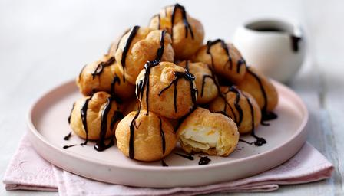Ingredients:

* 50g margarine,
* 65g plain flour,
* 2 eggs,
* 130ml water,
* 100g melted chocolate,
* ½ pint double cream.

Method:

1. Melt margarine and water together in a saucepan until boiling.
2. Sift flour onto a piece of greaseproof paper.
3. Pour into saucepan whilst still boiling, and beat with wooden spoon until mixture is smooth, thick and comes away from the sides of the pan.
4. Beat eggs in a jog and add ½ to mixture, beating well. Add more egg and beat until mixture is glossy and holds its shape. You may not need all the egg.
5. Either place in piping bag with a plain nozzle, and pipe rounds or place teaspoons of mixture onto a baking sheet lined with parchment paper. Push down any pointy tops.
6. Bake gas 6/200C for 20-25 minutes until puffed up and golden.
7. Place on cooling rack and allow to cool.
8. When cool, whip cream until stiff, and pipe into each profiterole.
9. Melt chocolate slowly in microwave and spread onto each profiterole.

Focaccia

Decoration ingredients:

### Cherry tomatoes

### Pitted olives

### Chives

### Spring onions

### Red onions

### Rosemary sprigs

### Mini peppers

### Mini courgettes

### Rosemary

### mushrooms

### Basil

### Flat leaf parsley,

### Garlic,

### Fresh chilli,

### Capers,

### Seeds

## Ingredients

**Home Learning**:

Bring in a rectangle baking tray.

* 500g [strong bread flour](https://www.bbcgoodfood.com/glossary/flour-glossary), plus extra for dusting
* 7g dried fast action yeast
* 2 tsp fine sea salt
* 5 tbsp [olive oil](https://www.bbcgoodfood.com/glossary/olive-oil-glossary), plus extra for the tin and to serve
* 1 tsp flaky sea salt

### Method

1. Sieve 500g strong bread flour into a large mixing bowl. Add yeast and salt and gently mix.
2. Make a well in the centre of the flour. In a jug mix together 2 tbsp oil and 375ml lukewarm water. Gradually add to the flour until you have a slightly sticky dough (you may not need all the water)
3. 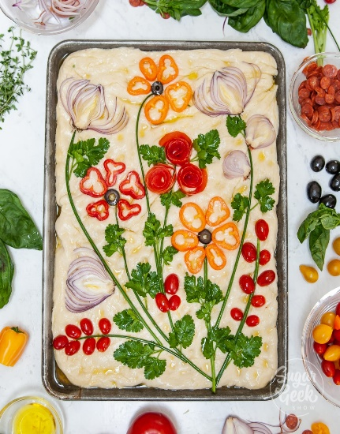 Sprinkle the worksurface with flour and knead dough for 5 – 10 minutes until it is soft and less sticky.
4. Put dough into a clean bowl, cover with a tea towel and leave to prove for 1 hour until doubled in size.
5. Oil a rectangle, shallow tin (25 x 35cm). Stretch your dough to fit in the tin. Cover with a tea towel and leave to prove for another 35-45 mins.
6. Whilst this is rising you can prepare your vegetables for decoration.
7. Mix together 2tbsp of olive oil and 1tbsp of water, brush this over the dough and arrange your vegetables and herbs, use the remaining oil to brush over the vegetables.
8. Bake for 20-25mins at 220C until golden, whilst bread is still hot drizzle 1-2tbsp of olive oil over the top.

Mini Pavlovas with lemon curd and fruit

**Don’t forget…a container to take home in.**

Ingredients:

* 3 egg whites,
* 150g caster sugar,
* 1 tsp cornflour,
* 1 tsp lemon juice,
* 200g fruit (berries work well)
* 250 ml double cream

Lemon curd:

* 1 tbsp cornflour,
* 3 tbsp caster sugar,
* 15g butter,
* 1 lemon,
* 1 egg yolk.

Method:

1. Preheat oven to 140C,
2. Whisk the egg whites until they are stiff and dry,
3. Whisk half of the sugar mixture until stiff and shiny,
4. Fold in the remaining sugar, cornflour and lemon juice,
5. Spoon or pipe onto a baking sheet lined with parchment,
6. Bake in the oven until firm and crispy on the outside and slightly gooey in the middle about 30-40 minutes,
7. Combine caster sugar and cornflour,
8. Measure 90ml of cold water and add just enough to make a paste,
9. Grate the lemon zest into a small saucepan and pour the rest of the water in,
10. Gently heat,
11. Squeeze the lemon juice into the cornflour paste, the pour the mixture into the pan and whisk together,
12. Cook until thickened,
13. Cube in the butter, add egg yolk and stir until combined, leave to cool,
14. Cool meringues,
15. Decorate with fruit, lemon curd and whipped cream.

Quiche Lorraine

**Please choose either Quiche or Egg Custard Tart**

**The shortcrust pastry**

Method:

1. Preheat the oven 200c/400f/Gas 6
2. Rub the fat into the flour and salt until the mixture resembles breadcrumbs.
3. Using a table knife mix in some water a little at a time until the mixture comes together to form a dough.
4. Place the dough on a floured surface and roll out to the required thickness and shape.
5. Place into the tin/dish and blind bake for approximately 10 minutes.

**The Quiche filling**

Method:

1. Preheat the oven 200c/400f/Gas 6
2. Break the bacon into small pieces into the pastry case.
3. Beat the eggs, milk together, and pour over the bacon.
4. Sprinkle cheese salt and pepper over the top.
5. Bake for 25-30 minutes until golden and firm to touch.

**Please bring in a flan dish**

Ingredients:

* 200g plain flour
* 50g hard margarine or butter
* 50g lard or white fat e.g. trex
* Pinch of salt
* Cold water to mix

Ingredients:

* 150g cooked bacon
* 3 eggs
* 250ml milk
* 50g grated cheese
* Salt and pepper

Egg Custard Tart

**The shortcrust pastry**

Method:

1. Preheat the oven 200c/400f/Gas 6
2. Rub the fat into the flour and salt until the mixture resembles breadcrumbs.
3. Using a table knife mix in some water a little at a time until the mixture comes together to form a dough.
4. Place the dough on a floured surface and roll out to the required thickness and shape.
5. Place into the tin/dish and blind bake for approximately 10 minutes.

The egg custard filling

Method:

1. Preheat oven 180c/350f/Gas 4
2. Heat the milk in a saucepan until warm.
3. Add the milk to the beaten eggs and sugar, stir in the vanilla essence.
4. Pour into your pastry case and sprinkle with nutmeg.
5. Bake in the oven for 30-40 minutes, until set.

**The shortcrust pastry**

Ingredients:

* 200g plain flour
* 50g hard margarine or butter
* 50g lard or white fat
* 50g caster sugar
* Cold water to mix

**The Egg custard filling**

Ingredients:

* 2 eggs
* 250ml milk
* 30g caster sugar
* 1 drop vanilla essence
* A sprinkle of nutmeg

Cheesecake

*with homemade biscuit base*

**Please bring in a flan dish**

Cheesecake method:

1. Crush biscuits using a rolling pin or in a food processor.
2. Melt margarine and stir in biscuits.
3. Press into bottom of 20 cm round tin, using the back of a metal spoon.
4. Make filling by whipping cream until stiff, and stirring in sugar and cream cheese with a wooden spoon.
5. Be careful not to beat or the mixture will go runny!
6. Stir in lemon rind and/or melted chocolate.
7. Spread over biscuit base with palette knife and smooth over.
8. Decorate with fresh fruit or small slices of lemon or grated chocolate.

Cheesecake ingredients:

* 200g digestive biscuits you have made above,
* 75g butter or hard margarine
* 200g soft cream cheese
* 50g caster sugar
* 1/2pt double cream
* 50g melted chocolate (optional)
* 100g fresh or tinned fruit for decoration.

Biscuit ingredients:

* 100g [wholemeal flour](https://www.bbcgoodfood.com/glossary/flour-glossary)
* 50g [plain flour](https://www.bbcgoodfood.com/glossary/flour-glossary)
* 50g [porridge oats](https://www.bbcgoodfood.com/glossary/oats-glossary)
* 150g [unsalted butter](https://www.bbcgoodfood.com/glossary/butter-glossary)
* 40g [caster sugar](https://www.bbcgoodfood.com/glossary/sugar-glossary)
* 1/4 tsp [bicarbonate of soda](https://www.bbcgoodfood.com/glossary/bicarbonate-of-soda-glossary)
* 1 tbsp [milk](https://www.bbcgoodfood.com/glossary/milk-glossary)

## Biscuit method

1. Line one baking trays with baking parchment.
2. Rub the butter into the flour mixture using your hands.
3. Stir in the sugar, bicarb and 1/4 tsp salt, then pour in the milk.
4. Bring together into a cohesive dough then flatten into a disc, cover and chill in the fridge for at least 30 minutes.
5. Lightly flour a clean work surface and tip the biscuit dough out. [Roll out](https://www.bbcgoodfood.com/review/kimberley-wilsons-top-five-marble-rolling-pins) until roughly 0.5cm thick, then stamp out biscuits using a 6-7cm cutter.
6. Arrange on the baking trays
7. Heat the oven to 200C/180C fan/gas 6.
8. Bake in the oven for 12-15 mins until golden around the edges. Leave to cool completely on the trays.

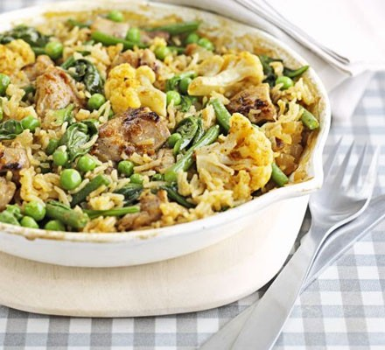

Method:

1. Heat the oil in a frying pan, then fry the onion for 5-6 mins until softened. Add the chicken pieces, fry for a further couple of mins just to colour the outside, then stir in curry paste and rice. Cook for another min.
2. Pour in the chicken stock and throw in any larger bits of frozen veg.
3. Bring to the boil, lower the heat, then cover the pan with a lid.
4. Cook for 10 mins, then stir in the remaining veg.
5. Scatter over the spinach, cover, then cook for 10 mins more until all the stock is absorbed and the rice is tender.