


Admissions, Transition & Induction Policy 2025-2026

Document Owner: | Alexis Bull – Executive Headteacher
Approved By: | IEB (Governance) TBC
Queries to: | Portland School
Review Period: | 1 Year or as appropriate
Date of Last Review: | December 2025
2

1) Purpose

Portland School is part of the Shaw Education Trust (SET). We provide specialist education for primary and secondary aged pupils whose primary area of need is Social, Emotional and Mental Health (SEMH) as identified within an Education, Health and Care Plan (EHCP).

This policy sets out lawful, transparent procedures for admitting pupils who have Education, Health and Care Plans (EHCPs), including the standard induction steps we will take to safeguard pupils, prepare staff and ensure appropriate provision and reasonable adjustments before full-time attendance begins.

It is designed to uphold our duties under:

- Keeping Children Safe in Education (KCSIE) statutory guidance (KCSIE 2025)

- Children and Families Act 2014 (CFA 2014)

- Equality Act 2010, Section 20 duty to make reasonable adjustments to avoid substantial disadvantage to disabled pupils (including PCPs, physical features, and auxiliary aids/services) (EA 2010)

- Special educational needs and disability code of practice: 0 to 25 years (SEND - 2015)

- The School Attendance (Pupil Registration) (England) Regulations 2024 (SAPR-(E) R 2024)

Placements at Portland School are determined by the relevant Local Authority (LA) in accordance with the Children and Families Act 2014 and the SEND Code of Practice (2015).

To ensure we provide effective placements for our students, we provide robust admissions, induction and transition arrangements before placing a student on roll.

We aim to work closely with families, professionals and Local Authorities to ensure that we can meet the needs of every child admitted to Portland School.

2) Principles

This policy operates on the following legal principles:

- Admissions: We admit when named in an EHCP (CFA 2014, s.43).

- On Rolling: The names of pupil shall be entered upon the first expected day of school attendance (SAPR-(E) R 2024).

- Safeguarding First: Transition and induction periods with initial timetables are planned to ensure safety and welfare of pupils and staff (KCSIE 2025).

- Reasonable adjustments: We anticipate and implement adjustments so pupils are not placed at a substantial disadvantage (Equality Act 2010, s.20).

3) Implications

- Admissions
  - We agree to admit the pupil to Portland School when named in Section I of the student’s EHCP.

- On Rolling
  - We work collaboratively with local authorities, parents/carers and multi-agency professionals to agree start dates for pupils following being named in Section I of the student’s EHCP.

  - Where the ‘proprietor of a school must ensure that the name of each pupil at the school is entered in the school’s admission register on the pupil’s starting day’ (SAPR-(E) R 2024), we aim to offer timely start dates to ensure compliance with aforementioned legislation and steps listed below.

  - The school will provide start dates as to avoid issues of incompatibility and inefficiency with the education of others. As such we may offer start dates to avoid start dates that coincide with the start dates of other new, highly disadvantaged pupils.

  - Where the school is directed to take students during the transition of other new students, if we are unable to collaboratively agree a change to the start date, we will call an emergency annual review, on grounds that the needs of the student’s transition are not compatible with the needs of students already in the setting.

- Safeguarding First
- ‘Schools and colleges must have regard to [KCSIE] when carrying out their duties to safeguard and promote the welfare of children’ (KCSIE 2025).

- As safeguarding must be embedded in all processes, we include admissions and induction processes during this period. To appropriately and effectively safeguard students, we provide a transition process prior to on-rolling a student which is necessary to identify key safeguarding information prior to allowing a student to access an environment with other highly vulnerable student.

- Reasonable adjustments
    - Within this transition period, ‘SEN support should include planning and preparation for the transitions between phases of education’ (SEND – 2015 - 6.57). As such the school aims to provide a transition period to identify reasonable adjustments which may be required in the new setting.

    - We aim to identify, anticipate and implement adjustments so pupils are not placed at a substantial disadvantage and do so during an induction period (Equality Act 2010, s.20).

4) Admissions & Induction Process

- Prior to Consultation
- The local authority to be aware that pupils admitted to Portland School will have:
- An Education, Health and Care Plan (EHCP)
- Have ‘Social, Emotional & Mental Health Need’ identified as their primary need

- Pupils may also present with additional needs, which can include:
- Attachment difficulties
- Autism Spectrum Condition
- Attention Deficit Hyperactivity Disorder
- Moderate learning needs
- Physical disabilities
- Sensory impairments (VI, HI, MSI)

    - These secondary needs must not prevent the school from meeting the child’s primary SEMH needs effectively and safely.

    - We currently admit pupils predominantly from:
    - City of Stoke-on-Trent Local Authority
    - Staffordshire Local Authority

- Pre-Naming Initial Consultation (Pre-naming)
- The Local Authority (LA) consults Portland School before naming us in Section I of the EHCP. We provide written feedback on cohort compatibility, safeguarding considerations and resource requirements to meet Section F provision (CFA 2014 duties; KCSIE safeguarding).

- Confirmation of Duty to Admit (Post-naming)
- If named, Portland School confirms agreement to be named in Section I of the student’s EHCP in line with CFA 2014, s.43 and seeks agreement with the local authority to establish a provisional start date dependent upon completion of the steps below to ensure safe, appropriate provision from the pupil’s agreed start date. Start dates will typically be three weeks from the date of being named in Section I, allowing Portland School to engage the stages listed below.

- Induction & Readiness Steps (Prior to Full-Time Attendance)
    - Typically, three weeks before being placed on roll, the school will seek to enact…

- Parent/carer meeting and pupil visit(s) — co‑production of initial plans; collection of emergency contacts and permissions (KCSIE 2025; SEND – 2015)

- Transport Application – support from internal staff to complete transport application.

- Contact with Home School & Parent Meeting - Complete Safeguarding & behaviour risk assessment — e.g., absconding, self‑harm, peer compatibility; mitigations and staff briefing (KCSIE).

- Identify Relevant Medical information & Reasonable adjustments planning — identify disability‑related barriers and implement adjustments (EqA 2010 s.20).

- Meeting with SENCO & Head of School - Teaching/pastoral group allocation — placement planned to support the pupil’s needs while protecting the efficient education of others (KCSIE).

- Meeting with SENCO & Staff preparation — DSL/Deputies, SENCO and class teams briefed; training arranged for identified adjustments (KCSIE/SEND Code).

- Transition Steps (Prior to Full-Time Attendance)
    - We use a structured, time‑bound phased timetable where necessary to implement safeguarding measures and reasonable adjustments, prior to full‑time attendance (KCSIE; SEND Code para 5.47 on planning transitions; EqA s.20).

    - Typically, one week before being placed on roll, the school will offer two weeks’ worth of ‘visits’ to the Portland School.

    - These visits are to take place whilst the student remains in their current educational provision and student will be registered as a ‘guest’, allowing the school to be co-responsible for safeguarding the students.

- Readiness Criteria for Full-Time Attendance
- The school will detail progress through Induction, Readiness & Transition steps informing the Case Officer, as a representative to the Local Authority, if there are causes to delay the start point.

- The school will report any difficulties with the following aspect of our readiness criteria that may prevent the student being placed on roll;

- Inability to complete Safeguarding/behaviour risk complete; identify mitigations and/or brief (KCSIE).

- Inability to identify disability‑related barriers and identify relevant adjustments required for access (EqA 2010, s.20).

- Inability to identify Teaching/pastoral group to gain understanding of compatibility with cohort (KCSIE).

- No Parent/carer consents or emergency/medical information received; no communication channels established (KCSIE; SEND Code participation principle).

- Failure to attend during ‘guest registration’ which prevents the school from identifying reasonable adjustments and completing safeguarding/compatibility assessments.

- On-rolling (Full-Time Attendance)
- The pupil’s start date is agreed with parents/carers and the LA; the pupil is added to the admissions register on the agreed starting day, which is typically three weeks from being named in Section I and attendance is recorded from that point (operational alignment with safeguarding; CFA 2014 s.43 duty).

5) Equality, Accessibility & Reasonable Adjustments

- We implement adjustments across the three statutory limbs of the Equality Act 2010, s.20:
- Provision/criterion/practice — e.g., flexible arrival, leaving times, modified behaviour expectations, bespoke transitions (s.20(3)).

- Adaptations for Physical features — e.g., safe spaces, wayfinding, environmental adaptations (s.20(4)).

- Access to Auxiliary aids/services — e.g., assistive technology, communication supports (s.20(5)) or interventions required to access the school setting.

6) Exceptions
- We aim to fully engage with the commitments identified in the policy.

- It remains the local authority’s responsibility to arrange transport for the student from the agreed start date which will be agreed following the completion of induction and transition procedures.

- If the local authority does not arrange transport within a timely manner, the school will place the student on roll from the agree start date but will “Q” code the student which we define as:

  - Q - Unable to attend the school because of a lack of access arrangements

    - Lack of LA Arrangements: The pupil cannot attend because the local authority has not provided the legally required transport or other provision to access school.

- This will statistically be considered an authorised absence and not counted towards attendance.

- If parent/carer or student does not engage with the Induction or Transition process, we will not on-roll, will communicate difficulties with case officer and re-negotiate the students’ formal start date.

7) Complaints & Dispute Resolution

- Parents/carers may use the school complaints procedure if they disagree with induction or adjustments (KCSIE 2025). If concerns arise during LA consultation or post‑naming, we will not refuse admission (CFA s.43 duty) but will escalate to the LA for support/resources and, if necessary, seek legal advice regarding compliance routes.

- The local authority are required to consult the Portland School ‘Admissions, Transition & Induction Policy 2025-2026’, prior to consulting Portland School.

This policy applies to admissions for all year groups from the date of review identified at the start of this document.

References

• Keeping Children Safe in Education (September 2025): https://assets.publishing.service.gov.uk/media/68add931969253904d155860/Keeping_children_safe_in_education_from_1_September_2025.pdf

• Children and Families Act 2014 (s.43): https://www.legislation.gov.uk/ukpga/2014/6/section/43

• Equality Act 2010 (s.20 — reasonable adjustments): https://www.legislation.gov.uk/ukpga/2010/15/section/20

• SEND Code of Practice (0–25): https://www.gov.uk/government/publications/send-code-of-practice-0-to-25

• SEND Code ‘have regard to’ — Schools/Nasen mini guide: https://5f2fe3253cd1dfa0d089-bf8b2cdb6a1dc2999fecbc372702016c.ssl.cf3.rackcdn.com/uploads/ckeditor/attachments/5284/the_send_code_of_practice_0_to_25_years_-_mini_guide__1_.pdf

• The School Attendance (Pupil Registration) (England) Regulations 2024 - https://www.legislation.gov.uk/uksi/2024/208

Appendix A — Model LA Letter (Post‑naming)

Subject: EHCP Admission & Structured Induction for [Pupil Initials].
In accordance with Section 43 of the Children and Families Act 2014, we confirm admission of [Pupil] to Portland School. To meet our duties under KCSIE (Sept 2025), the Equality Act 2010, s.20, and the SEND Code of Practice (graduated approach; transition planning), we will implement a structured induction and phased timetable from [date] and move to full‑time attendance once safeguarding measures and reasonable adjustments are in place.

As such, we intend to on-roll the student, in accordance with our ‘Admissions, Transition & Induction Policy – 2025-2026’ on the following date [date].

Appendix B — Timeline



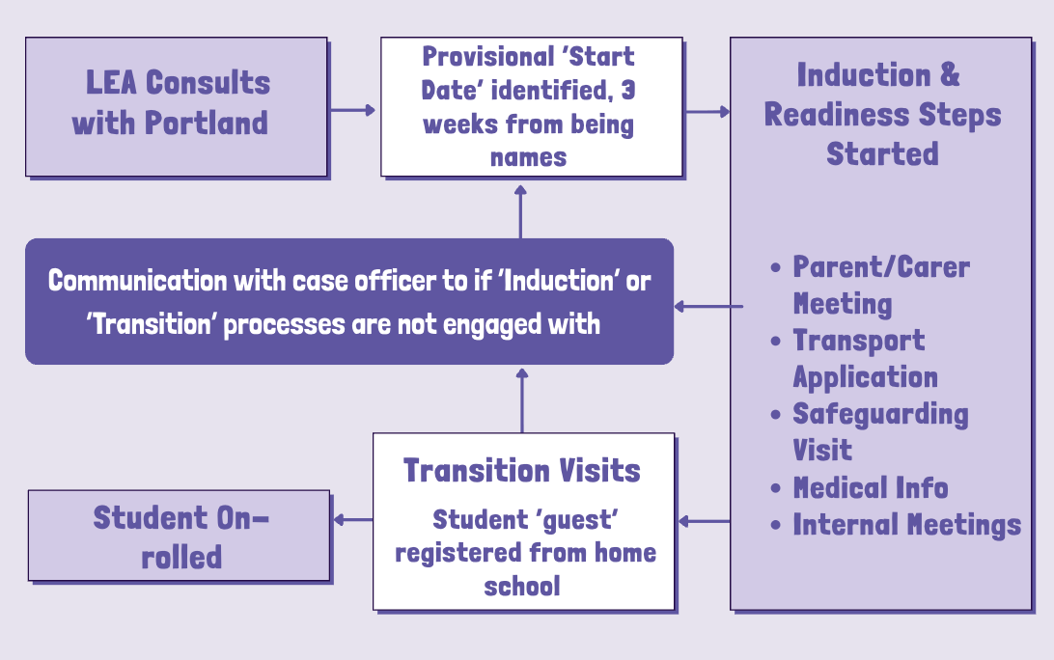
Graphic to identify overview of Portland School Admissions Process.





S
h
a
w

E
d
u
c
a
t
i
o
n

T
r
u
s
t

H
e
a
d

Office,
Kidsgrove Secondary School,
Gloucester Road,

Kidsgrove,

ST7 4DL

Twitter
LinkedIn
Call
Email

Visit

@ShawEduTrust
@ShawEducationTrust
01782 948259

info@shaw-education.org.uk

shaw-education.org.uk

[
Type

here]

