# Portland School

*Health & Safety Policy*



|  |  |
| --- | --- |
| Document Owner: | Alexis Bull |
| Approved By: | Shaw Education Trust |
| Queries to: | Alexis Bull Executive Head |
| Review period: |  |
| Last review: | 1st May 2025  Asbestos & CDM added May 2025  Fire Marshall List added May 2025 |

Statement of Health and Safety Policy

This policy statement supplements both the general statement of policy issued by Stoke on Trent City Council and the more detailed statement issued by the DFE.

SHAW Education Trust and Senior Management Team of Portland School are recognised as responsible persons in control of premises and the requirement to provide a safe and healthy working environment for all staff, visitors and pupils.

In compliance with the Health and Safety at Work Act, the Trust of Portland School will regularly review and ensure so far as is reasonably practicable that.

1. The premises are maintained with safe access and all equipment is safe to use.
2. Appropriate safe systems of work exist and are maintained.
3. Sufficient information, instruction, training and supervision are available and provided.
4. Arrangements exist for the safe use, handling and storage of substances at work.
5. Will endeavour to have a healthy working environment including adequate welfare facilities.

In addition to the above commitment, The Trust also recognises its obligations to non-employees i.e. members of the public and contractors; ensuring that the necessary information, instruction, training and supervision are available for their safety whilst on the premises. As an educational institution, which must set standards by example for its pupils, this commitment is seen as especially important.

Within the financial restraints dictated by the Council the Premises/Health and Safety Committee will make decisions in the confines of the Health and Safety budget to ensure through the Senior Management Team, that adequate resources are set aside from the total budget allocation for the policy statement to be properly implemented.

For the policy to be effectively implemented, the school must have the full co-operation of employees and others who use the premises. Employees are reminded of their own duties; to take care of their own safety and that of others and to co-operate with the Trust and Senior Management Team so that they may carry out their own responsibilities successfully.

All known regulations and procedures will be compiled with and any safety representative consulted in the formulation of these procedures.

A copy of this statement will be provided to the appropriate members of staff and a copy will be available in the Staff Room. This policy statement and the accompanying organisation and arrangements will be revised as and when necessary.

SIGNED----------------------------------------------- SIGNED------------------------------------------

TRUST CEO EXECUTIVE HEAD TEACHER

DATE -------------------------------------------------- DATE -------------------------------------------

Organisation

In order to ensure that health and safety issues are dealt with in accordance with this establishment’s safety policy, the Trust has accepted the following organisational structure. Duties and responsibilities have been assigned to staff and trust members as laid out below.

The Trust is ultimately responsible for health and safety matters at a local level. They accept that the delegation of funds to them from the Education Department carries with it some power of control and hence increased accountability. Where the Trust controls the spending decisions they will accept a share of the responsibility for the way in which health and safety issues are addressed.

Overall responsibility for the day-to-day management of health and safety in the school rests with the Executive Head Teacher. As manager of the establishment and of all the activities carried on within it the Executive Head will advise The Trust of the areas of health and safety concern which may need to be addressed by the allocation of funds. Matters requiring particular consideration by the Executive Head Teacher will include;

1. Adequate staffing levels for safe supervision;
2. The delegated responsibility for maintenance through the premises committee;
3. The purchase of equipment which meets appropriate safety standards;
4. The repair, maintenance and testing of school equipment;
5. The provision of appropriate protective clothing where necessary;
6. The purchase and maintenance of first aid materials and fire fighting appliances;
7. The funding of necessary safety training for staff;
8. The arrangements of securing health and safety assistance from a competent source.

The Executive Head may choose to delegate to other members of staff any or all of the duties associated with the above matters. It is clearly understood by everyone concerned that the delegation of certain duties will not relieve the Executive Head Teacher from the overall day-to-day responsibilities for health and safety within the establishment.

**Health and Safety Co-ordinator**

The Executive Head Teacher will be responsible for the majority of the duties working alongside the health and safety co-ordinators from the trust. They will;

a) Review this policy statement as necessary and ensure that the appropriate amendments are made as and when circumstances change;

b) The Health and Safety Co-ordinator to follow the correct procedure for the reporting, recording, investigation and follow-up of accidents on the premises and;

c) Formulate and review the arrangements for action to be taken in an emergency and ensure that all involved are informed of the arrangements;

d) Arrange for termly evacuation drills and weekly alarm tests;

e) Advise the Director of Property Services etc of any defect within the building or its surrounds, which is identified as being unsafe and minimise the risk until repairs can be arranged;

f) Arrange for the repair, replacement of any item of furniture or equipment which has been identified as unsafe;

g) Co-ordinate annual health and safety monitoring checklist ensuring, all areas of the establishment and all activities are covered;

h) Report to the Executive Head Teacher of any situation which is unsafe or hazardous to health which cannot be remedied from within the resources available (risk assessment);

i) Liaise with and monitor as far as is reasonably practicable, the activities of contractors (including catering and cleaning staff) and others on the site to ensure that any risks to the health and safety of staff and others are kept to a minimum

1. Ensure that all Staff are kept informed of the names and details of those persons appointed to provide competent health and safety assistance

Senior Staff

All Staff are responsible to the Senior Staff (via the health and Safety Coordinator) for ensuring the application of this policy to all activities undertaken by their department. They will also have responsibilities for ensuring that all relevant parts of the statement are observed and implemented. In particular, staff holding such positions of responsibility will;

1. Ensure that appropriate safe working rules and procedures exist within the department and that these are brought to the attention of everyone concerned;
2. Ensure that all accidents (including near misses) occurring within their department are promptly reported and recorded using the appropriate forms, etc;
3. Ensure that all accidents are investigated with a view to preventing a recurrence;

d) Ensure that all staff within the department are aware of their; specific roles in case of fire and/or emergency;

e) Remove from use and inform the Health and Safety Coordinator of any equipment or appliance, which has been identified as being unsafe and in need of repair;

f) Ensure that adequate levels of class supervision are available at all times;

1. Carry out (in conjunction with other members of staff) the annual health and safety audit within their areas of responsibility and provide a report to the Health and Safety Coordinator;
2. Maintain or have access to an up to date library of relevant published health and safety guidance from sources including the CLEAPSS, DFE and LA, etc and ensure that all subordinate staff are aware and make use of such guidance;
3. Identify specific staff health and safety training needs and inform the Health and Safety Coordinator immediately;
4. Consult with all staff on any matters which may affect their health or safety whilst at work;
5. Carry out departmental induction training including and specific information and training that may be necessary because of activities which are peculiar to the department;
6. Ensure that levels of first aid provision remain adequate for the activities being undertaken;
7. Resolve health and safety problems referred by members of staff within their department. Any problems that cannot be satisfactorily solved within the department must be referred to the Deputy Executive Executive Head Teacher;
8. Ensure that all pupils are given the necessary health and safety information and instruction prior to commencing practical activities which may involve some risk;
9. Ensure that good standards of housekeeping are maintained;

**All Teaching Staff**

Teaching staff are responsible for the health and safety of all pupils under their control whilst involved in organised work activities both on the site e.g. classrooms, laboratories, workshops etc. and off site e.g. school trips. Class teachers shall;

1. Ensure effective supervision by only permitting practical work to be carried out by pupils after carrying out a risk assessment. The class size, the abilities of the pupils involved, the activities to be undertaken etc. will all need to be considered;
2. Be aware of the schools health and safety policy and any local rules and arrangements which may apply specifically to the department concerned;
3. Ensure that safety instruction is given to all pupils prior to commencing particular sessions;
4. Know the location of the nearest fire fighting equipment and first aid box and also know the emergency procedures in respect of fire/first aid/bomb scare etc.;
5. Ensure that the pupils follow school/departmental safety rules and that protective equipment is worn where appropriate;
6. Ensure that all personal protective equipment is suitable and in good condition prior to issue;
7. Ensure safety e.g. machinery guards are in good condition and are used;
8. Report any defective equipment to the Head of Department;
9. Investigate all accidents (in conjunction with Head of Department) which occur through activities organised –supervised by the departments;
10. Propose for consideration by the Head of Departments any improvements which they consider would improve health or safety standards within the departments;
11. Ensure that an agreed adequate level of supervision is available and that appropriate health and safety arrangements exist prior to taking school parties off site on educational visits.

## **Premises Manager**

The Premises Manager is responsible to the Executive Head via the Health and Safety Coordinator. Duties include;

1. Arranging for the removal from service of any item of furniture, apparatus or equipment, which has been identified as unsafe;
2. Taking appropriate action when necessary to prevent injury to others on the site who might otherwise be exposed to unnecessary dangers .e.g. erect barriers around opened manholes, etc;
3. Participating in the termly health and safety audit paying particular attention to the building structure, services access to/egress from the school, main circulation areas etc.;
4. Ensuring that other site staff are adequately supervised;
5. Identifying any particular health and safety training needs of site staff in the group;
6. Ensuring that staff within the group are not involved in activities outside their limitations;
7. Ensuring that any personal protective equipment issued to staff is suitable for the task and that training is provided in the correct use of equipment;
8. Ensuring that all staff work in accordance with safe working practices issued by the school, the Authority etc.

## **All employees**

## All employees have general health and safety responsibilities both under criminal and civil law. Staff must be aware that they are obliged to take care of their own safety and health whilst at work along with that of others who may be affected by their actions.

Employees must also co-operate with the Trust and the senior management team of the school so that they may fulfil any legal requirements placed on them as employers and/or persons in control of premises. All employees are required;

1. To report all defects in the condition of the premises or equipment to which they become aware;
2. To report all accidents and near misses according to the procedures included in this document (Appendix A)
3. Be familiar with the procedure to be followed in the event of a fire or other serious emergency;
4. To make use of all necessary personal protective equipment provided for safety and health reasons;
5. Follow all relevant codes of safe working practice and local rules;
6. To wear protective clothing if applicable
7. Report any unsafe working practices to a member of the Senior Leadership Team.
8. Make themselves familiar with the SOT City Council accident, and Health and Safety guidance for employees

## **Pupils**

All pupils must be encouraged to follow all safe working practices and observe School values. All pupils will;

1. Follow all instructions issued by any member of staff in the case of an emergency;
2. Ensure that they do not intentionally or recklessly interfere with equipment provided for safety purposes e.g. fire extinguishers etc.;
3. Inform any member of staff of any situation, which may affect their safety.

(NOTE: this part of the policy statement should be brought to the attention of all pupils and parents)

Risk Assessment

As Key Manager, the Executive Head will ensure that regular written risk assessments are undertaken of premises, methods of work and all school activities. In high-risk areas risk assessments should be reviewed termly. In other activity areas, a review of the risk assessments is on an annual basis.

Written risk assessments will identify all defects and deficiencies together with the necessary remedial action or risk control measures.

Emergency Plans

As Key Manager, the Executive Head will ensure that an emergency plan(s) is prepared to cover all foreseeable major incidents that could put the occupants or users of a school at risk, e.g. crisis management, bad weather procedures. The school plan will indicate the actions to be taken in the event of a major incident.

First Aid

First aiders will ensure their training remains in date and their first aid kit is suitably stocked. They must take care to ensure that when items are discarded, they are discarded safely. They will provide first aid to injured people within their scope of competence.

The school will ensure that there are sufficient trained first aiders to provide first aid to anyone on site. Please refer to the first aid policy.

Notices will be displayed in prominent locations throughout the school identifying school first aiders

First-aid kits must also be held at various locations throughout the school

A written record will be kept of all first aid administered either on the school premises or as part of a school related activity and retained by the first aid co-ordinator

A care plan for pupils with life threatening conditions is to be written and located in classrooms. Staff must make themselves familiar with these plans.

Accidents

All employees must report accidents and near misses that occur to them. (Appendix A staff incident accident form)

Line Managers will ensure that all accidents and near misses they are aware of are recorded on the Councils Incident form and a copy sent immediately to the H&S co-ordinator. Accidents which have the potential to be a major incident will undertake a formal accident investigation and where necessary convene an accident investigation panel. The H&S co-ordinator will compile accidents statistics and inform staff of areas of concern.

School Vehicles

All school vehicle drivers shall comply with the policy and procedures within the School Vehicle Policy.

Auditing

Under the H&S SLA agreement, the local authority H&S department will periodically undertake an H&S audit to identify strengths and weaknesses and make recommendations to the school.

Fire

The school will ensure that evacuation procedures exist and are tested. Regular checks will be undertaken to ensure fire routes are kept clear and alarms tested to ensure staff can hear them. Fire fighting equipment will be provided for trained users and maintained. Fire risk assessments will be carried out and reviewed. Please see the school’s Fire Policy and management procedures.

A list of Fire Marshals and the Fire Incident Officer can be found in the appendix

Communication

The school will ensure the effective communication of H&S information by ensuring H&S will be a regular item on staff meetings and email circular.

Health & Safety Training

It is a moral and legal requirement to ensure that employees are competent to undertake any task required of them. H&S information will be provided to employees on their induction into the school and training will also be given when deemed necessary.

Routine inspection checks

* Risk assessments
* Portable electrical equipment, checked annually
* Water hygiene and temperature
* Personal protective equipment
* Storage of hazardous materials (COSHH)
* Gas appliances

Security procedures of visitors and contractors

* Health & Safety Policy
* No smoking Policy
* Fire evacuation Policy
* Contractor risk assessments
* Site security

Asbestos

Portland School has buildings constructed prior to the year 2000 and contains asbestos containing materials (ACM) within its construction. *See the Asbestos Register for further details.*

We have an Asbestos Register in school, with the data stored centrally at the local authority. The register will show identified locations of ACM’s. It will show the asbestos type, material and a photo of the material or area containing the asbestos. The register may also show areas of negative samples and areas of previous ACM’s since removed. The register is checked and updated annually by the local authority.

An inspection programme has been established (condition and labelling, if applicable). The school may nominate a monitoring person who will monitor the ACM’s condition and location visually throughout the year. The school will manage access to the locations containing ACM’s and inform staff of the ACM locations.

With regards to managing exposure, including that of any potential works to be conducted, we follow and comply with the Control of Asbestos Regulations 2012 and The Construction (Design and Management) Regulations 2015 for any planned works or maintenance. We also follow and comply with the Permission To Access process operated by the local authority and Engie (PFI). Additional asbestos surveys may be required prior to any works.

All contractors working on site will read through and sign the asbestos register contactors declaration.

CDM

The Construction (Design and Management) Regulations 2015 is followed for any planned works or maintenance, where applicable.

The intention of these regulations is to help plan and manage health and safety within the works or maintenance. Method statements and risk assessments are generated in compliance of these regulations.

Off site visits

The schools Educational visits policy should be followed when taking pupils on a school trip or residential placement. Key information needed for visits away is:

* Authorisation from the Educational Visits Co-ordinator (EVC)
* Individual medical conditions
* Risk assessment
* Parental consent
* Emergency contact details
* Close supervision and regular head counts
* Pupils off site register completed

Work experience Yrs 10/11

Portland School has adopted the arrangements for health & safety welfare and insurance as set out in the Stoke on Trent City Council document.

Appendix A

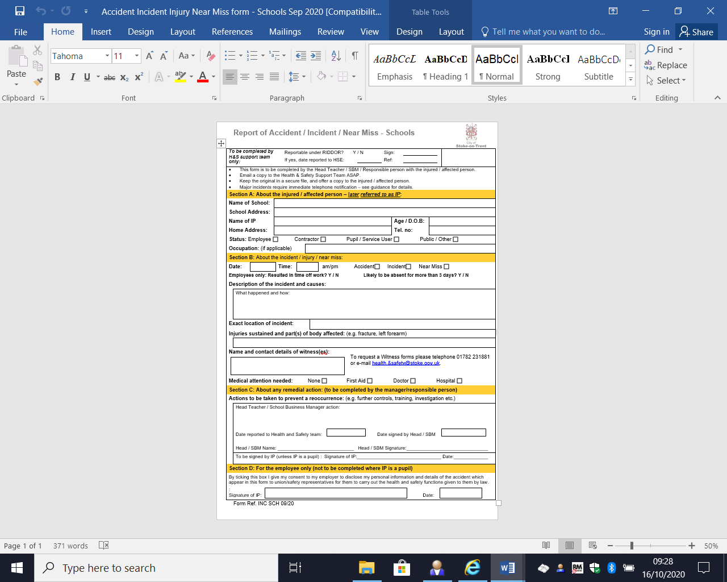

Appendix B

Fire Marshalls:

* Executive Head (Fire Incident Officer/Lead Fire Marshall)
* Head of School
* Assistant Head
* Lead Teachers