Portland School

Planning for Learning: Short, Medium & Long Term

(Embedding Individual Needs and Personalised Outcomes)

Purpose of Planning

Effective planning at Portland ensures that learning is:

- Purposeful; with clear intent, progression, and connection to the wider curriculum sequence
- Personalised; directly linked to each learner’s EHCP outcomes and Pupil Passport targets
- Inclusive; promoting engagement, regulation, and success across all areas of development
- Practical and applied; with opportunities for pupils to actively use, make, perform, or test their learning
- Sequenced; following the Engage - I Do - We Do - You Do - Reflect model, guided practice, and independent application, particularly in medium- and short-term planning

All planning levels should consider how teaching supports curriculum intent, EHCP outcomes, and personalised learning goals, alongside the development of social, emotional, and communication skills. This framework ensures consistency and coherence across all subjects and pathways at Portland.
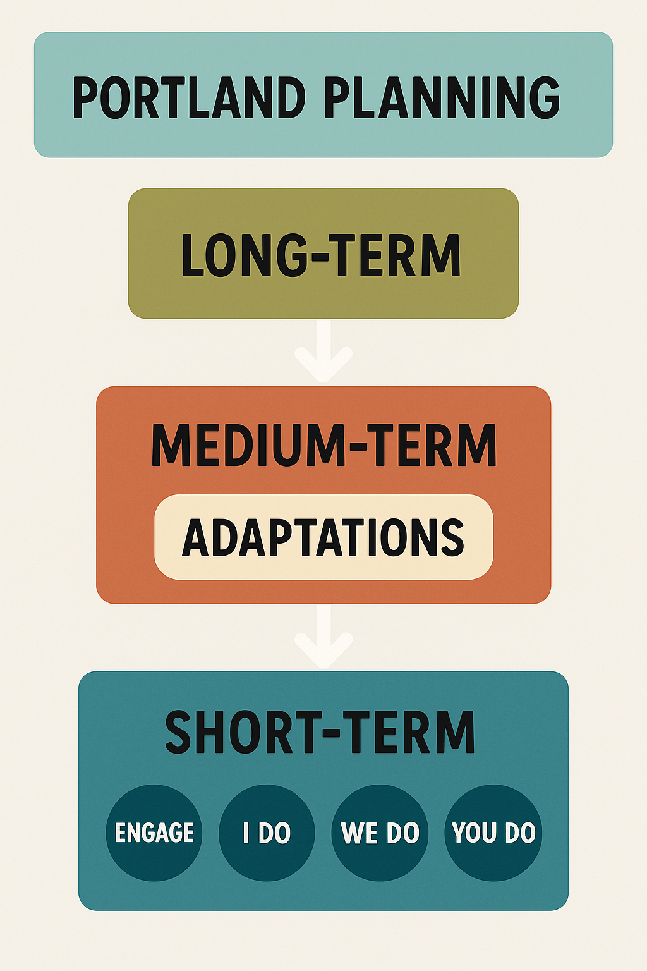

Long-Term Planning

Purpose:
Long-term planning provides an overview of learning across the year or key stage.
It outlines the curriculum intent, sequence, and progression of knowledge and skills across subjects, themes, and experiences.

Long-term plans show what will be taught and when, ensuring coherence and progression over time.

In some cases, long-term planning may use externally purchased or established curriculum programmes. These are adapted to suit the Portland context, following a review of their suitability for pupil needs, accessibility, and alignment with school intent.

Includes:
- Key curriculum themes and areas of learning
- Knowledge and skills progression across the term/year/key stage
- Subject-specific links to broader learning intentions and school pathways
- Opportunities for communication, regulation, and independence
- Cross-curricular or enrichment experiences (e.g. outdoor learning, community participation)
- Assessment points or broad indicators of progress
- Sequencing showing how learning connects to prior and future content

Summary:
The Long-Term Plan should act as the curriculum map, giving a clear overview of what pupils will learn, when, and why. It should also demonstrate intentional thought about how therapies, personal development, enrichment, and life skills are integrated into the broader learning experience.

Medium-Term Planning

Purpose:
Breaks long-term goals into manageable units of learning (usually half-term), showing how skills and knowledge build progressively through sequenced, active, and applied learning.

Each Medium-Term Plan (MTP) ensures that:
- Knowledge and skills are built progressively,
- Learning is practical, applied, and engaging,
- Adaptations are identified and embedded to support accessibility, communication, regulation, and independence,
- Assessment and reflection opportunities are built into the sequence.

If an external or purchased scheme is used (e.g. White Rose), a Portland Medium Term Plan Front Sheet must be completed and placed in front of it. This ensures the scheme has been reviewed for accessibility, suitability, and alignment with Portland’s curriculum intent.

What Each Medium-Term Plan Must Include:
1. Unit Information
- Subject
- Scheme of Learning (SOL) Title
- Year Group
- Length of Scheme of Work (e.g. 6 weeks, 12 lessons)

2. Required Prior Knowledge
A short summary of what pupils should already know or be able to do before starting the unit.

3. Key Knowledge
A clear outline of the knowledge pupils will gain during this unit, the “what” of learning.

4. Key Skills
The specific skills pupils will develop, the “how” of learning and application.

5. Experiences & Cultural Capital
Planned opportunities that develop creativity, independence, empathy, communication, and understanding of the wider world.

6. Key Vocabulary
Subject-specific and communication-rich vocabulary to be explicitly taught, modelled, and reinforced.

7. Adaptations
Planned adjustments that ensure inclusion and engagement for all learners, such as:
- Communication support (visuals, simplified language)
- Regulation support (sensory breaks, predictable structure)
- Scaffolded task design and differentiated materials
- Environmental adaptations
- Integration of therapeutic approaches
- Challenge and extension opportunities

Adaptations should be responsive; staff may adjust these during delivery based on pupil engagement or regulation needs

8. Lesson-by-Lesson Sequence
A structured outline of each session, showing the Engage – I Do – We Do – You Do model of learning.

9. Assessment and Review
Outline how progress will be measured both academically and personally, including:
- Formative assessment methods (questioning, feedback, observation, discussion)
- Summative assessment at the end of the unit
- Reflection and retrieval opportunities to consolidate learning

See Appendix 1 for a completed example of a Medium-Term Plan (MTP).

Summary:
The Medium-Term Plan provides a clear, sequenced structure for teaching and learning. It demonstrates how learning is made accessible through well-planned adaptations, and how pupils’ communication, regulation, and independence are developed alongside curriculum knowledge and skills.

Short-Term Planning

Purpose:
Guides daily teaching and learning, ensuring every lesson is inclusive, purposeful, and personalised, and where applicable, follows the Portland Sequenced Learning Framework.

At Portland, short-term planning is usually presented through lesson slides or equivalent visual formats.

Expectations:
Short-term planning should:
- Follow the Engage – I Do – We Do – You Do - Reflect model to support structured progression.
- Reflect the learning intent, key knowledge, and skills outlined in the medium-term plan.
- Include adaptations within the lesson to ensure that every pupil can access, engage, and succeed.
- Provide a clear learning sequence that builds understanding, confidence, and independence.
- Incorporate opportunities for feedback, reflection, and regulation throughout the session.

Adaptations:
Adaptations are a central feature of short-term planning.
They should be visible within slides or delivery and demonstrate how the lesson design meets the needs of all learners.
These may include adjustments to communication, sensory environment, task structure, level of support, or challenge.

Adaptations reflect strategies planned in the Medium-Term Plan but may be refined in response to pupil need.

Examples of adaptations within short-term planning:
- Visual and communication support (symbols, images, simplified text, colour coding)
- Scaffolded or chunked tasks to support understanding
- Regulation opportunities (movement breaks, structured transitions, calming visuals)
- Differentiated levels of support or outcomes (e.g. “all/most/some”)
- Use of assistive tools or sensory equipment
- Alternative methods of response (oral, written, practical, visual)
- Extension tasks to stretch confident learners

Adaptations should be planned intentionally and embedded throughout the learning sequence to ensure every pupil can participate and progress successfully.

Structure:

Where applicable, short-term planning should follow the Engage – I Do – We Do – You Do format:

Phase | Description | Evidence in Slides / Delivery
Engage | Captures interest, establishes focus, and connects to prior learning | Starter activity, visual prompt, sensory or practical hook
I Do | Teacher modelling and explanation | Clear modelling, visuals, demonstration, verbal and visual scaffolds
We Do | Guided or shared practice | Supported group task, peer modelling, structured rehearsal
You Do | Independent or applied learning | Individual, paired, or small group application
Reflect | Review of learning and emotional state | Discussion, self-assessment, visual check-in, plenary task

Assessment and Reflection:
Short-term planning should include:
- Formative assessment opportunities throughout (questioning, observation, discussion, feedback).
- Reflection activities that encourage pupils to think about what they have learned and how they felt during the session.
- Review and retrieval moments that consolidate learning and inform next steps.
- Teacher reflection on engagement, adaptations, and the effectiveness of strategies used to support access and progress.

Summary:
Short-term planning at Portland demonstrates how teaching is adapted to meet the needs of all learners. Lessons should make these adaptations visible, showing that learning has been designed to be inclusive, engaging, and purposeful for every pupil.
How the Plans Connect

Type | Time Frame | Focus | Adaptation and Sequenced Learning Application
Long-Term Plan | Year / Key Stage | Provides an overview of the curriculum intent and progression across subjects, themes, and key skills. | Outlines the broad sequence of learning. Adaptations are considered at a whole-school or subject level.
Medium-Term Plan | Half-term / Term | Breaks the long-term plan into sequenced, practical units of learning. Identifies the key knowledge, skills, and experiences pupils will gain. | Shows how learning builds progressively and includes specific adaptations to ensure access, engagement, and success for all learners. Follows the Engage – I Do – We Do – You Do - Reflect model to promote independence.
Short-Term Plan | Daily / Weekly | Details the day-to-day delivery of learning, usually presented through slides. | Demonstrates how adaptations are applied in practice, visible within lesson activities, resources, and support strategies. Reflects real-time flexibility and responsiveness to pupils’ needs.
Reflection and Review | Ongoing | Evaluates progress, engagement, and impact across the sequence of learning. | Informs next steps, updates medium-term planning, and evidences the effectiveness of adaptations, therapies, and teaching strategies.

Key Principles for Planning at Portland

Effective planning at Portland is guided by a shared commitment to purposeful, personalised, and inclusive learning. All planning, long-, medium-, and short-term, should clearly demonstrate how the curriculum enables every pupil to make progress academically, socially, and emotionally.

Core Principles:
- Start with the learner.
All planning begins with an understanding of each pupil’s strengths, needs, and motivations. Learning experiences are designed to build engagement, confidence, and independence.
- Plan for progression.
Sequences of learning should show how knowledge and skills build over time, moving from supported to independent application through the Engage – I Do – We Do – You Do - Reflect model.
- Embed adaptations.
Adaptations should be visible across all levels of planning. These include adjustments to communication, sensory input, environment, and task design to ensure all learners can access and participate fully.
- Integrate therapies and support.
Planning should reflect conscious thought about where therapeutic strategies (e.g. communication aids, sensory regulation, physical movement, or occupational therapy approaches) are naturally embedded within teaching.
- Keep learning active and applied.
Pupils should learn by doing, making, performing, or testing to develop understanding and independence. Practical, hands-on learning should be evident throughout the curriculum.
- Foster communication, regulation, and wellbeing.
Every plan should show how opportunities for communication, emotional regulation, and wellbeing are built into learning. These are integral to progress, not separate from academic outcomes.
- Differentiate, challenge, and extend.
Tasks and expectations should be tailored to individual readiness levels, with clear pathways for challenge and independence as pupils develop mastery.
- Collaborate across teams.
Teachers, support staff, and other professionals work together to ensure learning, personal development, and wellbeing goals are aligned and consistent.
- Reflect and review.
Regular reflection should inform next steps. Planning is a working process, responsive to pupil engagement, progress, and changing needs.
- Maintain coherence.
Long-term, medium-term, and short-term plans should connect seamlessly, showing a clear thread from curriculum intent to implementation and impact.

Summary:
Planning at Portland is purposeful, personalised, and proactive.
It ensures that every pupil experiences a curriculum that is accessible, ambitious, and meaningful, enabling them to learn, communicate, regulate, and thrive.


Appendix 1 – Medium Term Plan Example (For illustration only)

Medium Term Plan – Scheme of Learning
Subject | SOL Title | Year Group | Developer
English | Narrative Writing | 10 | Example

Required Prior Knowledge | Students should already have a foundational understanding of how stories work, including the basic structure of a narrative (beginning, middle, and end) and the ability to identify and use literary techniques such as similes, metaphors, and personification.  They should be able to:  - Write in complete, coherent paragraphs using correct punctuation, grammar, and spelling.  - Use a consistent tense and narrative viewpoint (first or third person).  - Recognise and comment on language features and their effects in short extracts.  - Understand how to create descriptive settings and realistic characters.  - Have prior experience in planning, drafting, and editing a short piece of writing.  - Be familiar with reading short fiction extracts from authors such as Dahl, Conan Doyle, and Dickens to understand tone, mood, and structure.
Length of scheme of work | 6 weeks (12 lessons)

Key Knowledge delivered in this unit | Students will learn how to:  - Construct engaging narratives using a clear structure and effective pacing.  - Develop characters and settings that enhance mood and tone.  - Apply narrative techniques such as dialogue, foreshadowing, and cyclical endings.  - Use sentence variety and paragraphing to control tension and reader engagement.  - Refine language choices to convey emotion, atmosphere, and perspective.  - Understand how writers use narrative voice and point of view to shape meaning.  - Strengthen accuracy in grammar, punctuation, and spelling (SPaG) through editing and redrafting.
Key Skills delivered in this unit | Linked to GCSE English Language Assessment Objectives (AQA):  - AO5: Communicate clearly, effectively, and imaginatively, selecting and adapting tone, style, and register for different forms, purposes, and audiences. Organise information and ideas using structural and grammatical features to support coherence and cohesion.  - AO6: Use a range of vocabulary and sentence structures for clarity, purpose, and effect, with accurate spelling and punctuation.  Additionally, students will develop:  - Creative thinking and planning skills when structuring their own narratives.  - Critical self-assessment skills when reviewing and improving drafts.  - Collaborative skills through peer feedback and group discussion of models and techniques.
Experiences & skills to improve cultural capital and life chances | This unit supports students in developing not only literacy but also creativity, empathy, and cultural awareness. Through studying and writing narratives, students will:  - Explore a range of classic and contemporary short stories, exposing them to diverse voices, settings, and perspectives.  - Develop their confidence in self-expression — essential for interviews, presentations, and real-world communication.  - Build resilience and independence through the drafting, editing, and refinement process.  - Strengthen emotional intelligence and empathy by understanding how storytelling reflects human experience.  - Enhance their appreciation of how literature connects to identity, society, and cultural heritage, broadening horizons beyond their own lived experience.

Lesson |  | Learning Intent | Sequence of Learning  (Engage, Teacher Input, I do, We do, You Do –  including Practical/Active Learning element)) | Resources | Adaptations  (Adjustments to support effective learning for all students.) | Assessment
1 | Understanding Narrative Genre | Identify how genre shapes reader expectations | Engage: Genre Carousel – students rotate around short extracts, props, or images from different genres and discuss: “What genre is this and how do you know?”  Teacher Input: Introduce genre conventions (e.g. horror = suspense; adventure = action). Read aloud a model extract (“The wind clawed at the door.”) and annotate tone, vocabulary, and imagery.  I Do: Model identifying genre features and their effect.  We Do: Pairs use colour-coded cards to sort descriptive features by genre (e.g. horror/adventure/realism).  You Do: Students write a 50-word micro-story using chosen genre conventions. | Genre cards, printed extracts, PowerPoint | J.B. – Provide genre vocabulary list and model answers.  L.T. – Colour-coded cards for memory support.  K.S. – Offer clear instructions and reassurance during carousel transitions.  M.S. – Challenge to combine two genres (hybrid story). | Peer review of micro-stories; teacher Q&A on genre conventions.
2 | Building Character and Setting | Develop characters using description and dialogue | Engage: Character Walk – students move around room acting out emotions (e.g. nervous, excited, angry). Others guess emotion and describe body language.  Teacher Input: Model “show not tell” using example (“She tapped her nails…”). Annotate verbs and connotations.  I Do: Live-write a paragraph describing a character using one sense.  We Do: Students act out a short scene and discuss how dialogue reveals emotion; then jointly write a short descriptive paragraph.  You Do: Write own paragraph combining sensory description and speech. | Emotion cards, example texts, AO5 checklist | J.B. – Sentence stems for sensory writing.  L.T. – Emotion vocabulary mats.  A.P. – Offer movement choice or paired role for comfort.  M.S. – Add internal monologue for complexity. | Teacher feedback on paragraph; peer “show not tell” check.
3 | Planning a Narrative | Organise a story using effective structure |  | Plot cards, sticky notes, string for wall arcs | J.B. – Simplified 3-part story frame.  L.T. – Use pictorial template.  C.D. – Allocate supportive group role to encourage participation.  M.S. – Add subplot or time shift. | Review of individual plans; formative teacher comments.
  Engage: Story Sequencing Race – students in teams arrange jumbled plot cards into a logical order.
  Teacher Input: Explain Freytag’s Pyramid (Exposition → Rising Action → Climax → Resolution). Model planning “A Life-Changing Rescue.”
  I Do: Demonstrate plotting turning points on whiteboard.
  We Do: Students create physical “story arcs” using string and sticky notes for each plot point.
  You Do: Students complete individual story mountains.
4 | Writing the Opening | Engage readers through narrative voice and tone | Engage: “Opening Line Gallery” – students write one opening line on paper and move around reading each other’s, voting with stickers for the strongest.  Teacher Input: Explain how “show not tell” and sensory verbs build atmosphere. Model rewriting a dull opening into a vivid one.  I Do: Live-write an engaging opening with narrated thought process.  We Do: Peer-edit and improve teacher’s model collaboratively on board or display.  You Do: Students draft their own openings and self-assess using AO5 criteria. | Opening line slips, stickers, AO5 checklist | J.B. – Sentence starters.  L.T. – Visual prompts.  E.R. – Provide calm, low-pressure voting; no public reading required.  M.S. – Begin in medias res (mid-action). | Peer/self-assessment; teacher samples for AFL.
5 | Developing Tension and Pacing | Manipulate sentence structure and paragraphing for effect | Engage: “Heartbeat Challenge” – students clap or step to slow, then fast beats; reflect on which feels more tense.  Teacher Input: Explain how sentence length and paragraphing create pace. Annotate model extract for short vs long sentences.  I Do: Live-edit an overlong paragraph for tension.  We Do: Pairs use scissors and strips of text to cut/rearrange sentences to control rhythm.  You Do: Apply pacing techniques to own story draft. | Model extracts, printed strips, highlighters | J.B. – Scaffold sheet for sentence types.  L.T. – Partnered editing task for confidence.  K.S. – Use rhythm-based starter to support focus and engagement.  M.S. – Experiment with time shifts or parallel structure. | AO5 feedback on redrafted paragraphs.
6 | Endings and Reflection | Craft effective endings that leave emotional impact | Engage: “Ending Swap” – read two final lines from different stories; students stand left/right of room for which feels more powerful and explain why.  Teacher Input: Model cyclical ending linking back to the opening. Annotate for tone and emotion.  I Do: Write model ending live, narrating punctuation and rhythm.  We Do: Pairs act out the emotional tone of an ending (e.g. relief, loss, irony) before writing.  You Do: Students complete their own story endings and short written reflection. | Example endings, reflection sheet |  | Final narrative marked AO5/AO6; reflection self-assessment.
  J.B. – Sentence stems (“In the end…”).
  L.T. – Reflection paragraph scaffold.
  A.P. – Calm environment during writing; clear guidance on structure.
  M.S. – Add foreshadowing to connect opening and ending.

