
Portland School

3 YEAR PUPIL PREMIUM STRATEGIC PLAN

Organisation
Section | Focus | Contents
Section 1 | School context & approach to the PPG | Philosophy driven by evidence and desired outcome and linked to wider school priorities
Section 2 | Long term (3 year) overview | Setting long term goals to reflect the school context
Section 3 | Academic Year Action Plan & Impact Statement | Action plan for the current academic year, funding and evaluation of impact
The Pupil Premium Strategic Plan is organised into 3 sections and based on our long-term approach to the Pupil Premium Grant using the Inclusion Framework (ofsted) as our guide and linked to wider school improvement priorities: ‘pupil premium strategy that is well thought through, based on evidence (EEF) of what works well to support the achievement of eligible pupils and accounts for any challenges they may face’

PHILOSOPHY & PRACTICE
We believe in maximising the use of the Pupil Premium Grant (PPG) by utilising a long-term strategy which is fully aligned to our Rapid Improvement Plan priorities (Inclusion): This enables us to implement a blend of short, medium and long-term interventions, which effectively coordinate use of Pupil Premium and wider school improvement strategies for maximum impact on pupil outcomes. Strong language and communication skills will be prioritised as a protective factor for pupils’ mental health, behaviour and self-regulation, ensuring disadvantaged pupils can express their needs, reduce frustration and access learning with confidence.

We build our practice around our teaching and learning approach using ‘The Portland Sequenced Learning Framework

IMPLEMENTATION PROCESS
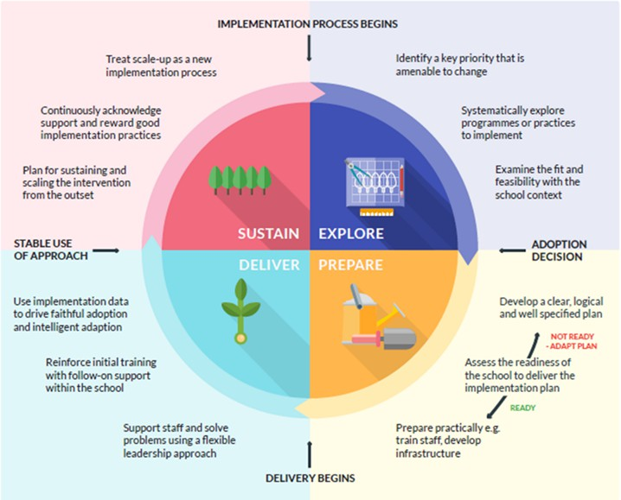
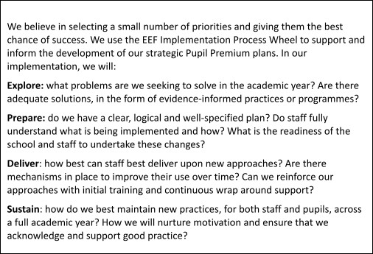

OUR REVIEW PROCESS
We believe in evidence-based interventions and learning from our experiences, which is why we carry out weekly checks during interventions to ensure clear progress from a pupil’s baseline and towards end of year objectives. To ensure our approach is effective, we will cease or amend any interventions that are not having the intended impact. The progress of pupils in receipt of the PPG is discussed with teachers at pupil progress review meetings. At the end of each year, we fully evaluate the impact of all our actions and strategies on pupil outcomes and use this information to inform next steps.

ACCOUNTABILITY
At Portland, an Interim Executive Board (IEB) is in place. The IEB reviews the school’s Pupil Premium strategy annually and monitors the attainment and progress of disadvantaged pupils throughout the academic year.
The Executive Headteacher and the Head of Schools are accountable for ensuring that pupils in receipt of the PPG achieve high standards and positive outcomes. This priority is also reflected in the appraisal process with teaching and support staff.
The school publishes its Pupil Premium strategy annually on the school website.
Barriers at Portland School:
Ofsted 2021:

Ofsted: What does the school need to do to improve further? (Summary from Ofsted Report 7/8 Dec 2021)
■ On the secondary site, leaders and staff are not meeting pupils’ SEMH needs.  Consequently, pupils lose interest in their learning and become disengaged, and  some display challenging behaviour. Leaders need to provide staff with the  training and support they need, so that they are able to meet pupils’ SEMH  needs.   Leaders are in the early stages of developing their curriculum areas in some  subjects. Some subject leaders do not have the required subject knowledge and  leadership skills to do this effectively. As a result, well-ordered curriculum plans  are not in place. Senior leaders need to provide subject leaders with appropriate  support so they can develop well-sequenced curriculum plans in their subject.   Staff do not have secure subject knowledge in some curriculum areas. They do  not deliver the curriculum effectively. Leaders need to provide staff with the  training and support they need so they can teach the curriculum effectively in all  subjects. | ■ Some staff do not teach phonics consistently well for pupils at the early stages of  reading. Pupils’ reading books are not well matched to their phonic ability. As a  result, pupils fall behind with their reading. Leaders need to provide all staff with  the relevant training so they can deliver the phonics curriculum effectively and  match reading books to pupils’ phonic ability.   There is not a clear and consistent approach to behaviour management on the  secondary site. Staff do not address incidents of negative behaviour and bullying  effectively. Consequently, incidents of bullying reoccur and behaviour incidents  escalate and get out of control. Leaders need to implement a clear behaviour  policy that staff and pupils understand and follow. | ■ Although the new leadership team is bringing about changes, currently there is  insufficient capacity in the leadership team. Leaders cannot implement  improvement plans effectively. Senior leaders need to arrange support and  training for leaders at all levels, so that leadership tasks can be shared to secure  future improvements.  ν Some pupils attend school on a rota system. This limits the ability of leaders to  check on pupils’ safety and has a negative impact on pupils’ education. As a  matter of urgency, leaders need to fill staff vacancies to increase levels of staffing in the school.  Pupils, especially those who attend the secondary site, are following a narrow  curriculum. The RSE curriculum does not support pupils’ understanding of healthy  relationships. CEIAG does not prepare pupils for the next stage of their education  or employment and training. Leaders need to broaden the curriculum beyond the  academic aspect to support pupils’ personal development

SECTION 2: LONG TERM (3 YEAR) OVERVIEW

SETTING THE PRIORITIES
Setting priorities is key to maximising the use of the PPG. Our long term priorities are identified in our 3 year strategic overview and progress towards them outlined in a detailed action plan relevant to each academic year (see Section 3). Our priorities are linked to our Rapid Improvement Plan and additional scrutiny is provided within each cycle of the RIP.

HEADLINE AREAS FOR DEVELOPMENT 2025 - 2026
PP AREA FOR DEVELOPMENT | IMPLEMENTATION | PPG DESIRED OUTCOME
Establish system attendance meetings  To ensure attendance for PPG pupils is in line with all pupils’ nationally and in line with non-PPG  To increase punctuality for all pupils | Executive leaders to meet with attendance teams to discuss:  - Attendance thresholds  - MLP/AP Provision  Establish key performance indicators for line management meeting | All pupils attend well  We aim to achieve:  - 75% attendance 2025-26  - 85% attendance 2026-27
Leaders need to implement a consistent approach to phonics across both sites; literacy targets need to be implemented onto the Pupils Passports  Raise standards in Phonics and Early Reading  To support phonics and early reading, leaders will implement a consistent handwriting and transcription programme through Read Write Inc. to ensure that pupils are able to form letters correctly, write fluently and apply their phonics knowledge when writing.  Language, Communication and Writing Development | Phonics groups set up correctly  Books are banded appropriately and gaps are closing  Staff confidently deliver RWI  Reading is sequenced and fully supported in the offer including reading for pleasure  Reading interventions are targeted correctly  Explicit teaching of letter formation linked to RWI sounds  Daily handwriting and fine motor practice  Consistent use of RWI phrases and language when teaching writing  Targeted support for pupils with weak motor control, poor pencil grip or low stamina  Alongside phonics, pupils will receive:  - Daily structured talk opportunities  - Explicit teaching of vocabulary and sentence structure  - RWI linked oral rehearsal before writing  - Handwriting and transcription taught as part of reading and phonics | All pupils able to read fluently and write with confidence, accuracy and increasing independence.  - 100% of pupils achieve the expected standard or above by the end of KS1  - 75% KS3 pupils will make progress towards age related expectations  - 75% KS4 pupils will make progress towards age related expectations  - Pupils can record what they know in reading and phonics  - Writing does not become a barrier to learning  - Disadvantaged pupils keep pace with their peers in early literacy  - Understand what they read  - Say what they want to write  - Write it clearly and accurately

To meet the SEMH needs of all children consistently through targeted, appropriate and timely interventions | 3 SMART targets aligned to EHCP outcomes  Targets reviewed every 6 weeks including pupil voice and assessment data  Increase the number and appropriateness of Interventions  Interventions are timely and address pupils’ needs and challenges | Children’s SEMH needs are consistently met and therefore academic achievements are rising with:  Good mental health  Children know and understand how to have positive relationship with their peers  Children are able to self-regulate their emotions  Children participate in all lessons and learning with greater confidence
For PPG children to have the same opportunities as non-PPG children  PPG children actively participate in extracurricular clubs and activities | Daily breakfast and lunch clubs and activities  Increase number and attendance on school trips  Continue to provide additional school uniform and any subject specific equipment | Children to be able to access:  Breaktime/Lunchtime Clubs  School Trips  Are provided with essentials such as school uniform etc.

SECTION 3: ACADEMIC YEAR 2023/ 2024 ACTION PLAN

Detail | Data
School name | Portland School
Number of pupils in school | 144
Proportion (%) of pupil premium eligible pupils | 76.3%
Academic year/years that our current pupil premium strategy plan covers (3 year plans are recommended) | 2024 - 2027
Date this 3 YEAR STRATEGY was published | September 2024
Date on which it will be reviewed | July 2025
Statement authorised by | Alexis Bull
Pupil premium lead | Exec Head / Head of Schools
IEB lead | Mark Howes

Funding overview

Detail | Amount
Pupil premium funding allocation this academic year FSM Ever 6 | £ 117,953.00
PLAC | £18,320.00
Pupil premium – Service Pupils (£X per pupil) | £ 0

Total PP for this academic year  If your school is an academy in a trust that pools this funding, state the amount available to your school this academic year | £ 136,273.00
Recovery premium funding allocation this academic year | £0.00
Pupil premium funding carried forward from previous years (enter £0 if not applicable) | £0.00

Teaching (£50,000)

LINKED TO 3 YEAR STRATEGIC OUTCOME: |  |  | Raise standards in Phonics and Early Reading to at least the same attainment levels as non –PP pupils (Read Write Inc.)
ACADEMIC YEAR 2025/2026 OBJECTIVE: |  |  | To teach phonics with fidelity.
AREA OF SPEND | PP S-PEND | RESPONSIBILITY | DESCRIPTION OF ACTIONS | INTENDED OUTCOMES & EVIDENCE | IMPACT
RWI phonics  GL assessments | Program  Training  Coaching  Mentoring | SLT  Phonics Co-originator  English Leads  T&L Leads | To buy and embed quality assured phonics program and resources  To launch the new phonics program as a whole school approach  To provide regular weekly CPD for the whole school through:  development meetings/coaching sessions  To carefully monitor and evaluate the impact of the new phonics program  -To assess children half termly to develop further strategies  -To provide small group keep up sessions daily. | Teachers to teach with fidelity  All staff trained in RWI  Children to make a strong start after transition and supported in well considered groupings | Phonics attainment raised for all children  Reading gaps are radically reduced  Pupils achieving age related outcomes

TIER 2 (£50,000 (ELSA, Art therapy, counselling, Stenghten welfare staff, extra trips, wider provision)

LINKED TO 3 YEAR STRATEGIC OUTCOME: |  |  | To meet the SEMH needs of all children consistently.
ACADEMIC YEAR 2025/2026 OBJECTIVE: |  |  | To provide effective and timely interventions for children with SEMH needs.
AREA OF SPEND | PP SPEND | RESPONSIBILITY | DESCRIPTION OF ACTIONS | INTENDED OUTCOMES & EVIDENCE | IMPACT

Elsa support  Social/emotional  Behaviour  Lit/num  Parental Support Worker | Councilors  ELSA team in place from November  Art therapist  Parental Support Worker | SLT  Welfare  SENCO/Inclusion ELSA practitioner  Parental Support Worker | - Councilors  - Training for the ELSA Team  Practitioners.  - Regular teaching of Health and Well-being sessions / PHSE  - CPD for staff on social and emotional needs.  - CPD on the delivery of the Jigsaw sessions  - Timetable ELSA session for vulnerable children  - Parentals support worker to oversee and support the most vulnerable families  - PACE training  - Bespoke SEND specific training January 2026 | -Targeted support for children over time and in crisis situations  - Health and Well-being sessions equip children with tools and strategies to deal with SEMH issues better. (Prevention)  - Children are able to self regulate their emotions  - Attitudes to learning and attendance improve  -Parents are supported and feel that they have a point of contact to address issues in their family. | - Children are starting to discuss their feelings as evident through “soft data”  - Children are able to identify triggers and know strategies to support them.  - Behaviour across the school is purposeful as evident in learning environment.  - Reduced anxiety levels by children so they are able to attend classes for longer.  - Children feel well supported as evident through pupil voice  - Attendance and punctuality rapidly improves

Prevention rather than escalation of SEMH related issues.
Parents feel supported and receive appropriate help
Sparkles  1:1 or group support for Parents  Parental engagement and support | Staff time increases and events and the accommodation of events including the resourcing of the events | SLT  FSW Manager  Welfare and safeguarding  Admin support | Regular Coffee morning for Sparkles parents  Parent workshops and online learning through Sparkles  - ​ | Provide Sparkles children/parents with more targeted support to reduce anxiety. | - Children are being supported emotionally At Portland , we are committed to providing opportunities for children to develop their creative enjoyment, awareness and skills.  - Parents are better  equipped to support children at home.

LINKED TO 3 YEAR STRATEGIC OUTCOME: |  |  | Promoting excellence in Attendance: all pupils to be above 85%.
ACADEMIC YEAR 2025/2026 OBJECTIVE: |  |  | Attendance to be in line with national for all pupils. Aim to achieve 75% 2025-26
AREA OF SPEND | PP SPEND | RESPONSIBILITY | DESCRIPTION OF ACTIONS | INTENDED OUTCOMES & EVIDENCE | IMPACT
Staffing/VIP services/welfare/upgrade to Arbor sophistication | VIP  Arbor upgrade  Staffing | Attendance Leaders  School Admin support for attendance  Parental Support Worker | Evaluate current practice and develop further strategies within the RIP(December 2025)  CPD Teachers as leader of attendance (Term 3 and 4)/Arbor training  Sparkles/Progress events/community events (Coffee mornings)  Coffee mornings/ events for PPG parents  Stricter appointments scheduled with parent/carers within attendance policy  VIP to support the recommendation of attendance stages and support with parental meetings | clear attendance strategy to ensure attendance issues are being picked up swiftly. (Proactive)  Teachers/support staff are responsible for initial contact about attendance -dilemmas can be discussed with the behaviour and attendance team where further support in meetings can be allocated  Parents can discuss issues – open door policy  Improved parental engagement | attendance increases for all pupils.  parent/school relationships is improving

