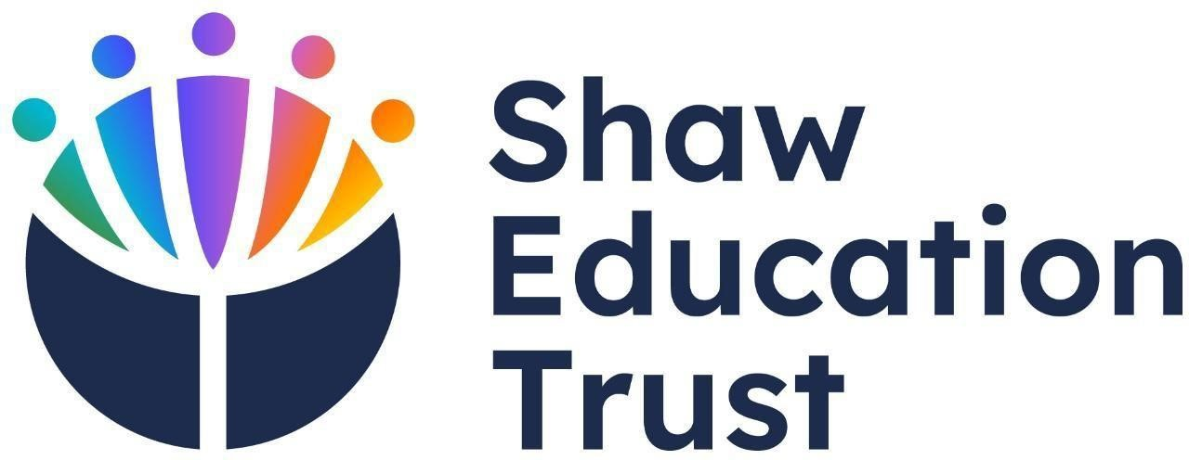

Relationship and sex education policy

Portland School 2026-2027

Approved by: | Alexis Billl
Last Reviewed on: | 1.09.2026
Next Review Date: | 1.09.2027

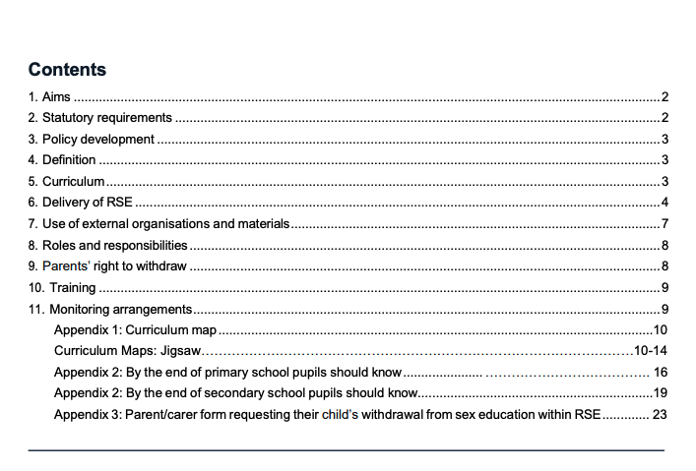

1. Aims
The aims of relationships and sex education (RSE) at our school are to:
Provide a framework in which sensitive discussions can take place
Prepare pupils for puberty, and give them an understanding of sexual development and the importance of health and hygiene
Help pupils develop feelings of self-respect, confidence and empathy, and cultivate positive characteristics such as kindness and integrity
Create a positive culture around issues of sexuality and relationships
Teach pupils the correct vocabulary to describe themselves and their bodies

2. Statutory requirements

Within our primary provision we must provide relationships education to all pupils under section 34 of the Children and Social Work Act 2017.
We are not required to provide sex education, but we do need to teach the elements of sex education contained in the science curriculum.
In teaching RSE, we must have regard to guidance issued by the secretary of state, as outlined in section 403 of the Education Act 1996.
We also have regard to legal duties set out in:
- Sections 404 to 407 of the Education Act 1996.
- Part 6, chapter 1 of the Equality Act 2010
- The Public Sector Equality Duty (PSED) (as set out in section 149 of the Equality Act 2010). This duty requires public bodies to have due regard to the need to eliminate discrimination, advance equality of opportunity and foster good relations between different people when carrying out their activities
Within our secondary provision, we must provide RSE to all pupils under section 34 of the Children and Social Work Act 2017.
In teaching RSE, we must have regard to guidance issued by the secretary of state, as outlined in section 403 of the Education Act 1996.
We also have regard to legal duties set out in:
- Sections 404 to 407 of the Education Act 1996
- Part 6, chapter 1 of the Equality Act 2010
- The Public Sector Equality Duty (PSED) (as set out in section 149 of the Equality Act 2010). This duty requires public bodies to have due regard to the need to eliminate discrimination, advance equality of opportunity and foster good relations between different people when carrying out their activities At Portland School, we teach RSE as set out in this policy.

3. Policy development
This policy has been developed in consultation with staff, pupils and parents/carers. The consultation and policy development process involved the following steps:
- Review – a member of staff or working group pulled together all relevant information including relevant national and local guidance
- Staff consultation – all school staff were given the opportunity to look at the policy and make recommendations
- Parent/stakeholder consultation – parents/carers and any interested parties were invited to attend a meeting about the policy
- Pupil consultation – we investigated what exactly pupils want from their RSE
- Ratification – once amendments were made, the policy was shared with governors and ratified

4. Definition
RSE is about the emotional, social and cultural development of pupils, and involves learning about relationships, sexual health, sexuality, healthy lifestyles, diversity and personal identity.
RSE involves a combination of sharing information, and exploring issues and values.
RSE is not about the promotion of sexual activity.

5. Curriculum
Our RSE curriculum is set out as per Appendices 1 and 2, but we may need to adapt it as and when necessary.
We have developed the curriculum in consultation with parents and carers, pupils and staff, and taking into account the age, developmental stage, needs (such as cultural and religious needs) and feelings of our pupils. If pupils ask questions outside the scope of this policy, teachers will respond in an appropriate manner so that pupils are fully informed and don’t seek answers online.
We will share all curriculum materials with parents and carers on request.

6. Delivery of RSE
RSE is taught within the personal, social, health and economic (PSHE) education curriculum. Biological aspects of RSE are taught within the science curriculum, and other aspects are included in religious education (RE).
The school will make sure that:
Core knowledge is sectioned into units of manageable size
The required content is communicated to pupils clearly, in a carefully sequenced way and within a planned scheme of work
Teaching includes sufficient and well-chosen opportunities and contexts for pupils to embed new knowledge, so that it can be used confidently in real-life situations

Relationships education in the primary provision focuses on teaching the fundamental building blocks and characteristics of positive relationships including:
Families and people who care for me
Caring friendships
Respectful, kind relationships Online safety and awareness Being safe

Primary sex education will focus on:
Preparing boys and girls for the changes that adolescence brings How a baby is conceived and born
Throughout each year group we will use appropriate material to assist learning, such as:
Diagrams
Videos Books
Games
Discussions and practical activities
Teachers will make sure that all pupils’ views are listened to, and will encourage them to ask questions and engage in discussion. Teachers will answer questions sensitively, honestly and appropriately for the age of the pupils.
The programme will be designed to focus on boys as much as girls, and activities will be planned to make sure both are actively involved.
The school will make sure that all teaching and materials are appropriate for the ages and needs of the pupils including any additional needs, such as special educational needs and disabilities (SEND).
At all points of delivery of the curriculum, the school will consult parents and carers, and their views will be valued. What will be taught and how will be planned in conjunction with parents and carers.
For more information about our RSE curriculum, see Appendices 1 and 2.
RSE in our secondary provision focuses on giving young people the information they need to help them develop healthy, nurturing relationships of all kinds, not just intimate relationships, including:
Families
Respectful relationships, including friendships
Online safety and awareness
Being safe
Intimate and sexual relationships, including sexual health
RSE complements several other curriculum subjects. Where appropriate, the school will look for opportunities to make links between the subjects and integrate teaching. The RSE curriculum will be delivered by appropriately trained members of staff.
Teachers will make sure that pupils understand the importance of equality and respect, and learn about the law relating to the protected characteristics, as set out in the Equality Act 2010, by the end of their secondary education. The curriculum is designed to focus on pupils of all gender identities and expressions, and activities will be planned to make sure all are actively involved.
Throughout each year group we will use appropriate material to assist learning, such as:
Diagrams
Videos Books
Games
Discussions and practical activities
Teachers will make sure that all pupils’ views are listened to, and will encourage them to ask questions and engage in discussion. Teachers will answer questions sensitively, honestly and appropriately for the age of the pupils.
The programme will be designed to focus on boys as much as girls, and activities will be planned to make sure both are actively involved.
The school will make sure that all teaching and materials are appropriate for the ages and needs of the pupils including any additional needs, such as special educational needs and disabilities (SEND).
At all points of delivery of the curriculum, the school will consult parents and carers, and their views will be valued. What will be taught and how will be planned in conjunction with parents and carers.
It is important for secondary pupils to know what the law says about certain topics covered in RSE, particularly in relation to the law and young people. This will help pupils identify what is right and wrong, and can provide a foundation of knowledge for deeper discussion. These topics include, but are not limited to:
Marriage, including forced marriage and civil partnerships
Consent, including the age of consent
Domestic abuse, stalking, rape, sexual offences, female genital mutilation (FGM), ‘virginity testing’ and hymenoplasty
Sexual abuse, harassment and exploitation, including public sexual harassment and harmful sexual behaviour
Online behaviours including image and information sharing (including sexual imagery, youth-produced sexual imagery and including AI-generated sexual imagery and deepfakes). Pupils should understand the law about online sexual harassment and online sexual abuse, including grooming and sextortion
Pornography
Abortion
The protected characteristics
The age of criminal responsibility
For more information about our RSE curriculum, see Appendices 1 and 2.
We may amend our curriculum content to respond to the needs and context of our pupils, to discuss issues affecting them in an age-appropriate manner. We will inform parents and carers of any deviation from our published policy in advance, and share any relevant materials on request.
These areas of learning are taught within the context of family life, taking care to make sure that there is no stigmatisation of children based on their home circumstances (i.e. families can include single-parent families, same-sex parents, families headed by grandparents, adoptive parents and foster parents among other structures), along with reflecting sensitively that some children may have a different structure of support around them (for example, looked-after children, young carers or kinship carers).
Across our school, we will also be mindful of the law and legal requirements, taking care not to condone or encourage illegal activity, such as violent action against people, criminal damage to property or hate crime.

6.1 Inclusivity
We will teach about these topics in a manner that:
Considers how a diverse range of pupils will relate to them
Is sensitive to all pupils’ experiences During lessons, makes pupils feel:
- Safe and supported
- Able to engage with the key messages We will also:
Make sure that pupils learn about these topics in an environment that’s appropriate for them, for example in:
- A whole-class setting o Small groups or targeted sessions o 1-to-1 discussions o Digital formats
Give careful consideration to the level of differentiation needed

6.2 Use of resources
We will consider whether any resources we plan to use:
o Are aligned with the teaching requirements set out in the statutory RSE guidance o Would support pupils in applying their knowledge in different contexts and settings o Are age-appropriate, given the age and maturity of the pupils o Are evidence-based and contain robust facts and statistics o Fit into our curriculum plan o Are from credible sources o Are compatible with effective teaching approaches o Are sensitive to pupils’ experiences and won’t provoke distress
We will make sure that when we consult parents/carers we provide examples of the resources that the school plans to use.

7. Use of external organisations and materials
We will make sure that an agency and any materials used are accurate, age and stage appropriate and unbiased and in line with our legal duties around political impartiality.
We will:
Make appropriate checks and engage with external agencies to make sure that their approach to teaching about RSE is balanced, and it and the resources they intend to use:
- Are age-appropriate o Are in line with pupils’ developmental stage o Comply with:
  - This policy
  - The Teachers’ Standards
  - The Equality Act 2010
  - The Human Rights Act 1998
  - The Education Act 1996
Only work with external agencies where we have full confidence in the agency, its approach and the resources it uses
Make sure that any speakers and resources meet the intended outcome of the relevant part of the curriculum
Review any case-study materials and look for feedback from other people the agency has worked with Be clear on:
- What they’re going to say
- Their position on the issues to be discussed
Ask to see in advance any materials that the agency may use
Know the named individuals who will be there, and follow our usual safeguarding procedures for these people
Conduct a basic online search and address anything that may be of concern to us, or to parents and carers
Check the agency’s protocol for taking pictures or using any personal data they might get from a session
Remind teachers that they can say “no” or, in extreme cases, stop a session
Make sure that the teacher is in the room during any sessions with external speakers
Inform all external organisations that the school is legally obliged to share all content with parents and carers
Share all external materials with parents and carers We won’t, under any circumstances:
Work with external agencies that take or promote extreme political positions
Use materials produced by such agencies, even if the material itself is not extreme
Work with agencies who don’t allow their material to be shared with parents and carers

8. Roles and responsibilities
8.1 The governing board
The IEB will approve the RSE policy, and hold the Executive Headteacher to account for its implementation.

8.2 The Executive Headteacher and Head’s of School
Are responsible for making sure that RSE is taught consistently across the school, for sharing all resources and materials with parents and carers, and for managing requests to withdraw pupils from components of RSE (see section 9).

8.3 Staff
Staff are responsible for:
Delivering RSE in a way that is sensitive, high-quality and appropriate for each year group
Modelling positive attitudes to RSE
Monitoring progress
Responding to the needs of individual pupils
Responding appropriately to pupils whose parents/carers wish them to be withdrawn from the [non- statutory/non-science] components of RSE
Modelling positive behaviour and avoiding language that might perpetuate harmful stereotypes, and being conscious of everyday sexism, misogyny, homophobia and stereotypes
Reporting any safeguarding concerns or disclosures that pupils may make as a result of the subject content to the school’s designated safeguarding lead (DSL) Jonathan Gillie.
Staff do not have the right to opt out of teaching RSE. Staff who have concerns about teaching RSE are encouraged to discuss this with the headteacher.

8.4 Pupils
Pupils are expected to engage fully in RSE and, when discussing issues related to RSE, treat others with respect and sensitivity.

9. Parents’ right to withdraw
Within the primary provision:
Parents/carers do not have the right to withdraw their child from relationships education.
Parents/carers have the right to withdraw their child from the [non-statutory/non-science] components of sex education within RSE.
Requests for withdrawal should be put in writing using the form found in Appendix 3 of this policy and addressed to the headteacher.
Alternative schoolwork will be given to pupils who are withdrawn from sex education.
Within the secondary provision:
Parents/carers have the right to request to withdraw their child from the [non-statutory/non-science] components of sex education within RSE up to and until 3 terms before the pupil turns 16. After this point, if the pupil wishes to receive sex education rather than being withdrawn, the school will arrange this.
Requests for withdrawal should be put in writing using the form found in Appendix 3 of this policy and addressed to the headteacher.
A copy of any withdrawal requests will be placed in the pupil’s educational record. The headteacher will discuss the request with parents/carers and take appropriate action and provide the parents/carers with their decision in writing.
In exceptional circumstances, for example because of a safeguarding concern or a pupil’s specific vulnerability, the headteacher can refuse a request to withdraw the pupil from sex education.
Alternative schoolwork will be given to pupils who are withdrawn from sex education.

10. Training
Staff are trained on the delivery of RSE as part of their induction and it is included in our continuing professional development calendar.
The headteacher will also invite visitors from outside the school, such as school nurses or sexual health professionals, to provide support and training to staff teaching RSE.

11. Monitoring arrangements
The delivery of RSE is monitored by Jonathan Gillie and George Anderson through:
Learning walks, Long term and Mid term planning, pupil, parent and staff voice and of course, working with our external partners
Pupils’ development in RSE is monitored by class teachers as part of our internal assessment systems. Our RSHE Lead teacher is Thomas Harding (based at the Trent Vale site)
This policy will be reviewed by Alexis Bull, annually. At every review, the policy will be approved by the IEB.

Appendix 1: Curriculum map Key Stage 2 Relationships and sex education curriculum map 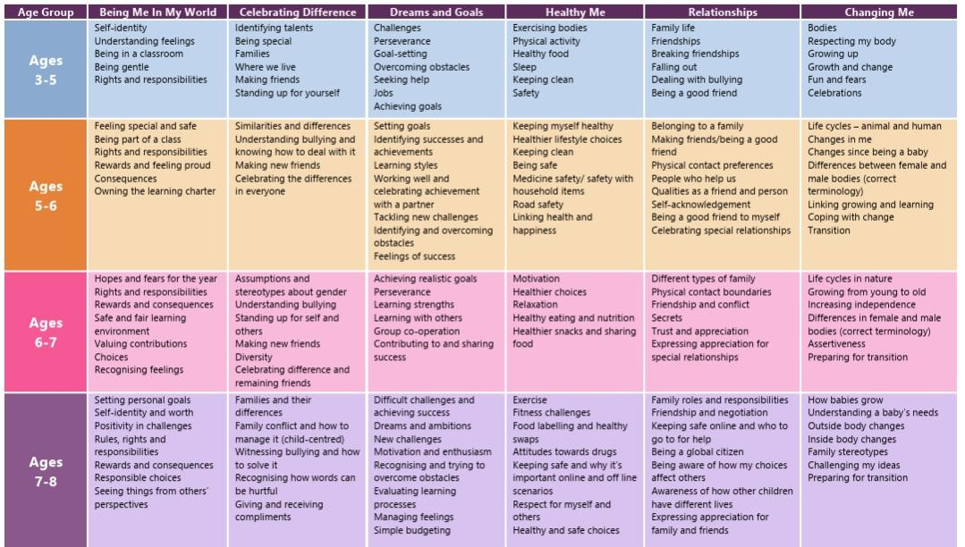

Key Stage 3/4 Relationships and sex education curriculum map

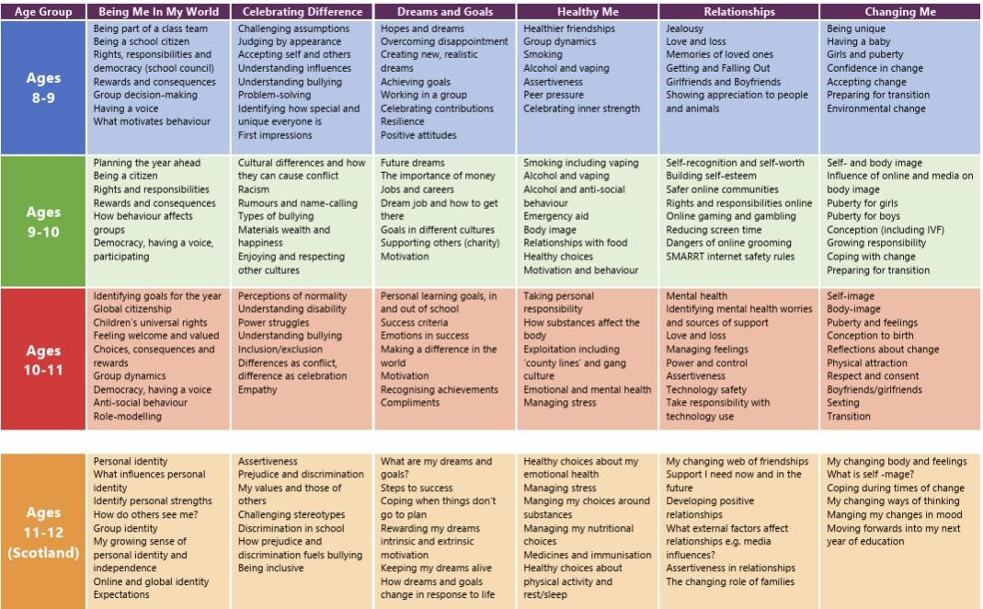
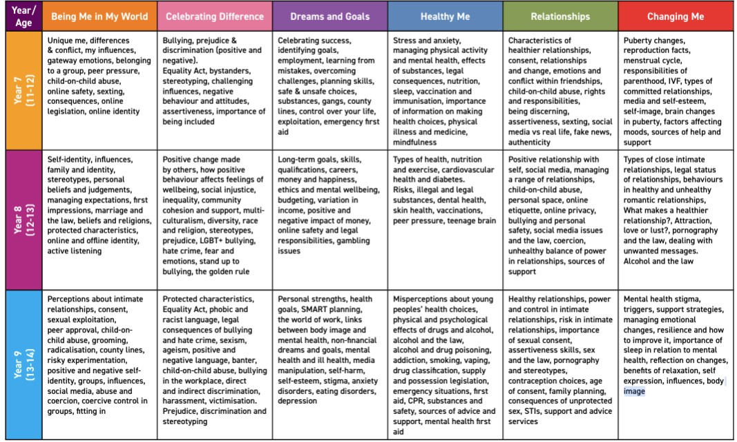

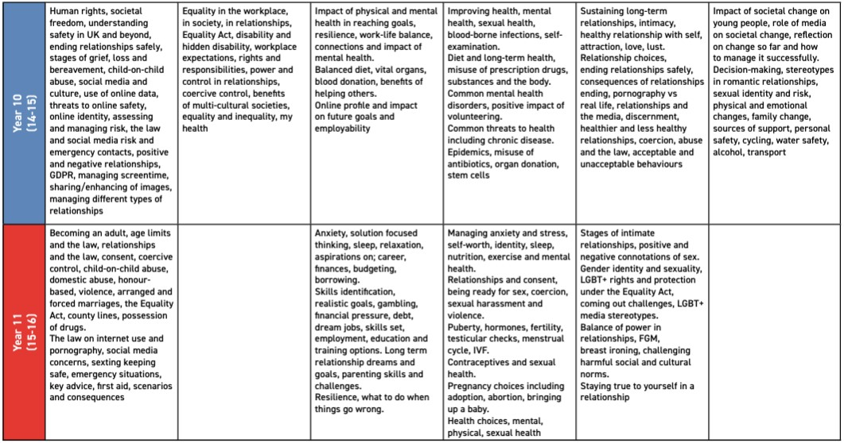

Skills Builder:

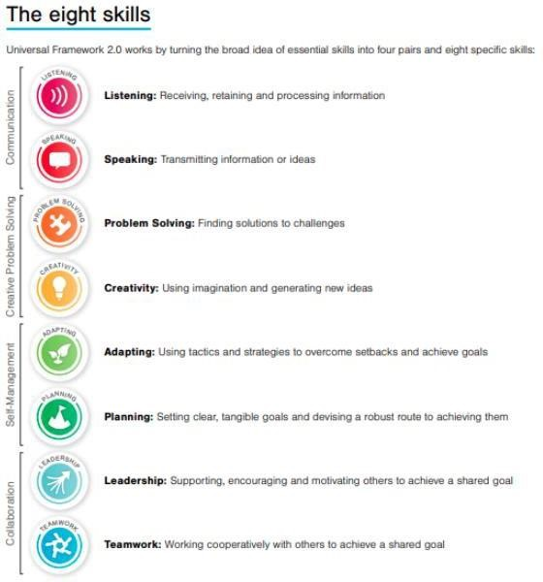

TOPIC | PUPILS SHOULD KNOW
Families and people who care for me | - That families are important for children growing up because they can give love, security and stability  - The characteristics of safe and happy family life, such as: commitment to each other, including in times of difficulty, protection and care for children and other family members, the importance of spending time together and sharing each other’s lives  - That other children’s families, either in school or in the wider world, sometimes look different from their own, but they should respect those differences and know that other families are also characterised by love and care  - That stable, caring relationships are at the heart of safe and happy families, and are important for children’s security as they grow up  - That marriage and civil partnerships represent a formal and legally recognised commitment of 2 people to each other which is intended to be lifelong  - How to recognise if family relationships are making them feel unhappy or unsafe, and how to seek help or advice from others if needed
Caring friendships | - How important friendships are in making us feel happy and secure, and how people choose and make friends  - The characteristics of friendships that lead to happiness and security, including: mutual respect, truthfulness, trust and trustworthiness, loyalty, kindness, generosity, sharing interests and experiences and support with problems and difficulties  - That healthy, caring and kind friendships are positive and welcoming towards others, and do not make others feel lonely or excluded. Pupils should learn skills for developing caring, kind friendships  - That not every child will have the friends they would like at all times, that most people feel lonely sometimes, and that there is no shame in feeling lonely or talking about it  - That most friendships have ups and downs, and that these can often be worked through so that the friendship is repaired or even strengthened  - About managing conflict with kindness and respect, and that violence is never right  - How to recognise when a friendship is making them feel unhappy or uncomfortable, and how to seek help or advice from others, if needed

TOPIC | PUPILS SHOULD KNOW
Respectful, kind relationships | - The importance of respecting others, including in families and friendships. Pupils should be encouraged to discuss how we can balance the needs and wishes of different people, and why this can be complicated  - The importance of setting and respecting healthy boundaries in all relationships with friends, family, peers and adults  - How to communicate effectively: how to be assertive and express needs and boundaries and manage feelings, including disappointment and frustration  - That they can expect to be treated with respect and the importance of respecting others, including those who are different (for example: physically, in character, personality or background), or make different choices, or have different preferences or beliefs  - The practical steps they can take in a range of different contexts to improve or support their relationships • The conventions of courtesy and manners  - The importance of self-respect and how this links to their own happiness. They should have opportunities to consider issues like self- esteem and building a sense of their own identity  - Pupils should have opportunities to discuss the difference between being assertive and being controlling, and the difference between being kind to other people and neglecting your own needs.  - About different types of bullying (including cyberbullying), the impact of bullying, responsibilities of bystanders (primarily reporting bullying to an adult) and how to get help  - How to seek help when needed, including when they are concerned about violence, harm, or when they are unsure who to trust  - What a stereotype is, and how stereotypes can be unfair, negative or destructive or lead to bullying and how to challenge a stereotype

TOPIC | PUPILS SHOULD KNOW
Online safety and awareness | - That people sometimes behave differently online, including by pretending to be someone they are not and/or pretending to be a child  - That the same principles apply to online relationships as to face-to face relationships, including the importance of respect for others online including when we are anonymous  - The rules and principles for keeping safe online, how to recognise risks, harmful content and contact, and how to report them  - That there is a minimum age for joining most social media sites which protects children from inappropriate content or unsafe content with older social media users, who may be strangers, including other children and adults  - That it’s important to be cautious about sharing any information about themselves online, and how to use privacy and location settings to protect their information online  - How to critically consider their online friendships and sources of information, including awareness of the risks associated with people they have never met  - How information and data is shared and used online, including where pictures or words might be circulated  - Online risks, including that any material provided online might be circulated, and that once a picture or words has been circulated there is no way of deleting it everywhere and no control over where it ends up  - That the internet contains a lot of content that can be inappropriate and upsetting for children, and where to go for advice and support when they feel worried or concerned about something they have seen or engaged with online
Being safe | - What sorts of boundaries are appropriate in friendships with peers and others (including in a digital context). This can include learning about boundaries in play and in negotiations about space, toys, books, resources for example  - About the concept of privacy and the implications of it for both children and adults, including that it’s not always right to keep secrets if they relate to being safe  - That each person’s body belongs to them, and the differences between appropriate and inappropriate or unsafe physical, and other, contact  - How to respond safely and appropriately to adults they may encounter (in all contexts, including online) including those they do/don’t know  - How to recognise when a relationship is harmful or dangerous, including skills for recognising who to trust and who not to trust  - How to report concerns or abuse, about something seen online or experienced in real life, or feelings of being unsafe or feeling bad about any adult, and the vocabulary and confidence needed to do so  - Where to get advice, for example from their family, school and/or other sources

TOPIC | PUPILS SHOULD KNOW
Families | - That there are different types of committed, stable relationships  - How these relationships might contribute to wellbeing, and their importance for bringing up children  - Why marriage or civil partnership is an important relationship choice for many couples. The legal status of marriage and civil partnership, including that they carry legal rights, benefits and protections that are not available to couples who are cohabiting or who have, for example, undergone a non-legally binding religious ceremony  - That ‘common-law marriage’ is a myth, and cohabitants do not obtain marriage-like status or rights from living together or by having children  - That forced marriage and marriage before the age of 18 are illegal  - How families and relationships change over time, including through birth, death, separation and new relationships.  - The roles and responsibilities of parents with respect to raising children, including the characteristics of successful parenting and the importance of the early years of a child’s life for brain development.  - How to judge when a relationship is unsafe and where to seek help when needed, including when pupils are concerned about violence, harm, or when they are unsure who to trust
Respectful relationships, including friendships | - About the characteristics of positive relationships of all kinds, online and offline, including romantic relationships. For example, pupils should understand the role of consent, trust, mutual respect, honesty, kindness, loyalty, shared interests and outlooks, generosity, boundaries, tolerance, privacy, and the management of conflict, reconciliation and ending relationships  - How to evaluate their impact on other people and treat others with kindness and respect, including in public spaces and including strangers. Pupils should understand the legal rights and responsibilities regarding equality, and that everyone is unique and equal  - The importance of self-esteem, independence and having a positive relationship with oneself, and how these characteristics support healthy relationships with others. This includes developing one’s own interests, hobbies, friendship groups, and skills. Pupils should understand what it means to be treated with respect by others  - What tolerance requires, including the importance of tolerance of other people’s beliefs  - The practical steps pupils can take and skills they can develop to support respectful and kind relationships. This includes skills for communicating respectfully within relationships and with strangers, including in situations of conflict  - The different types of bullying (including online bullying), the impact of bullying, the responsibilities of bystanders to report bullying and how and where to get help

TOPIC | PUPILS SHOULD KNOW
- Skills for ending relationships or friendships with kindness and managing the difficult feelings that endings might bring, including disappointment, hurt or frustration
- The role of consent, including in romantic and sexual relationships. Pupils should understand that ethical behaviour goes beyond consent and involves kindness, care and attention to the needs and vulnerabilities of the other person, as well as an awareness of power dynamics. Pupils should understand that just because someone says ‘yes’ to doing something that doesn’t automatically make it ethically okay
- How stereotypes, in particular stereotypes based on sex, gender, gender reassignment, race, religion, sexual orientation or disability, can cause damage (e.g. how they might normalise non-consensual behaviour or encourage prejudice). Pupils should be equipped to recognise misogyny and other forms of prejudice
- How inequalities of power can impact behaviour within relationships, including sexual relationships. For example, how people who are disempowered can feel they are not entitled to be treated with respect by others or how those who enjoy an unequal amount of power might, with or without realising it, impose their preferences on others
- How pornography can negatively influence sexual attitudes and behaviours, including by normalising harmful sexual behaviours and by disempowering some people, especially women, to feel a sense of autonomy over their own body and providing some people with a sense of sexual entitlement to the bodies of others
- How some sub-cultures might influence our understanding of sexual ethics, including the sexual norms endorsed by so-called ‘involuntary celibates’ (incels) or online influencers
Online safety and awareness | - Their rights, responsibilities and opportunities online, including that the same expectations of behaviour apply in all contexts, including online  - About online risks, including that any material they provide provides to another has the potential to be shared and circulated online and the difficulty of removing potentially compromising material placed online. They should also understand the difference between public and private online spaces and related safety issues  - Not to provide material to others that they would not want to be distributed further and not to pass on personal material which is sent to them. Pupils should understand that any material provided online might be circulated, and that once this has happened there is no way of controlling where it ends up. Pupils should understand the serious risks of sending material to others, including the law concerning the sharing of images  - About the characteristics of social media, including that some social media accounts are fake, and/or may post things which aren’t real or have been created with AI. They should also know that social media users may say things in more extreme ways than they might in face- to-face situations, and that some users present highly exaggerated or idealised profiles of themselves online

TOPIC | PUPILS SHOULD KNOW
- That keeping or forwarding indecent or sexual images of someone under 18 is a crime (even if the photo is of themselves or someone who has consented, and even if the photo was created by that child and/or using AI). That there are potentially serious consequences of acquiring or generating these images. That sharing indecent images of people over 18 without their consent is also a crime
- How to seek support. They should also understand that they will not be in trouble for asking for help, either at school or with the police, if an image of themselves has been shared
- What to do and how to report when they are concerned about material that has been circulated, including personal information, images or videos, and how to manage issues online
- About the prevalence of deepfakes including videos and photos, how deepfakes can be used maliciously as well as for entertainment, the harms that can be caused by deepfakes and how to identify them
- That the internet contains inappropriate and upsetting content, some of which is illegal, including unacceptable content that encourages misogyny, violence or use of weapons
- Where to go for advice and support about something they have seen online. Pupils should understand that online content can present a distorted picture of the world and normalise or glamourise behaviours which are unhealthy and wrong
- That social media can lead to escalations in conflicts, how to avoid these escalations and where to go for help and advice
- How to identify when technology and social media is used as part of bullying, harassment, stalking, coercive and controlling behaviour, and other forms of abusive and/or illegal behaviour and how to seek support about concerns
- That pornography, and other online content, often presents a distorted picture of people and their sexual behaviours and can negatively affect how people behave towards sexual partners. That this can affect people who see pornographic content accidentally, as well as those who see it deliberately. That pornography can also portray misogynistic behaviours and attitudes which can negatively influence those who see it
- How information and data is generated, collected, shared and used online
- That websites may share personal data about their users, and information collected on their internet use, for commercial purposes (for example, to enable targeted advertising)
- That criminals can operate online scams, such as using fake websites or emails to extort money or valuable personal information. This information can be used to the detriment of the person or wider society. About risks of sextortion, how to identify online scams relating to sex, and how to seek support if they have been scammed or involved in sextortion
- That AI chatbots are an example of how AI is rapidly developing, and that these can pose risks by creating fake intimacy or offering harmful advice. That it is important to be able to critically think about new types of technology as they appear online and how they might pose a risk

TOPIC | PUPILS SHOULD KNOW
Being safe | - How to recognise, respect and communicate consent and boundaries in relationships, including in early romantic relationships (in all contexts, including online) and early sexual relationships that might involve kissing or touching. That kindness and care for others requires more than just consent  - That there are a range of strategies for identifying, resisting and understanding pressure in relationships from peers or others, including sexual pressure, and how to avoid putting pressure on others  - How to determine whether other children, adults or sources of information are trustworthy, how to judge when a relationship is unsafe (and recognise this in the relationships of others); how to seek help or advice, including reporting concerns about others if needed  - How to increase their personal safety in public spaces, including when socialising with friends, family, the wider community or strangers. About ways of seeking help when needed and how to report harmful behaviour. That there are strategies they can use to increase their safety, and that this does not mean they will be blamed if they are victims of harmful behaviour. About the importance of trusting their instincts when something doesn’t feel right, and they should understand that in some situations a person might appear trustworthy but have harmful intentions  - What constitutes sexual harassment or sexual violence, and that such behaviour is unacceptable, emphasising that it is never the fault of the person experiencing it  - That sexual harassment includes unsolicited sexual language, attention or touching, taking and/or sharing intimate or sexual images without consent, public sexual harassment, pressuring other people to do sexual things, and upskirting  - About concepts and laws relating to: o Sexual violence, including rape and sexual assault  - Harmful sexual behaviour, which includes all types of sexual harassment and sexual violence among young people but also includes other forms of concerning behaviour like using age-inappropriate sexual language  - Domestic abuse, including controlling or coercive behaviour, emotional, sexual, economic or physical abuse, and violent or threatening behaviour  - Harms which are exploitative, including sexual exploitation, criminal exploitation and abuse, grooming, and financial exploitation  - Forced marriage  - Female genital mutilation (FGM), virginity testing and hymenoplasty  - That fixated, obsessive, unwanted and repeated behaviours can be criminal, and where to get help if needed  - That strangulation and suffocation are criminal offences, and that strangulation (applying pressure to the neck) is an offence, regardless of whether it causes injury

TOPIC | PUPILS SHOULD KNOW
- That any activity that involves applying force or pressure to someone’s neck or covering someone’s mouth and nose is dangerous and can lead to serious injury or death
- That pornography presents some activities as normal which many people do not and will never engage in, some of which can be emotionally and/or physically harmful
- How to seek support for their own worrying or abusive behaviour, or for worrying or abusive behaviour they have experienced from others, including information on where to report abuse and where to seek medical attention when required, for example after an assault
Intimate and sexual relationships, including sexual health | - That sex, for people who feel ready and are over the age of consent, can and should be enjoyable and positive  - The law about the age of consent, that they have a choice about whether to have sex, that many young people wait until they are older, and that people of all ages can enjoy intimate and romantic relationships without sex  - About sexual consent and their capacity to give, withhold or remove consent at any time, even if initially given, as well as the considerations that people might take into account prior to sexual activity, such as the law, their faith and family values. That kindness and care for others require more than just consent  - That all aspects of health can be affected by choices they make in sex and relationships, positively or negatively, e.g. physical, emotional, mental, sexual and reproductive health and wellbeing  - That some sexual behaviours can be harmful  - The facts about the full range of contraceptive choices, efficacy and options available, including male and female condoms, and signposting towards medically accurate online information about sexual and reproductive health to support contraceptive decision making  - That there are choices in relation to pregnancy. Pupils should be given medically and legally accurate and impartial information on all options, including keeping the baby, adoption, abortion and where to get further help  - How the different sexually transmitted infections (STIs), including HIV/AIDs, are transmitted. How risk can be reduced through safer sex (including through condom use)  - About the use and availability of the HIV prevention drugs pre-exposure prophylaxis (PrEP) and post exposure prophylaxis (PEP), and how and where to access them. The importance of, and facts about, regular testing and the role of stigma  - About the prevalence of STIs, the short and long-term impact they can have on those who contract them, and key facts about treatment  - How the use of alcohol and drugs can lead people to take risks in their sexual behaviour  - How and where to seek support for concerns around sexual relationships including sexual violence or harms  - How to counter misinformation, including signposting towards medically accurate information and further advice, and where to access confidential sexual and reproductive health advice and treatment

Appendix 3: Parent/carer form requesting their child’s withdrawal from sex education within RSE

TO BE COMPLETED BY PARENTS/CARERS
Name of child |  | Class
Name of  parent/carer |  | Date
Reason for withdrawing from sex education within relationships and sex education
Any other information you would like the school to consider
Parent/carer signature

TO BE COMPLETED BY THE SCHOOL
Agreed actions from discussion with parents/carers

