**RSHE at Portland**

The main aim of PSHE is to empower young people to understand themselves and their minds to combat stress, pressure and influences that may cause them harm, and know how to lead healthy, happy, fulfilling lives.

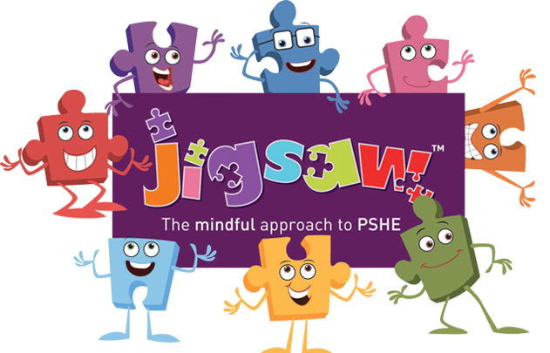

**What is PSHE Education?**

PSHE Education (Personal, Social, Health and Economic Education) is a planned programme of learning through which children and young people acquire the knowledge, understanding and skills they need to successfully manage their lives – now and in the future. As part of a whole-school approach, PSHE Education develops the qualities and attributes pupils need to thrive as individuals, family members and members of society.

What do schools have to teach in PSHE Education?

According to the National Curriculum, every school needs to have a broad and balanced curriculum that:

• promotes the spiritual, moral, social, cultural, mental and physical development of pupils at the school;

• prepares pupils at the school for the opportunities, responsibilities and experiences of later life;

• promotes British values.

**What is Jigsaw, the mindful approach to PSHE, and how does it work?**

Jigsaw is a whole-school approach and embodies a positive philosophy and creative teaching and learning activities to nurture children’s development as compassionate and well-rounded human beings as well as building their capacity to learn.

Jigsaw is a comprehensive and completely original PSHE Education programme including all the statutory requirements for Relationships and Health Education, and Sex Education is also included in the Changing Me unit.

Jigsaw has two main aims for all children:

• To build their capacity for learning

• To equip them for life

Jigsaw brings together PSHE Education, compulsory Relationships and Health Education, emotional literacy, mindfulness, social skills and spiritual development. It is designed as a whole school approach, with all year groups working on the same theme (piece of the puzzle) at the same time at their own level. There are six Puzzles (half-term units of work) and each year group is taught one lesson per week. All lessons are delivered in an age- and stage-appropriate way so that they meet children’s needs.

**In each school year of Jigsaw we teach 6 different puzzles:**

- Being me in my world

- Celebrating differences

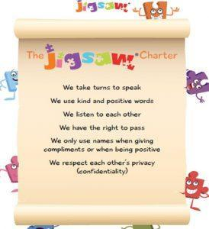- Dreams and goals

- Healthy me

- Relationships

- Changing me

