.0

Working together to be the best we can possibly be.

I can do all things through Christ who strengthens me. Philippians 4.13

8th March 2024
Dear Parents and Carers,

What a fabulous World Book Day we have marked today! Thank you to all our families for taking part.

Safeguarding:
Did you know when online as adults, we are all potentially three clicks away from seeing something that is inappropriate and offensive?

This is also true for our children if they use a device without necessary settings.

We have been made aware of some ‘chain texts’ that are being received by our older pupils which asks them to click on a link that takes them to inappropriate content.

We are hugely grateful to parents who have alerted us to this and would request that all parents and carers check their child’s devices regularly and monitor content that is being accessed and received via messaging.

Wellbeing and Mental Health:
As we have been marking World Book Day, please find attached some ideas about sharing a book with your child, ‘Promoting Storytime’.

Taking time together to share a book is a very positive boost to well-being for us all.

Collection of children after school:
We would like to update the details we hold for who is authorised to collect your child from school. Please would you complete this form if your child is Year 4 or younger.

If your child is in Year 5/6 - please complete this form

If you haven’t yet completed the appropriate form(s) please do so as soon as possible.

Easter Holiday Club:
Please find attached information about an Easter School Holiday Club which is being held at the Isle of Ely Primary School.

FWR Bingo:
FWR are holding their Easter Family Bingo on Friday 22nd March. Doors open at 7.00pm. We hope to see you there!

Education Inclusion Family Advisor Newsletter:
Please follow the link for the monthly newsletter from Emily Norman our EIFA: Community Notice Board | The Rackham C of E (VC) Primary School (rackhamprimaryschool.com)

St Andrew’s Flower Festival:
Our beautiful village church will host its Flower Festival on 4th, 5th and 6th May 2024. The Rackham will be preparing a display for the festival.
This year the theme is inspired by The Wind in the Willows written by Kenneth Grahame.

SATs information evening for parent and carers of pupils in Year 6:
The information evening will take place online on Tuesday 19th March. Further details to follow next week.

Phonics Screening information evening for parents and carers of pupils in Year 1:
Further details will be emailed to parents of this meeting which will take place before the Easter holiday online.

Attendance:
Thank you to all our parents and carers for supporting our drive for improved attendance. The Government has identified a child’s attendance of 96% and above is the key figure to give best chance of academic progress. Please can we remind you that absence must be reported to the office by 9am on each day.

This week our attendance figure as a school is: 94.14%
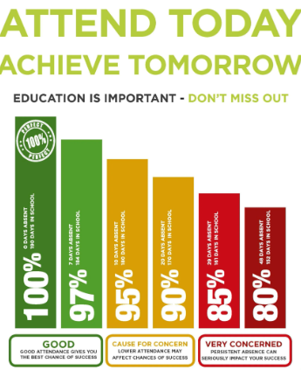

Looking forward to seeing everyone on Monday.

Best wishes,

Miss Turner

Dates for your diary
19.03.2024 | Year 6 SAT’s information evening (online) 6pm. Further information on how to book to follow.
22.03.2024 | Height and weight check - Reception and Year 6 only  Year 3/4 and Year 5/6 Netball Tournament morning  FWR Doughnut Day  FWR Family Bingo – Doors open 7pm
25.03.2024 | Rocksteady concert
27.03.2024 | FWR Disco
28.03.2024 | Last day of school for pupils and staff
29.03.2024 | Good Friday  Start of Easter holiday
15.04.2024 | First day of summer term  Pupils return to school

