Rackham Primary School | Year: Reception | TERM: Spring
Literacy:  Phonics – Success for All Phonics  Children will be focussing on Phase 3 sounds following the Success for All plans. Each day the children will take part in a 20-25 minute phonic session.  Reading  The children will be enjoying and joining in with a range stories. They will also be having 1:1 reading books and reading during our daily phonics and shared reading sessions.  Writing  The children will be writing about familiar events in stories, as well as creating labels. The children will be exploring rhyming words & rhyming books and writing through role play. They will add labels and write sentences linked to our learning about the world. | Mathematics: White Rose  Number  This term the children will be investigating 1:1 correspondence, numbers 0-15, number chants, language of more/less and addition by counting groups. We will explore the composition of numbers and will use part-whole models to help with this. We will also explore vocabulary linked to time.  Numerical Patterns  The children will be exploring 2D shapes/3D shapes. They will learn how to continue, copy and create patterns in many different ways. |  | Communication & Language:  The children will be encouraged to use their speaking and listening skills in the Role Play (indoor and outdoor) area. They will be enjoying listening and participating with a range of books (see Literacy – Reading).  The children will sequence stories and familiar events and retell them.
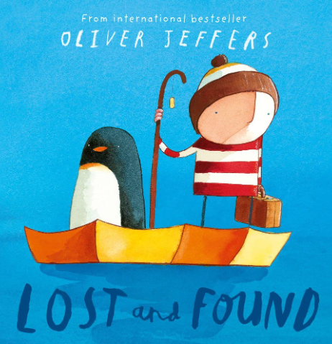 | TOPIC/THEME:  What is in our world?
TRIPS/ENRICHMENT ACTIVITIES:
Forest school will focus on numbers in nature and the changing seasons.

Physical Development:  Gross Motor Skills  This half term the children will be doing indoor PE. We will refine our movement skills of running, walking, jumping, hopping and skipping. We will also explore how to climb safely and use a range of apparatus to develop our travelling skills as well as consider different types of movements to develop our dance skills.  Fine Motor Skills  The children will continue to practise using a pencil and holding it effectively to form recognisable letters and numbers. | Personal, Social & Emotional Development:  The children will be developing their understanding of carpet expectations and class rules.  The children will be learning to play cooperatively, taking turns with others.  The children will be learning lots about relationships and forming new secure friendships within the class. |  | Understanding the World:  People, Culture and Communities  The children will be joining in with family customs and routines and gaining experiences with a range of celebrations and occasions such as Chinese New Year and Easter.  The Natural World  The children will be learning about the changing seasons and how our local area differs to other area.
Expressive Arts & Design:
The children will be beginning to build a repertoire of songs and dances, play cooperatively as part of a group to develop and act out a narrative during Role Play and learn about areas of the world and Easter. They will explore a range of percussion instruments. The children will be developing skills in drawing, collage, 3D sculptures and painting.

