[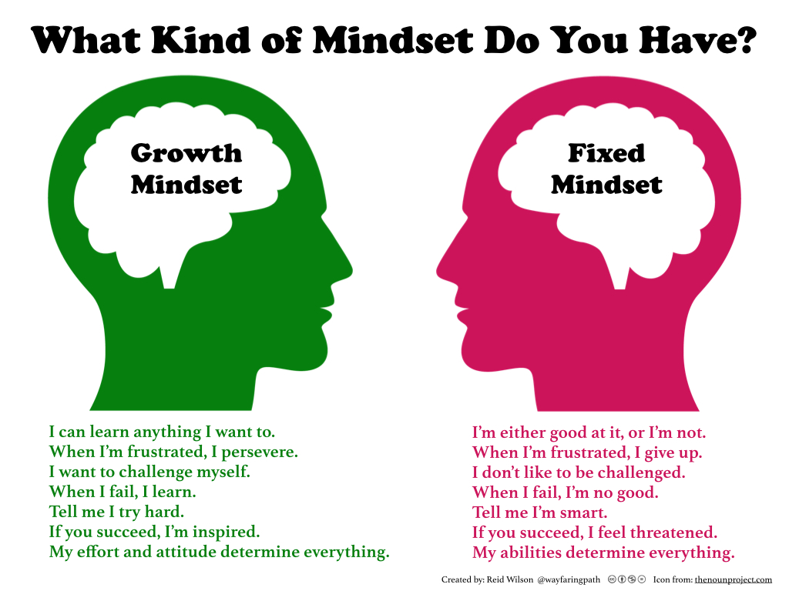](https://www.google.co.uk/url?sa=i&rct=j&q=&esrc=s&source=images&cd=&cad=rja&uact=8&ved=0ahUKEwjbnPbEzevOAhWDuBQKHSe2DmEQjRwIBw&url=http://carriekepple.com/2015/04/24/growth-mindset-vs-fixed-mindset-which-do-you-have/&psig=AFQjCNH_i9XUkQpG9tod3RztmoisOS6coA&ust=1472731004847956)[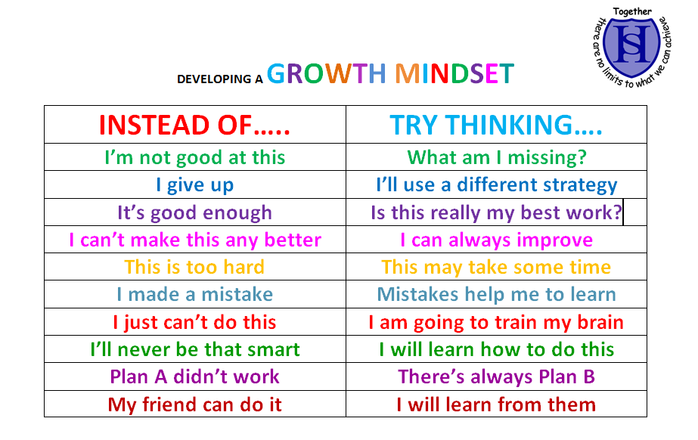](https://www.google.co.uk/url?sa=i&rct=j&q=&esrc=s&source=images&cd=&cad=rja&uact=8&ved=0ahUKEwi1oaDVzOvOAhVIVBQKHQ4WBy8QjRwIBw&url=http://www.hrzone.com/perform/people/these-words-help-people-develop-growth-mindsets&psig=AFQjCNH_i9XUkQpG9tod3RztmoisOS6coA&ust=1472731004847956)