Ramsden Lodge
Ramsden Hall Academy
Residential

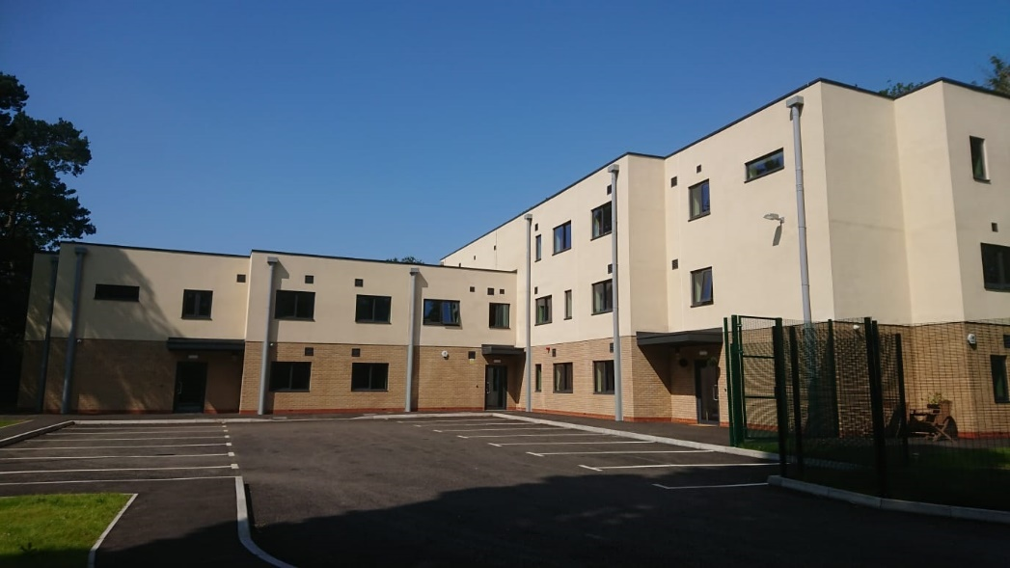

Welcome Pack
Welcome to
Ramsden Hall Academy Residential

Hello and welcome! If you’re reading this, you’ve been invited to join us at Ramsden Lodge, the residential part of our school, where we aim to make you feel safe, comfortable and happy.

We hope this booklet will help you to know a bit more about boarding at Ramsden Lodge but all the staff, especially the Care Team, love answering all and any questions you may have.

Residential Staff and Senior Leadership at Ramsden Hall Academy
Senior Leadership Team
Head Teacher
Antony Clements
Head of Residential Care  & Deputy DSL  Tara Cordrey | 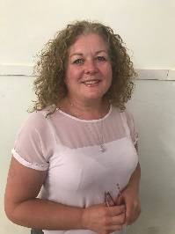
Deputy Head Teacher  & Deputy DSL  (Education link to residential)  Andy Stanford | 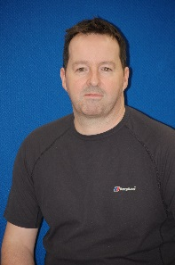
Associate Assistant Head Teacher
Tony Lane
Associate Assistant Head Teacher
& Deputy DSL

Adam Robbins
Engagement Manager
Designated safeguarding Lead
Claire Parker

Care Team
Senior Child Care Officer  Caroline Evenett | 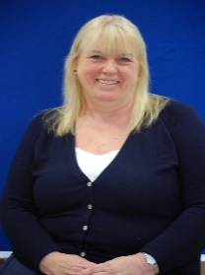
Senior Child Care Officer

Nikki Donovan
Child Care Officer  Sandra Wren | 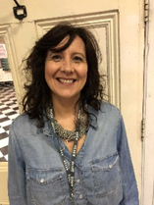
Child Care Officer  Vicky New | 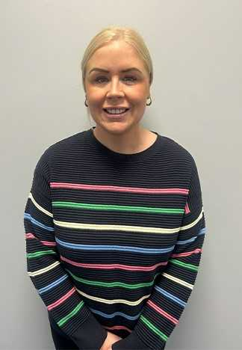
Child Care Officer
Chloe Scott

Child Care Officer

Night Awake Child Care Officer

Matt Baker

Extra Duty Assistants (EDA)
Sandra Barrett | 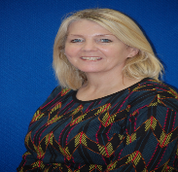
Cliff Bosdet
Ryan Carter | 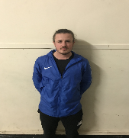
Vee Thakoordin
Carol Turner | 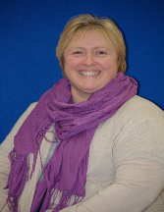
Dave Birch | 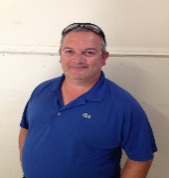
Juli Cowley | 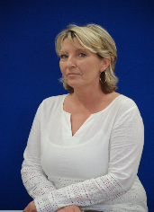

Residential Standard 3 Visitor
The Standard 3 visitor is from a company called Platinum care and he visits each half term to ensure we are keeping to the residential standards, as well as checking to see if you are happy and safe in residential

What do I do after school?
The academy day ends at 3.20pm and then you go straight over to Ramsden Lodge. You will go with all of the other boys into the Diner, where you will be met by the Care staff, be offered a drink and healthy snack and be asked what activities you would like to take part in that evening. You will then be reminded by staff to go to your room, change out of your academy uniform, have a shower and change into your evening clothes (e.g. joggers and a T-shirt). Once you are ready, you will head back to the Diner and wait with staff, who will let you know where to go and who to go with, for your first activity.
Your first activity will start between 4pm and 4.30pm.
Dinner is around 5pm - 5.30pm and we all eat together in the dining hall over in the school building.
At 6pm it’s time for our second activity. There are always lots to choose from, see below for the list of activities, and we more than welcome new activities introduced by boys. So have a think about something you would like to do.
The activities generally end between 7.30 - 8pm when it’s time to head to the residential lounge (Spring, Summer, Autumn or Winter) that you have chosen to spend the evening in, where staff will come with you. Each of the Lounges has a different activity for the evening, this may be to watch a film, play a board game, bingo and much more. If you have an idea of something you would like to take part in when in the residential lounges, please let a member of staff know and we will try to accommodate you. However, this may not be on the night you ask for it, as our activities are usually planned in advance and we may need a bit of time to organise.
Some evenings, when the weather is bad, we also have a quiz where we encourage everyone to take part. At the end there is a prize for the winner and a small prize for all that take part. It’s great fun!
At around 8pm we will bring your chosen drink and snacks to you in your lounge then collect the dirty plates and cups after – you will be asked to help sometimes too!

Activities
Some are continuously offered; some are seasonal and all are subject to any safety restrictions
Swimming at various pools (Riverside Ice & Leisure, Maldon and OUR OWN SWIMMING POOL – IF YOU’RE BRAVE ENOUGH!!!)
Various sports on our field and in our sports hall. (Dodgeball, football, basketball, cricket, rounders and more.)
Board games e.g. Monopoly, ChessScotland Yard, The Cube, Frustration, Cluedo, Billionaire Logo and any others you want to try. | 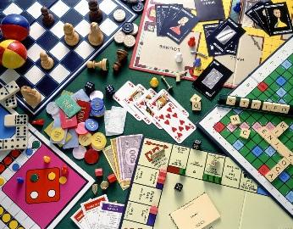
Card Games and Bingo | 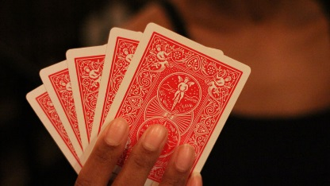
IT in our very own IT suite
Playstation / games console | 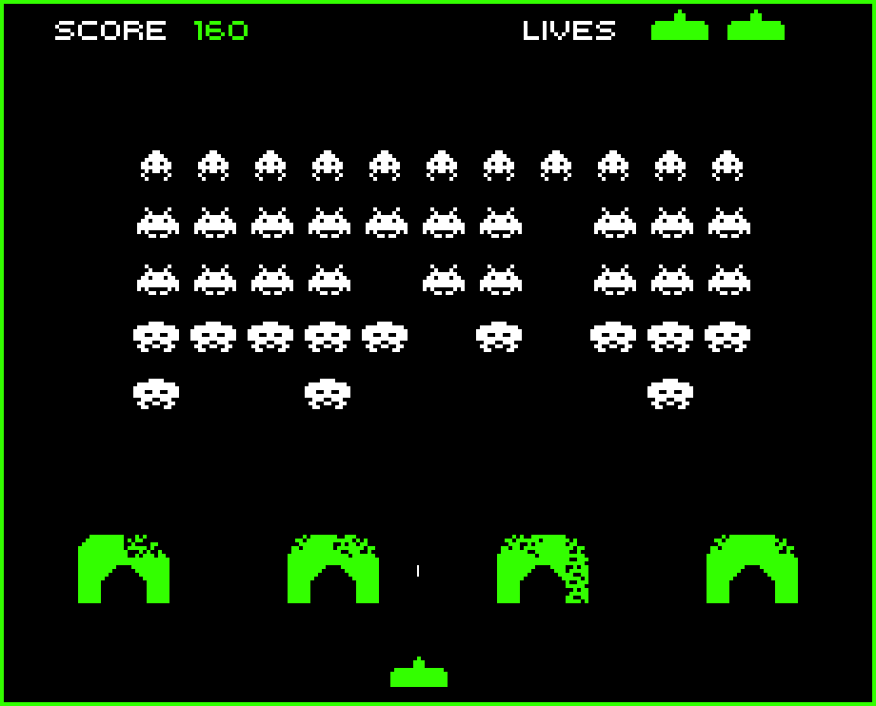
Spinney / Run Outs, Den Building | 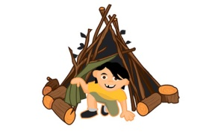
Cycles or scooters
Fire Pit / BBQ | 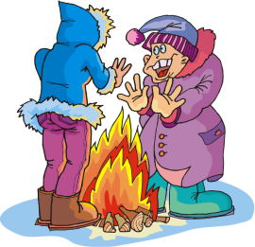
Orienteering / Hiking
Night Walks
Park and Woods Trips | 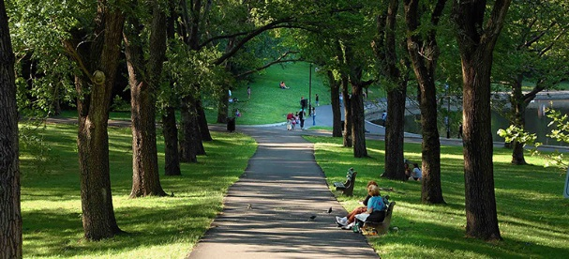
DT | 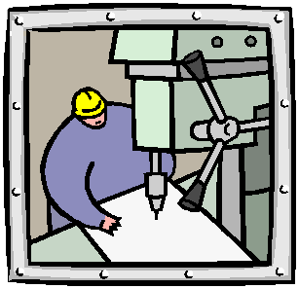
Arts & Craft | 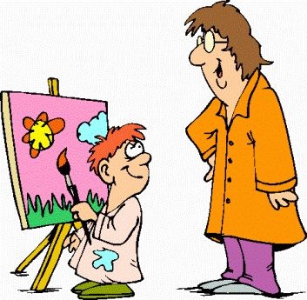
DVD / box set
Crabbing
Pool | 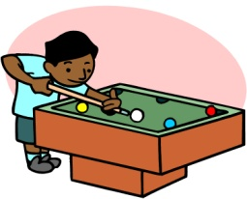
Table Tennis
Bowling
Beach trips | 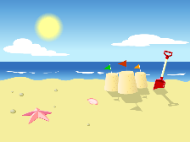
Trampoline
Music
YMCA Youth Club
Kayak/canoeing
Gym
Bedrooms

Most of our bedrooms are single rooms with your own bathroom with a shower and toilet. We also have several twin rooms that have a bathroom, with a bath / shower and toilet, near to them rather than in them. Most boys that do 3-4 nights will be in a single room and if you do 1-2 nights will be in a twin room but as soon as you move to 3 nights, and we have a room available, you should be able to move. But even if you are in a twin you will not need to share on the same nights as another student. Should you have any issue with your room, we will try our best to sort this out with you.
Each bedroom has a bed, clothes cupboard, bedside table with lamp, desk and chair plus pictures and notice board. You will be able to choose from a range of duvet covers and will also have a cosy blanket too. Please feel free to personalise your room with pictures, posters and personal items, its your room after all !

Staff 1:1 time
This is a member of care staff who can give you a helping hand when needed. You can always request a ‘key session’ (some 1:1 time) with any staff member if you feel you need to get something off your chest, tell us ideas for new activities, meals or just want a chat. There’s nothing the staff like to do more than have a good chat. We’re here to listen about the good things, as well as, any problems you may have.

The staff (and tutors for the academy day) are your main contacts with home.
Remember, you can always talk to any member of staff.
Tara (Head of Care) is also available to listen and hopefully help with any issues, you will see her around the school most days and over in boarding at the beginning of most evenings.

Valuables

There is a locking drawer in your bedroom. Staff will give you a key if you would like one, however, you should not need to bring any money or anything expensive to school or boarding. If you need us to look after anything just let us know.

Independent Skills – Training to be an adult
From year 9 onwards boys take part in our “Training to be an Adult” programme. This can be anything from making your bed to budgeting for shopping. These skills are intended to help you to learn some skills that will be of benefit to you in the future. Staff will work with you on this.

Points, Rewards, & Learning Consequences
During the evening you can earn residential points for positive behaviour. The boys with the best behaviour can earn the highest points of up to 60 per night. On reaching a minimum of 45 points you’ll earn trips off site and may even achieve ‘Boarder of the Week’ if you do something outstanding to help others, support each other or try really hard at something. If you do achieve “Boarder of the week” you will also be invited to attend our end of term trip.

Our older and more experiences boarders love to help out the new boys and will explain the points system, as will any member of the Care Team.

When we get it wrong!

To help boarders learn, especially with regards to keeping themselves and others safe, there are some social learning consequences that the residential team may have to put into place from time to time, in addition to the points system.
These include:
- Protective consequences
Maybe a restriction on a trip, in the vehicles, swimming, ICT, sport or other specific related activities. These are recorded in our consequences folder where we welcome your feedback and comment.
- Restorative work
This may be repairing damage, within the boarding or school environment.
- Restorative meetings and key sessions
This may be meeting with peers & staff when wishing to put differences aside.
- Parental / carer conversation
We may call your parents / carers and talk to them over the phone or even ask them to come in for a meeting.
- Boarding suspensions
Sometimes, for more serious or ongoing issues or due to a safety reason, we may need to suspend your boarding placement until the issue is resolved or the risk reduced.

We are Individuals

Life Skills is taught in our academy, plus, we learn about different cultures around the world.
Each of us is different and we should respect this. Some of us are small, some of us are big, some of us wear glasses and some of us do not.
Whatever our differences we ask you for just one thing - RESPECT
Respect of property (yours, others and ours).
Respect for others.
Respect for yourself
We do not support and actively discourage all sexual relationships between pupils. Please speak to a staff member if you have any worries or concerns.

Feeling Sick

Urg! It is horrible when you feel unwell. Make sure you tell a member of staff and we can look after you or call home to be collected if you are not well enough to be in school.
If you need to take regular medication, don’t worry as the staff will give it to you when you need it. Please make sure you hand in any medicines to a member of staff as soon as you arrive at school.
If you feel sick at night, speak to Matt, who is our staff member that stays awake all night to help you if necessary.

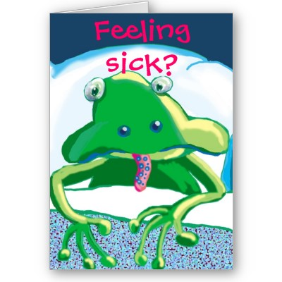
Academy

You will already know lots about your lessons from your tutors, but what you should notice is that your classes are a lot smaller than in most academies with up to only eight boys in a class. This is to make it easier for you to learn.
If there is anything you feel unhappy about, please ask a member of staff and we will listen to you and help you, we will also talk to your tutors if you, or we, feel you are struggling with your classes.
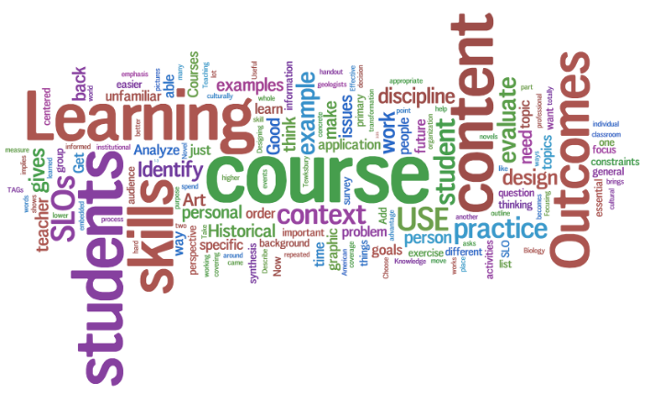

The Ramsden Hall Residential Council

We have regular meetings to discuss ways to improve boarding where we encourage the boys to talk amongst themselves and when they have ideas, to take them to the Residential Council meeting where it can be discussed, planned and hopefully put into practice.

Suggestion sheet

In addition to the Residential Council, we have a Suggestion sheet that is on the wall in the diner, please write on it with any good ideas.

Senior Boarder

Once you reach 15 years old you will have the opportunity to work towards becoming a Senior Boarder. Once you have earned the Senior Boarder status, you may, with staff permission, choose to use the senior / games lounge after 7.30pm. This means you can watch most 15 DVDs, chat and play board games or cards in a more grown up environment. Staff will not necessarily be in the room with you all of the time, but will check that you are ok.

Best of all, you may be able to earn a later bedtime if you are quietly watching a film in the senior / games room and do not disturb the other boys when you go to bed.

Senior boarders are expected to be an outstanding role model to other boys by promoting good behaviour and supporting social learning for other students both in the school day and in the residential time. More detailed requirements are on the points board.

Laundry

You can have all your washing done whilst you are at school; wonderful isn’t it! Each evening you can drop dirty washing in the laundry where it will then be cleaned and dried every morning. Simple? ... Not always!
Occasionally an item of clothing may take a little longer to be washed, especially if it is big, or cannot be tumble dried. If your clothes are not named, it can be very hard to return them to you! So please, please, make sure you or an adult puts your name in your clothes for you before you bring them into school, or staff can write your name on the label with a special pen, just ask.

Telephone
There is access to a residential mobile, so that you can make calls home to your family. If you have a mobile phone you can keep it with you and put in your bedside table until the morning, but if you are found with it out late at night we will need to hold on to it for you. You may know that you cannot get mobile service inside the residential building so up until your bedtime staff will support you going outside with you if needed.
The numbers listed below are of other people and organisations that can help young people.

Residential mobile 07710 372150
National Bullying Helpline: 0300 323 0169
Children’s Commissioner: 0800 528 0731
Childline: 0800 1111
NSPCC 0808 800 5000
Ofsted: 0300 123 4666
Frank (confidential drugs advice): 0300 123 6600
CEOP 0370 496 7622
Young Minds https://www.youngminds.org.uk/young-person/
If you have any concerns during the day about your stay within the residential, there is at least one member of the Care Team in every day that you can talk to, or, remember, any member of staff will listen to you and try to support you.

NO BULLY ZONE
We do not accept bullying at this academy!
If you feel you are being bullied, please tell a member of staff and we will deal with it, with you, and for you. You will not get into any trouble by telling us, we are here to help you!
There are lots of different types of bullying; name calling, hitting, threatening, and making someone feel frightened or left out. And of course, cyber bullying, texting and communication over computer games and email.
Please don’t suffer in silence. If you do not tell us we will not know!!!
If you are someone who bullies others, the staff may be able help you to change your behaviours and help you to be happier about yourself. Just talk to your keyworker or any other staff member!

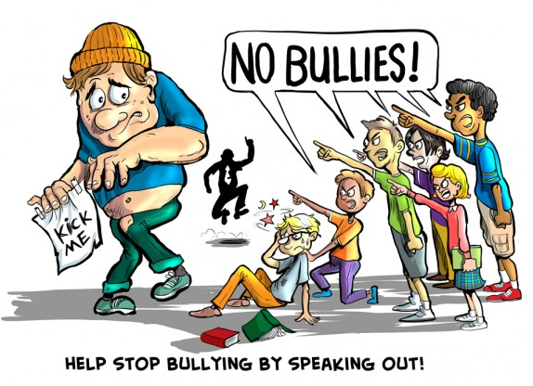
Complaints
It is important to all the staff at Ramsden Hall Academy that our boys are as happy as possible, but unless you tell us about the bits that are not so good – we will not be able to make changes.
Complaint Forms about boarding are kept in the diner, and the residential offices. They can be used by you at any time. If you need any help to complete a form just ask any member of staff who can write it for you if you would prefer.
You should receive a reply from the Head of Care or Head teacher very quickly.

Independent Person
Once a month we will be visited by our independent person called Emma. She will give you the chance to chat about any worries you have that you may not feel able to tell anyone else. Her contact details are on the information board in the hallway.

Shower / Bath Time
Every day after school, each boy needs to take a shower or a bath. You will need toiletries, such as toothbrush, toothpaste, deodorant (no aerosols cans please), shower gel, bubble bath and anything else that you use. In most of our rooms you will have your own bathroom with a shower and toilet; twin rooms have a separate bath / shower and toilet, whichever type of room you have, a bathroom is solely for your use and all have doors you can lock for your privacy. Please let a member of the Care staff know if you have forgotten any of these items, as we will have supplies that you can use.

Bedtime
After you’ve finished the activities, you will go to a lounge that you have chosen for that evening for your snack and where there is still time for some TV or a chat with your friends before bed at 9pm. Once you’ve brushed your teeth and are quiet in your bed, unless you join the group story until 9.20pm.
Morning
Staff will be round to wake you about 8am. Then it’s rise and shine, morning wash, brush your teeth and change into your clean uniform ready to go to the school dining hall for breakfast.

We really hope that you enjoy your stay at Ramsden Lodge.

