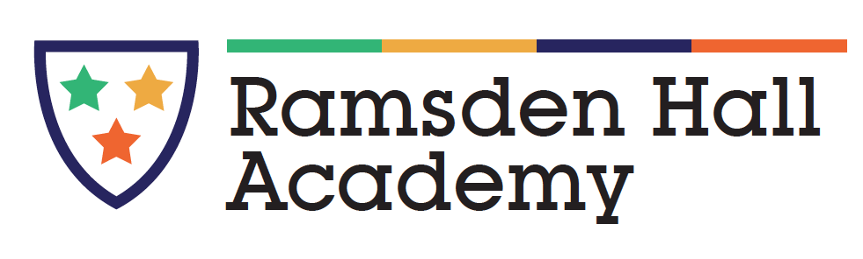
Statement of Purpose

Ramsden Hall Academy is a part of a family of Academies called Parallel Learning Trust (PLT) who educate and care for boys just like you.

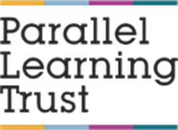

The Academy can have up to 100 boys and here in boarding we can take up to 40 boys in total. All boys are aged between 10 and 16 years old.
If you choose to board it is because you, your family and we have agreed that is will help you to make friends, try new activities, attend school more and do better in school so that you reach your exam and life potential. If you can choose to board, this is called “flexi” boarding so we can be really flexible and treat you all as an individual, though we do hope and will encourage you to move towards 3 or 4 nights . We hope that the relationships you build with staff and other boarders will help you better manage the school day and make it a more comfortable and positive place for you to be.
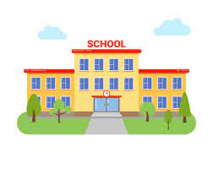
We work with the school to hopefully help them understand you a little better. Sometimes this is with counsellors and sometimes this is with staff who have had lots of training in how to support you.
Our school had a large extension in 2021 and this is when the residential area was built too. At this time the boys and staff agreed to name the residential building……..

Ramsden Lodge.

The building may seem large, that’s because it is! We have 24 single bedrooms with en-suite shower rooms, and 8 twin bedrooms with an adjacent shower or bathroom. However, if you are in a twin room you will not be staying on the same night as the other boy in your room, so no need to worry about sharing with anyone. We also have four lounges with large TV, a lounge for reading playing cards, cooking or quiet games, a cinema room with extra large TV and beanbags, a pool and senior room plus an American 50’s style diner. We also have a large garden and hard play area as well as being able to use the school grounds when we choose, including the swimming pool and woodland.
.

To help keep you safe we have CCTV image recording and voice recording around the outside of Ramsden Lodge and CCTV visual recording in the corridors, but not in the lounges or your bedrooms, this is your private space. The bedroom doors also have a sensor so that if you need staff at night you just need to open your door and sit in your doorway and the night awake will come to support you.

All our staff are lovely and only want the best for you so if you need anything just talk to:- Tara - Head of Residential Care
Caroline – Senior Care Officer
Nikki – Senior Care Worker
Sandra – Care Worker
Vicky – Care Worker
Chloe – Care Worker
Matt – Night awake

All staff are also trained and qualified in how to look after you, but we don’t know everything, so if you are struggling with anything please let us know and I expect we will be able to change something to help you a little better.
When you first ask about boarding we will talk to your family and see how they feel before inviting them to visit us and hear about what we do. After your induction, and several trial nights you will start at 1 night per week to board, then 2, 3 and 4 nights as soon as you are ready.
You will do lots of fun activities, such as swimming, ice skating, youth club, bike riding, cinema, playing in the sports hall and going to the park, to name a few.

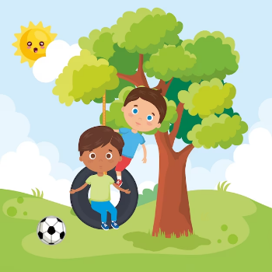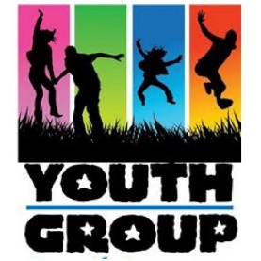

We want you to be confident and give you a chance to succeed.
The Academy and residential team work really closely together to give you hope, compassion, experience and qualifications for you to take your place in the world.

