Ramsden Lodge
Residential
Handbook
Parents section

Updated April 2024

Contents
Page No
- Academy Ethos and Mission Statement I
- Principles & Practice of Boarding
at Ramsden Hall Academy III - X
- The Ramsden Hall Academy Residential
Welcome Pack 1 – 26
Appendix (Highlight selection and change to ‘print selection’ in printer settings to separate when printing)
  - Ramsden Hall Academy Residential Induction

  - Ramsden Hall Academy Residential Activity Learning Objectives

  - Boarders Checklist.

  - Boarders Personal Property Agreement.

Ramsden Lodge
Ramsden Hall Academy
Ramsden Heath
Billericay
Essex
CM11 1HN
01277 624580

http://www.ramsdenhall.org.uk/

1. Mission and Purpose
Located in Billericay, Essex, Ramsden Hall Academy is part of the Parallel Learning Trust. In addition to the academic day provision, Ramsden Hall offers a residential provision for students aged 10-16. Our students are drawn from a wide area of Essex and neighbouring London boroughs plus unitary authorities, all of whom have been identified to have a wide range of social, emotional and mental health needs (SEMH).
We believe that every student can have, and is entitled to, a positive future. We see potential in each of our students and our purpose is to help them access this by supporting them to learn, develop their skills, abilities and talents in order to help them manage themselves and their SEMH needs effectively and successfully. This is summarised below.

1a. Mission.
Our mission is to: “We aim to give all our pupils and their families the hope, compassion, experience and qualifications to enable them to take their place in the World.”

1b. Vision.
Working together we will:
- Meet our student’s social, emotional and mental health needs enabling them to thrive both in the academy and the wider community;
- Support our students to develop the attributes, skills, knowledge and understanding required to become valuable members of society;

1c. Values and beliefs.
Learning is our core purpose. We believe:
- Every child can achieve
- Every student must make progress
- Every member of the community matters
- Everyone deserves a second chance

1d. What we will do:
We will provide a safe secure environment where students are valued, respected, challenged and supported to achieve and make progress.

2. Through our actions we will develop young people who are:
- Respectful of themselves, each other and the academy;
- Trustworthy, polite, honest and helpful;
- Tolerant of others, open minded and without prejudice
- Resilient, determined and have a strong work ethic
- Responsible, independent and supportive of each other
- Empathetic, thoughtful, compassionate and caring
- Good communicators who are equally good as leaders and team players
- Confident having both self-belief and high aspirations
- Good role models;

Principles & Practice of Ramsden Lodge @ Ramsden Hall Academy
Overview
The boarding provision for Ramsden Hall has long been established alongside the academic provision. The benefits of boarding are equally established, reflected by all corners of the academy community; young people, parents and staff.
When asked via a pupils questionnaire in February -March 2023 what we do well? the comments included, everything, treating us fairly and teaching us good skills, activities, kind staff, managing everyone, nice food.
The parents / carers were also asked and answered, independence and confidence, communication, sons progress, activities, taking care of them, staff support, helping with routines.
We were graded by OFSTED in May 2023 as Outstanding in all areas. They made comments such as:-
“Responsive strategies are exceptionally well considered and highly tailored to children’s needs. Consequently, there is evidence of exceptional progress in children’s behaviour, social understanding, health and well-being”.
“Staying in residence has a positive and enduring impact on children. Some children return to the school after Year 11 to engage in work experience and support the school. Children said that they love being with the residential staff. This shines through in the warm exchanges that staff have with children. Children are better equipped for the world beyond the school because of staying in residence”

Please see the full Ofsted report https://files.ofsted.gov.uk/v1/file/50221235

Residential Purpose
The main aim of the boarding provision is to support the Statement and Purpose of the academy running in conjunction with the overall ethos, values and theoretical approach.
Ramsden Hall Academy strives for young people to reach their academic, physical, emotional and social potential, creating an ethos of engaging young people with their learning:
- Developing values of respect and resolve.
- Using theoretical approaches of positive reinforcement and restorative practice.
The key aim of Ramsden Lodge Residential is enabling young people to improve their ability of engaging with learning. A prime aspect of the provision is based on safety and wellbeing of young people with an operation aiming at providing learning experiences via fun, stimulation and social enhancement.

Arrangements for the residential provision
The boarding provision is a voluntary decision taken by the student and his family, but we encourage all families and students to consider boarding as a positive choice to help with the holistic development and social learning experiences it offers. There must be an agreement that the young person stays safe with regard to himself and to others while boarding and that boarding in Ramsden Lodge is aiding his ability to engage with learning throughout the academy day.
Residential staff then risk assess the young person by observing their behaviours in school and the care team will decide, along with the support and agreement of the family, when they are or will be ready to join, subject to a place being available.
Students are offered a number of night’s residential provision that is agreed to on individual and needs basis.
The boarding provision work is in conjunction with all Ramsden Hall Academy policies. All policies can be obtained upon request or viewed on the academy website.

Complaints
Unfortunately, sometimes we do not get it right and you may feel that you would like to make a complaint. Hopefully any issues can be ironed out by a call to a staff member or the Head of Care using option 4 on the school telephone number. If this does not resolve your complaint or you have a further worry, please feel free to access the school website for the full complaints policy.

https://files.schudio.com/parallel-learning-trust/files/documents/Item_10.3_Complaints_Procedure_PLT__March_.24(1).pdf

Residential Staffing Structure
Essex Safeguarding,
Essex Police

Academy Advisory Board
Mark Burgiss (Residential link)

Independent Visitor
Emma Baker
The boarding visitors are volunteers, and are not employed by the school or Essex County Council.
Headteacher
(On-call support manager)
Antony Clements

Head of Care
Tara Cordrey

Engagement Manager
Designated Child Protection Lead
Claire Parker
School Departments
Teaching / Administration / Catering / Premises
Academic Residential Link
(Assistant Headteacher)
Mr Andrew Stanford

Medical Officer
Isabel McNally (PT)
Transition Manager
Amanda McIver

Residential Extra Duty Assistants
(Breakfast & Evening Assistance from teachers and LSA).

Senior Care Worker
Nikki Donovan

Senior Care Officer
Caroline Evenett

FT Care Officer
Vicky New
PT Care Officer
Sandra Wren

FT Care Officer
Chloe Scott
Night Awake Officer
Matt Baker

Academy Trust and Head Teacher

The Academy Trust and the Head Teacher are responsible for the overall operation of Ramsden Hall Academy. Jo Oldham is the designated Safegarding lead on the Board and visits the school termly, plus when required or requested to do so.

Head of Care
Tara Cordrey is the Head of Residential Care and is part of the Academy Senior Management Team (SLT) where she is responsible for the running and Management of Ramsden Lodge residential provision. She is qualified to level 7 Diploma in Health and social care Management, plus has level 3, level 4 and the Registered Manager’s Qualification, equivalent to level 5. The Head of Care will complete a mixture of day and evening hours to ensure the smooth running of the provision. She is on call to the staff for guidance and advice each evening with the support of the SLT if needed.

Transitions Manager
The Care Team work closely with the Transition Manager who is responsible for the implementation of the admissions policy and the academy transition process.

Care Team
In addition to the Head of Residential Care, the care team comprises of Senior Care Officers, full and part time Care Officers and a Night Awake Care Officer. Most evenings EDA (extra duty assistants) who work in the school in the school day undertake additional support for the provision
All of the Care Team hold the National Minimum Standard (NMS) requirement of a relevant level 3 diploma, or are working towards it, after a satisfactory probation period.
Monday to Thursday, full time Care Officers work up to four evening shifts (14.30 – 22.45) and up to one-day shift (7.30 – 15.30). The whole Care Team (apart from the Night Awake Officer and part time Care Officers) work a day shift on Friday.
The Residential operates so there are always a minimum of two staff on duty. During the night, there is at least one Night Awake Officer plus a sleeping-in member of Care Team and an on-call senior manager on duty, supported by the Head Teacher / SLT for any notifiable events.
During the day, the academy has staff of both genders available for the students. During night hours when the students are sleeping (between 22.45 - 07.30) there may be only be staff of one gender available.
The Night Awake Care Officer works 22.30 – 08.30 and is available to support the students with health and wellbeing needs throughout the night. They are supported, if necessary, by a sleeping-in member of the staff.
The Night Awake Care Officer takes the lead in emergencies occurring at night utilising the on-call Senior Manager and emergency services if necessary.
One of the duties as a Senior Care Officer is to help with the smooth running of the evening. Having organised with the Care Officers what activities are being provided by the team, the Senior Care Officer will organise the evening’s activities taking into account the academy risk assessments, dynamics between students and any consequences in place. The Senior Care Officer also takes responsibility for evening medication, while the Night Awake Officer takes responsibility for any overnight and morning medication needs.
All staff are encouraged to give support and advice to each other, while line managers hold the responsibility to ensure that all staff are supported and advised sufficiently.
All staff receive an annual appraisal and regular supervision.
Staff are required to undertake training to keep updated with professional and legal practice developments reflecting the policies, legal obligations and business needs of the academy as a whole.

Care Team & Academic Link
All Care Officers act as residential academic links the students, maintaining strong links with the teaching team, particularly those teachers and Learning Support assistants who also work as residential Extra Duty Assistants (EDA) in the mornings and evenings, again maintaining strong links between the residential and the academic provision.

Independent Person & Standard 3 Independent Visitor
The Independent visitor is a volunteer who is not employed by the Academy or Essex County Council. They are completely independent of our Academy and are available to listen to any concerns the students may have. They make visits monthly and are there to support all areas of the students’ care.
The Standard 3 independent visitor, visits the residential provision each half term. He is independent of the Trust and commissioned by the academy, to do Standard 3 monitoring visits, which involve looking at all aspects of the students’ care.

Residential Accommodation
Students within the residential provision are assured that there is a continuity of care provided by a permanent staff team employed through the Parallel Learning Trust.
Ramsden Lodge Residential comprises of one large residential building, for practical purposes, the four main lounges are named Spring, Summer, Autumn and Winter. In addition, there is an American inspired 50’s diner, a cinema lounge, a quiet / cooking lounge and a games / senior lounge.
All Care Officers have the responsibility of ensuring the upkeep of the lounges and bedrooms. This includes being;
- clean and tidy,
- well maintained,
- appropriately lit, heated and ventilated,
- suitably furnished,
- adhering to health, safety and welfare Standards.
To support the Care Officers in achieving this, the academy employs full time premises staff and contracted professional cleaners.
Ramsden Lodge Residential (opened in May 2021) is an L-shaped building that has a Ground, First and a second floor. On the first two floors there are four lounges; a mixture of single bedrooms with an en-suite and some twin rooms that have an allocated bathroom next to or opposite. The second floor has more single and twin rooms with the games / senior room and quiet lounge. The students are encouraged to personalise their bedrooms with suitable posters, photos and personal items. Each room has a lockable drawer where the students can put their personal items, if they would like to lock the drawer, they need to talk to a member of care staff who will arrange for them to have a key. However, they are discouraged from bringing in valuables or money, as it is not needed during boarding time. Bedding is provided, although it can be brought from home if preferred. All bedding is routinely cleaned by the Ramsden Lodge Laundry.
All areas of residential accommodation are reserved for the use of those students designated to use it and are protected from access by unauthorised persons via locked doors.
Only one boy will stay in the twin rooms at any one time even if in a twin room, students will not need to share a boarding night
Each single room has its own toilet and shower but twin rooms have a nearby designated bathroom and all are capable of being secured from the inside for privacy. Parents/carers are asked to supply their children with personal care items such as toothbrush / paste, shampoo, soap / shower gel and deodorant (no aerosols please), although Ramsden Lodge provides this if a student runs out or forgets it. These items can be left in their individual rooms. Hand & body soap is provided in all toilets / bathrooms by Ramsden Lodge and toilets routinely checked and replenished for loo roll.
Students may use their bedroom for private reading and / or studying; all bedrooms each have a desk and chair. Stationery items will be supplied by the academy on request.
Clothes / school uniform laundry is done in the Ramsden Lodge laundry and cleaned laundry is generally ready when the students get up, or the end of the next day if it takes longer to dry. Parents/carers are also asked to have an identification label or mark within their child’s clothing.
While all main meals are prepared and served within the main Academy catering area, each lounge also has a small kitchen area that has a fridge, kettle, toaster, microwave and cooker, to make hot and cold drinks and snacks.
There are separate staff areas within the residential building with private staff sleeping and bathroom, in addition to securable office areas.
There is a minimum of one fire drill per term carried out within residential time.

Electronic monitoring & CCTV
The CCTV system covers the corridors of all floors of the residential building. There is no coverage in the bedrooms, bathrooms, or communal lounges / kitchens. A monitoring system alerts staff when a bedroom door is opened after students have settled. CCTV is also in place around the outside of the building and also has both recording and audio facilities.

Introduction and Transition
Prior to starting at Ramsden Hall students and families are told about and given the opportunity to look around the provisions. New year 6 & 7 pupils are positively encouraged to consider boarding to aid their school and learning experience. Any students who show interest in the residential are invited to look around Ramsden Lodge again and talk to staff and current boarders. Then with parents / carers support and agreement they are invited to do an extended day, staying for evening tea and evening activities before being collected by parents/carers. We aim to offer at least two of the extended evening sessions before trial boarding nights to see that the young person enjoys the experience, however this is student led so this can be individualised and lengthened depending on their need.

Keyworker & Boarding Nights
When the decision is taken by a student and his family, and he agrees to the safety and learning requirements associated with Ramsden Lodge in order to board, all staff are key workers, so he can ask for any staff member he has a connection with.
The boarding nights will be agreed on an individual basis between the student, his parents / carer and the care team.
Once boarding nights have been agreed, the students will be expected to board on those nights as transport may not be available if the student changes their mind. We try and support with transport under exceptional circumstances.
Most students will initially start in a twin room until a time they go up to 3 nights. For the purpose of stability, the aim is for the students to then remain in their allocated room. However, in some circumstances staff may recommend a change or students can request to change if necessary and the care team will endeavour to reach the best outcomes for the student.
New boarders are given a Welcome Pack on their induction day which they will take away with their family to read, or staff will work through with them if they wish.
Senior and more established boarders are encouraged to help new boarders to settle in.

Residential Placement Plans and Risk Assessments
Residential Placement Plans are compiled for every boarder, detailing daily care needs. This includes religious, dietary, personal needs / care, or students with disabilities being provided with appropriate assistance to eat, in a manner which promotes dignity and choice, within their Education, Health and Care Plan (EHCP) objectives. These plans are agreed with by the child and their parent / carer.
Residential Placement Plans may include ‘safe’ places or ‘calm’ places that the students identify to go to if necessary, these may be in their bedroom, another place inside or outside the residential building, so long as the identified place is easily accessible when / if necessary.
Individual risk assessments are drafted then read and signed by the boarder before being put in place. Each term they are reviewed and updated or earlier, if required. Risk assessments include behaviours, activities and specific risks.
We do not support and actively discourage all sexual relationships between pupils. Should staff / parents become aware or concerned then the appropriate sharing of safeguarding information will be acted upon as appropriate.

Education Health Care Plans (EHCP)
It’s probable there could be parallel information between the Residential Placement Plan and the EHCP. The EHCP will help populate Residential placement plan where needed. All students with medical needs also have a detailed Individual Health Care Plan (IHCP) to inform staff of the student’s health care needs, in addition to enabling the students to making informed decisions regarding their health. Students have the opportunity to put forward their own wishes and feelings regarding their health care.
Residential staff attend at least part of the EHCP review or if this is not possible they will give feedback to the school staff leading the meeting
Activities and Free Time
A wide variety of activities are available for the residential students. It is expected that they participate at these times with one of the offered activities. There may include playing on scooters, den building, swimming, ice skating, park visits, cinema, beach, IT, cooking to name a few. Senior students may choose to go to the senior’s lounge to play pool, chat or play board games. The aim of the activities is to promote their development holistically while enhancing their self-esteem and having fun.

Contacting residential staff
As you may guess residential staff are always with the students so please be patient if we are unable to call you back straight away, however please call the below numbers if you need us.
Staff will call you if we have a concern, your son needs to be collected due to behaviour, illness or choice, or in an emergency. We will also call parents/carers on a Thursday or Friday to update you on his week, with any issues and positives and confirm his boarding nights for the following week.
Please ensure that you are still available to collect your son on his boarding nights in case of illness, emergency or your son choosing to return home.

Family Hub
As a parent / carer with a son who boards you will have access to the Family hub. The Family hub is a supportive environment to share ideas about what works in boarding, and receive individualised support from the Family hub team. Please inform Caroline / Tara if you like to arrange a meeting.

Out of school hours mobile Telephone numbers:-
07710 372150 or
07874 864900
01277 624580 – School telephone – option 4

Ramsden Lodge Induction

Pupil Name:
Hello & Welcome Pack
Introduced to boarding house (staff & student)
Staff structure & introductions
Safeguarding staff (Claire Parker)
Independent Visitor (St 3) & Independent Person
Family hub
Childline, Ofsted & other helpline numbers
Tour of building (s), grounds & OOB explained
Lockable draw offered
Games / Senior Lounge explained
Fire evacuation procedure (day & night)
Practiced fire exit routes
Residential routines explained, e.g.
Dinner & activity times
settling time & night / sleep-in staff
what to do at night if needing staff help
laundry routine & clothing identification
Reward points system
Phone call to parents / carers
Medication / health / dietary requirements
Multi vitamins
School day / times & uniform
House phones
Mobile / on line safety
Behaviour expectations
Residential council
How to make a complaint
CCTV and Door Sensors
Boarder signature:
Parent/carer signature:
Staff signature:
Date:
Date:

Getting to know you
My name is
I am ………………. years old
I live with …………………………………………………………………………………………………………………………………………………
My siblings and their age
………………………………………………………………………………………………………………………………………………………………
My pets
…………………………………………………………………………………………………………………………………………………………….
Some favourite food and drinks …………………………………………………………………………………………………………………………………………………...…………………………………………………………………………………………………………………………………………….…..
Things I like to do ……………………………………………………………………………………………………………………… ……………………………………………………………………………………………………………………………………….….……..
Games I like to play …………………………………………………………………………………………………………………… ………………………………………………………………………………………………………………………………………….……...
Leisure / hobby pursuits …………………………………………………………………………………….……………………....
………………………………………………………………………………………………………………………………………………….
Favourite football / rugby team etc ………………………………………………………….
…………………………………………………………………………………………………………………………..
Do I like swimming? Am I a confident swimmer? ………………………………………………………….
Height …………………..…… Build………………………….………………… Hair colour………………………………………………….
Eye colour……………………………………. Distinguishing features…………………………………...
Residential Support Agreements for
Triggers: -
What helps me: -
Preferred Residential adults: -
How I like to fix it: -
P.T

Ramsden Hall Academy Residential Activity Learning Objectives

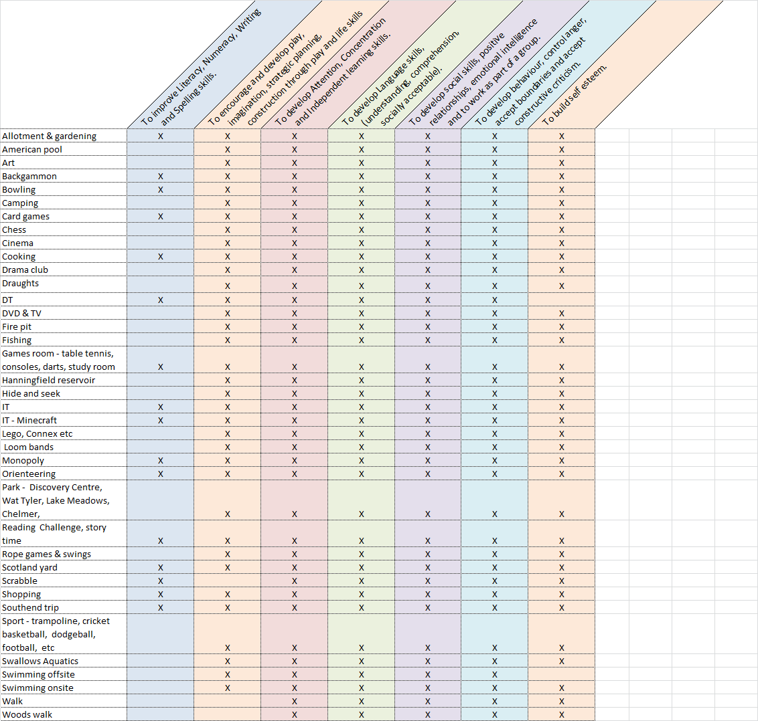

Boarder’s Check List
Overnight bag & sports kit bag or carriers bag for swimming
To put boarding items in and to take on swimming trips
Academy uniform
Recommend two pairs of trousers and two academy shirts. One jumper, one Academy coat and one pair of black footwear for academy day.
Casual clothing
Required change of clothes for each boarding night, along with one emergency change of clothes. (Includes a change of underwear & socks for each day / night, along with one emergency pair).
Tracksuit / Jeans
Sweat shirt / jumper
T-Shirts
Trainers
Nightwear – pyjamas
dressing gown, slippers (recommended)
Swimming shorts
Hats (recommended)
Warm hat (winter).
Cap (summer).
Toiletries
Toothbrush, toothpaste.
Soap / shower gel / shampoo etc.
Deodorant (no aerosols, roll on only).
Comb or hair brush.
Bedding and towels
Welcome to bring their own, or we do provide.

Note: all clothing to be labelled with name on all clothing / property.
Staff are happy to do this if not complete.

Boarders Personal Property Agreement

We aim to make the residential as homely as possible, and for residential students to feel like this is their home from home. We, therefore, encourage that they bring some personal possessions. e.g. pictures, posters and toys that will be kept in their bedroom.
Any personal possessions that are brought in from home need to have been agreed by the parents / carers and the residential staff. There should be no possessions that are not age appropriate or could be used inappropriately, this is especially noteworthy with devices that can connect to the internet.
All electrical appliances need to have passed the Portable Appliance Test (PAT Test). This can be arranged through the academy, but it must be at an arranged time, so please ensure nothing comes in unless planned.
Ramsden Hall Academy does not accept liability for the loss or damage of any property, so no valuables please.
Additional space for questions

AT RAMSDEN HALL WE . . .

