Assessment Criteria 5. Follow and understand the need for safety and security practices when working online.

5.1 Identify the threats to user safety when working online.
Name and explain the following internet security risks

____________________________________________________________________________________________________________________________________________________________________________________________________________________________________________________________________________________________________________________________________________________________________________________________________________________________________

____________________________________________________________________________________________________________________________________________________________________________________________________________________________________________________________________________________________________________________________________________________________________________________________________________________________________

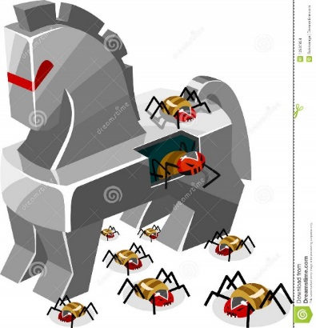
____________________________________________________________________________________________________________________________________________________________________________________________________________________________________________________________________________________________________________________________________________________________________________________________________________________________________

____________________________________________________________________________________________________________________________________________________________________________________________________________________________________________________________________________________________________________________________________________________________________________________________________________________________________

____________________________________________________________________________________________________________________________________________________________________________________________________________________________________________________________________________________________________________________________________________________________________________________________________________________________________

Provide an explanation for the following terms
Online Fraud | Identity Theft

5.2 Outline how to minimise internet security risks.
Threat | Prevention Method | How it will protect your computer
Malware
Trojans
Viruses
spyware
phishing
worms
hackers
Online fraud
Identity theft

Tick which password you would consider to be the strongest:

- studentone

- StudentOne

- #StudentOne!0

- password

