**THE BODY AND SPORT**

[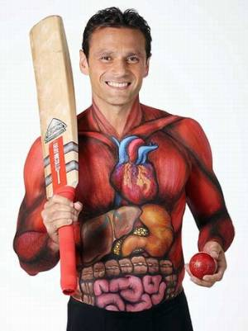](http://www.getmadeup.com/index.htm)

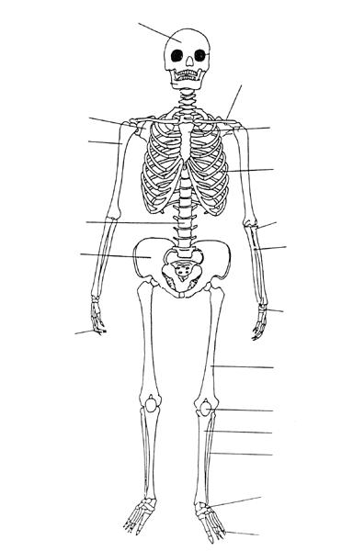

**A**

**F**

**E**

**D**

**CV**

**B**

**J**

**I**

**H**

**G**

**K**

**L**

**M**

**R**

**Q**

**O**

**N**

**P**

SCAPULA

CRANIUM

ULNA

TIBIA

RIBCAGE

VERTEBRAE

PATELLA

TARSALS

PHALANGES

CLAVICLE

HUMERUS

FIBULA

STERNUM

PELVIS

RADIUS

FEMUR

CARPALS

Can you match the names of the bones to the correct place on the skeleton by placing the correct letter in each box?

**the skeleton**

**SKELETON FUNCTIONS**

**PROTECTION**

There are 5 functions of the skeleton provided below. Research each function and provide a description of each one using the sentence starters provided below.

**SHAPE/STRUCTURE**

**SUPPORT**

**MOVEMENT**

**BLOOD CELL PRODUCTION**

**SENTENCE STARTERS:**

One function of the skeleton is… The skeleton provides…

The skeleton must be able to… The functions of the skeleton are…

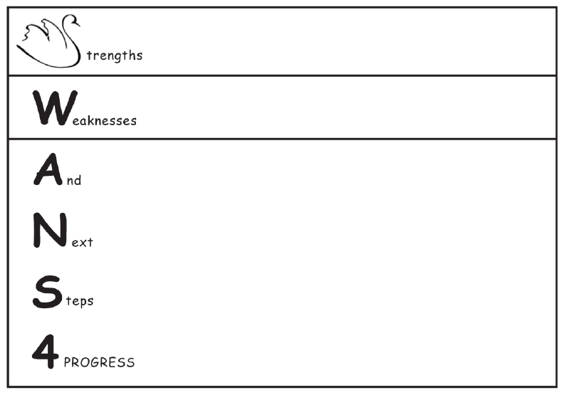

**PEER ASSESSMENT**

**BLOOD CELLS**

Blood is a vital part of the body, without blood, our organs wouldn’t receive the oxygen and nutrients they require.

Using the internet, find out the answers to the following questions:

1. Blood is made up of 2 parts, what are they?
2. There are two types of cells found in blood, what are they?
3. What organ is responsible for pumping blood around the body?
4. How many litres of blood does an adult human body contain?
5. What shape are red blood cells?

Describe the differences between RED and WHITE Blood cells using the T-diagram below.

|  |  |
| --- | --- |
| RED BLOOD CELLS | WHITE BLOOD CELLS |
|  |  |

Read each of the definitions below and try to match the correct one with the correct image of each blood vessel by drawing a line to it.

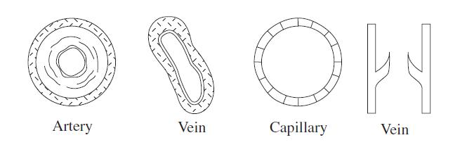

They carry deoxygenated blood back to the heart with the help of pocket valves that prevent backflow

A network of tiny 1-cell vessels where the exchange of gases, such as O2 or CO2 takes place

These blood vessels carry blood away from the heart. They have thick elastic walls that help to move the blood through the body

**joints**

There are 3 major types of joint in the body. Look at the sentences below and using the words provided in the box, complete the missing words to explain each joint. Be careful, there are a few incorrect words.

|  |  |  |
| --- | --- | --- |
| **TYPE OF JOINT** | **WHAT IS IT?** | **WORD BANK** |
| FIXED OR IMMOVEABLE JOINTS | A ______ or immoveable joint is when _______ bones are _______ together and _______ movement can occur. An example of this is the________. | FIXED  FUSED  NO  SOME  CRANIUM  HUMERUS  TWO  ONE |
| SLIGHTLY MOVEABLE  JOINTS | A slightly moveable ______ is when the bones are separated by _________; this allows some ________ to occur. An example of this is the _________ in the ______. | JOINT  BONE  CARTILAGE  TISSUE  SWINGING  MOVEMENT  FEMUR  VERTEBRAE  SPINE  LEG |
| FREELY MOVEABLE OR SYNOVIAL JOINTS | A ______ moveable joint is where two or more bones meet and a _______ range of movement can be made. This is the most ________ joint found in the ______. An example of this is the _________ joint. | LINKED  FREELY  LARGE  LIMITED  BODY  WORLD  POPULAR  COMMON  CHEST  SHOULDER |

**types of synovial joints**

Synovial joints or freely moveable joints are the most common joints found in the body. These joints can be placed into certain groups depending on how they allow movement.

***Using the information below, define each type of synovial joints in your own words.***

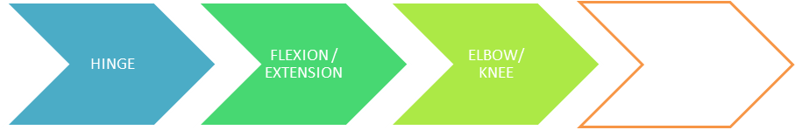

A hinge joint is

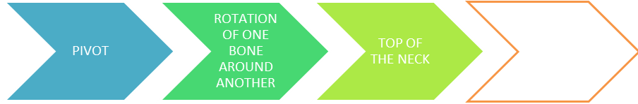

A pivot joint is

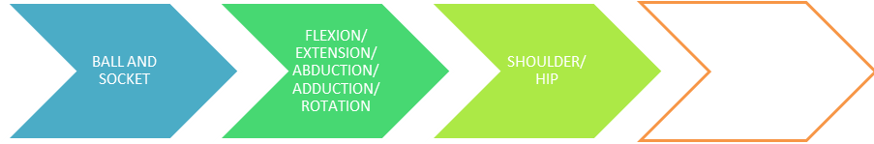

A ball and socket joint is

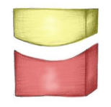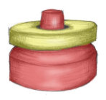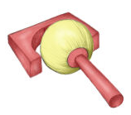

**types of synovial joints**

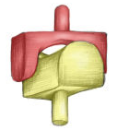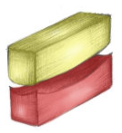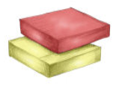

**RECAP**:

NAME THE 3 TYPES OF JOINTS IN THE BODY.

**RECAP**:

MAKE A LIST OF 10 BONES YOU REMEMBER

**5 QUESTIONS**:

ASK YOUR PARTNER 5 QUESTIONS ABOUT WHAT YOU HAVE LEARNT SO FAR.

A saddle joint is

A condyloid joint is

A gliding joint is

**TYPES OF MOVEMENT**

Even though Synovial joints are freely moveable, some of the joints can have restricted movement. The types of movement that each joint can have has been given specific names, can you match the correct name to the correct definition?

|  |  |  |
| --- | --- | --- |
| **Name of Movement** |  | **Definition** |
| Circumduction | Movement away from the midline of the body. |
| Extension | Movement towards the midline of the body. |
| Rotation | A combination of flexion, extension, adduction and abduction. |
| Flexion | Bending the limbs at a joint. |
| Adduction | A circular movement around a fixed point. |
| Abduction | Straightening the limbs at a joint. |

Thinking about the above definitions, look at image below. Can you label the joints identified in all four players and suggest the type of movement occurring in the image?

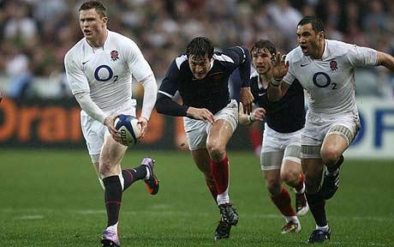



**SELF ASSESSMENT**

**the MUSCLES**

Can you match the names of the muscles to the correct place on the skeleton by placing the correct letter in each box?

GASTROCNEMIUS

OBLIQUES

LATISSIMUS DORSI

TRICEPS

QUADRICEPS

HAMSTRING

TRAPEZIUS

GLUTEUS MAXIMUS

ABDOMINALS

PECTORALS

DELTOID

BICEP

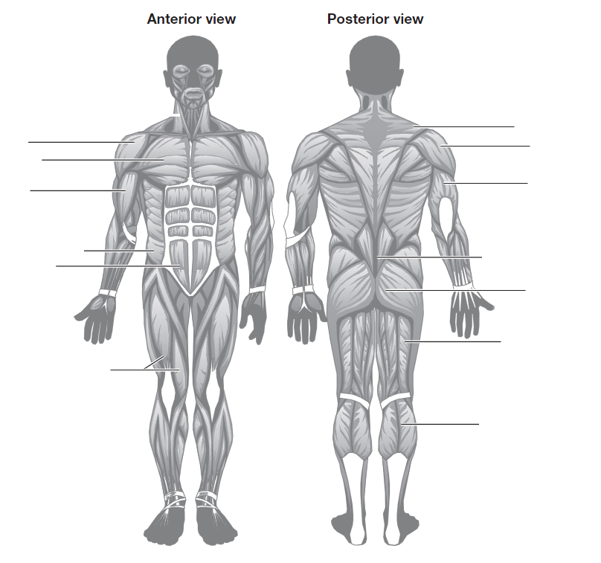

**G**

**H**

**F**

**E**

**D**

**C**

**B**

**A**

**I**

**K**

**L**

**J**

**ANTAGONISTIC PAIRS**

***Find out the answers to the following two questions:***

1. What is the name of the tissue that attaches bone to bone?
2. What is the name of the tissue that attaches muscle to bone?

Muscles that are attached to bones act as a lever in order to enable the joint to work and move other bones or limbs. Often, muscles will work together in two’s to help control the movement. This is called an Antagonistic Pair.

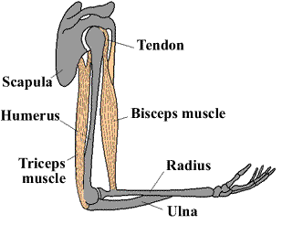***Look at the diagram below showing a BICEP CURL using the arm. Write a short paragraph say what and how it is happening.***

***You may wish to use these sentence starters to help you:***

In order for the… When the arm moves upwards…

The muscle that moves first is… The muscle that attaches to the…

The muscle that pulls the lower arm up is… Movement is produced by…

**TYPES OF MUSCLES**

***Can you think of two other muscles in the body that may work as an antagonistic pair?***

There are 3 types of muscles found in the body. They are called:

SKELETAL (VOLUNTARY) MUSCLE CARDIAC (HEART) MUSCLE) INVOLUNTARY MUSCLE

***Using the diagram below, label the diagram to show which term belongs to which muscle.***

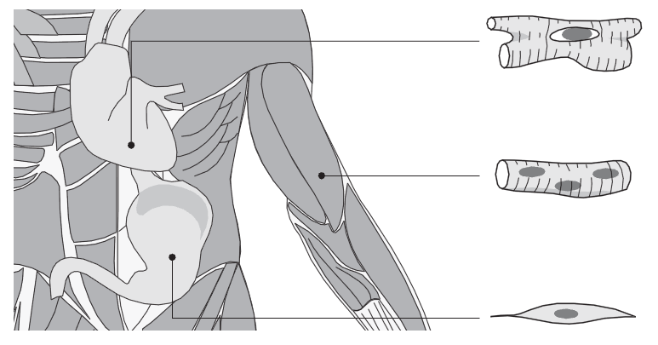

***Research each muscle by describing what it looks like and what it does in the table below:***

|  |  |  |
| --- | --- | --- |
| CARDIAC MUSCLE | VOLUNTARY MUSCLE | INVOLUNTARY MUSCLE |
|  |  |  |

**RECAP:**

IN YOUR OWN SPORT, WHICH TYPE OF MUSCLE DO YOU USE THE MOST?

**DID YOU KNOW?**

YOU USE 17 MUSCLES TO SMILE AND 43 TO FROWN.

**DID YOU KNOW?**

THE STRONGEST MUSCLE IN THE BODY IS THE TONGUE.

**TYPES OF MUSCULAR CONTRACTION**

***Do the following activities and think about the questions that follow:***

1. Stand in a doorway, place your hands on its frame (one either side) and gently push.
2. Place your right hand on your upper left arm; lift your left hand upwards towards your face in a bicep curl.
3. Keep your right hand on your upper left arm when it is in a raised position. Now lower your left hand downwards.

* *Do your muscles move in activity 1?*
* *What is happening to the muscles in your arms in activities 1?*
* *Do your muscles move in activities 2 and 3?*
* *What is the difference between activities 2 and 3?*
* *Why do you think the movement is different between activities 2 and 3?*
* *Can you name* *an example in sport when your muscles may move in a similar way to activities 1, 2 and 3?*

Muscles can contract in lots of different ways. There are 3 common ways:

**ISOMETRIC CONTRACTION**

This is the name given to a muscular contraction that does not require movement.

An example of this in sport is:

**CONCENTRIC CONTRACTION**

This is the name given to a muscular contraction that causes the muscle to shorten in length.

An example of this in sport is:

**ECCENTRIC CONTRACTION**

This is the name given to a muscular contraction that causes the muscle to extend in length.

An example of this in sport is:

|  |  |
| --- | --- |
| What went well / Strengths:  ✓  ✓  ✓ Literacy/Numeracy | Next Steps / Weaknesses:  ⮚  ⮚  ⮚ |
| Date: | Staff Signature: |

**TEACHER ASSESSMENT**

**the heart**

Using the words provided below, can you match the letters with the correct words for each part of the heart?

LEFT ATRIUM

RIGHT ATRIUM

LEFT VENTRICLE

RIGHT VENTRICLE

SUPERIOR VENA CAVA

INFERIOR VENA CAVA

SEPTUM

AORTA

PULMONARY ARTERY

PULMONARY VEIN

PULMONARY VALVE

AORTIC VALVE

MITRAL VALVE

TRICUSPID VALVE

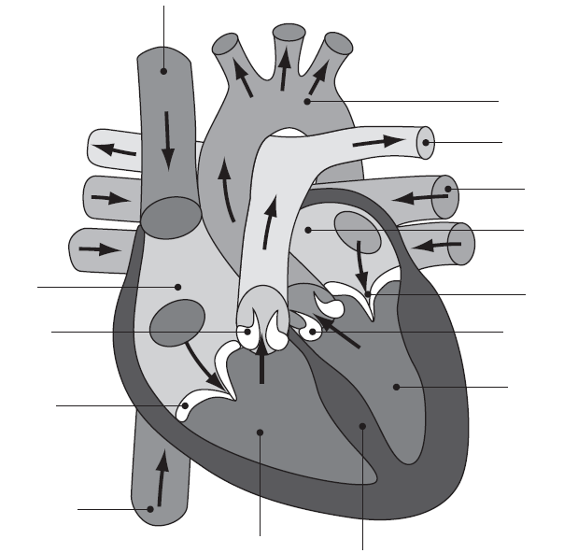

**A**

**K**

**J**

**C**

**G**

**L**

**F**

**I**

**E**

**H**

**D**

**B**

**N**

**M**

**The FUNCTION OF THE HEART**

***Read the following statements and decided if you think they are true or false.***

1. The heart has 6 chambers TRUE/FALSE
2. The heart beats between 60-80 beats per minute TRUE/FALSE
3. The heart grows weaker due to exercise TRUE/FALSE
4. The right wall of the heart is thicker than the left wall TRUE/FALSE
5. If you exercise on a regular basis, your resting heart rate decreases TRUE/FALSE
6. The top chambers of the heart are known as ventricles TRUE/FALSE
7. Only oxygenated blood passes through the heart TRUE/FALSE
8. The size of the heart is the same size as a clenched fist TRUE/FALSE
9. The heart is a muscle TRUE/FALSE
10. The sound the heart makes when it pumps blood is a lub-dub TRUE/FALSE

***Look at the statements below, each one describes the flow of blood through the heart; draw an arrow from one box to another to explain the correct route. Colour each box RED when the blood is oxygenated, BLUE when the blood is DEOXYGENATED and PURPLE when there is both.***

Blood enters the heart through the *pulmonary vein* into the *left atrium*.

The blood then flows through the *mitral valve* into the *left ventricle*.

Blood is carried from the lungs back to the heart via the *pulmonary vein* and the cycle repeats itself.

Through the *pulmonary valve*, out of the *pulmonary artery* via the lungs where gaseous exchange takes place.

The blood flows through the *tricuspid valve* into the *right ventricle*

Blood & waste products are delivered back to the heart via the *vena cava* into the *right atrium*

Blood is delivered to the working organs and muscles where oxygen is required.

Through the *aortic valve* out of the heart via the aorta.

The blood then flows through the *mitral valve* into the *left ventricle*.

Blood enters the heart through the *pulmonary vein* into the *left atrium*.

Blood enters the heart through the *pulmonary vein* into the *left atrium*.

The blood then flows through the *mitral valve* into the *left ventricle*.

Through the *aortic valve* out of the heart via the aorta.

Blood is delivered to the working organs and muscles where oxygen is required.

Blood & waste products are delivered back to the heart via the *vena cava* into the *right atrium*

The blood flows through the *tricuspid valve* into the *right ventricle*

Through the *pulmonary valve*, out of the *pulmonary artery* via the lungs where gaseous exchange takes place.

Blood is carried from the lungs back to the heart via the *pulmonary vein* and the cycle repeats itself.

Blood enters the heart through the *pulmonary vein* into the *left atrium*.

The blood then flows through the *mitral valve* into the *left ventricle*.

Through the *aortic valve* out of the heart via the aorta.

Blood is delivered to the working organs and muscles where oxygen is required.

Blood & waste products are delivered back to the heart via the *vena cava* into the *right atrium*

The blood flows through the *tricuspid valve* into the *right ventricle*

Through the *pulmonary valve*, out of the *pulmonary artery* via the lungs where gaseous exchange takes place.

Blood is carried from the lungs back to the heart via the *pulmonary vein* and the cycle repeats itself.

Blood is carried from the lungs back to the heart via the *pulmonary vein* and the cycle repeats itself.

Through the *pulmonary valve*, out of the *pulmonary artery* via the lungs where gaseous exchange takes place.

The blood flows through the *tricuspid valve* into the *right ventricle*

Blood & waste products are delivered back to the heart via the *vena cava* into the *right atrium*

Blood is delivered to the working organs and muscles where oxygen is required.

Through the *aortic valve* out of the heart via the aorta.

The blood then flows through the *mitral valve* into the *left ventricle*.

Blood enters the heart through the *pulmonary vein* into the *left atrium*.

Through the *pulmonary valve*, out of the *pulmonary artery* via the lungs where gaseous exchange takes place.

Blood is carried from the lungs back to the heart via the *pulmonary vein* and the cycle repeats itself.

The blood flows through the *tricuspid valve* into the *right ventricle*

Blood & waste products are delivered back to the heart via the *vena cava* into the *right atrium*

Through the *aortic valve* out of the heart via the aorta

Blood is delivered to the working organs and muscles where oxygen is required.

**the short term & long term effects of sport on the heart**

Sport and exercise can have many effects on the heart in many positive ways; these effects can be short-term or long-term.

***Below are is list of statements that describe both short and long term effects of exercise on the heart. Can you sort them out by writing either short-term or long-term above each box?***

Increased heart rate, stronger contractions and more blood flowing through the heart

Blood diverted to muscles away from digesting food and others systems

Blood temperature rises

Blood vessels near the skin open and allow heat to escape; this is why we go red

The heart muscle increases in size and strength

The amount of blood pumped by the heart in one minute increases

Reduced risk of heart disease

Lower heart resting rate and quicker recovery after exercise

More production of blood and blood cells

More capillaries found in the muscles to increase blood flow



**PEER ASSESSMENT**

**the lungs**

Using the words provided below, can you match the letters with the correct words for each part of the lungs?

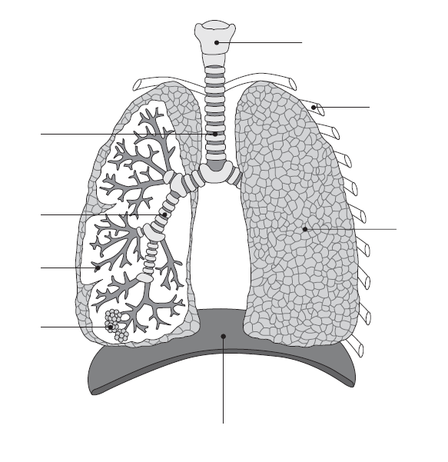

**G**

**F**

**E**

**B**

**D**

**C**

**A**

**H**

RIBCAGE

ALVEOLI

BRONCHI

BRONCHIOLES

TRACHEA

LUNG

EPIGLOTTIS

DIAPHRAGM

**inspiration & expiration**

The respiratory system is responsible for allowing oxygen and carbon dioxide to circulate around the body. You are now going to complete the following paragraph using the words from the word box below:

**The Mechanics of Breathing**

When we breathe in, ***­­­­­________***comes in through the nose and­­­ ­_________. It travels down the ***_______*** until it arrives at the bronchi. The ***_______*** can be described as thick ***_______*** split into two parts that direct the air into the ***___________*** and the ***___________***. These trunks are divided further into smaller ***________***, known as ***__________***. The bronchioles have little air ***_____*** (***­­­­­­________***) at the tips. These air sacs allow ***_______*** and other ***________*** to change place with ***_______*** products that need to be ***________*** from the body.

*Oxygen Waste Trachea Oxygen Trunks Sacs*

*Left Lung Removed Bronchioles Right Lung Alveoli Bronchi*

*Nutrients Mouth Branches*

Look at the two images below, decide which image represents inspiration (breathing in/inhaling) and which image represents expiration (breathing out/exhaling).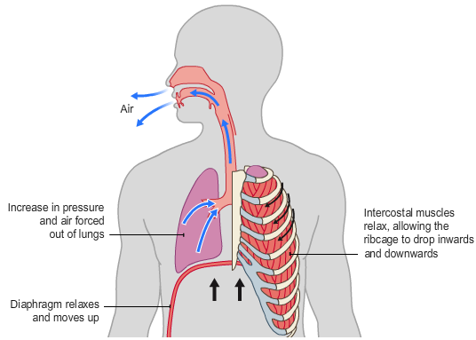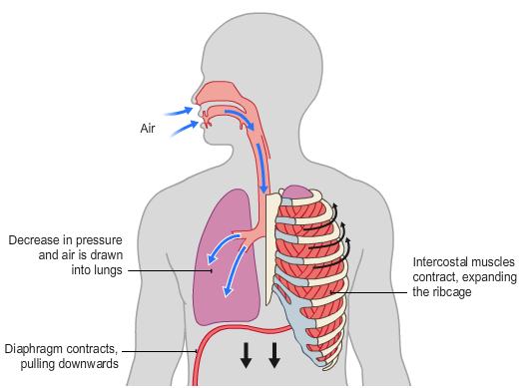

Inspiration/Expiration

Inspiration/Expiration

**DID YOU KNOW?**

AN AVERAGE PERSON BREATHES IN AROUND 11,000 LITRES OF AIR EVERYDAY

**DID YOU KNOW?**

WHEN RESTING, AN ADULT BREATHES AROUND 12 TO 20 TIMES A MINUTE

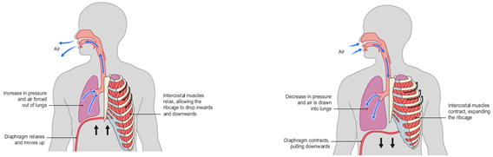

**the short term & long term effects of sport on the lungs**

Sport and exercise can have many effects on the lungs in many positive ways; these effects can be short-term or long-term.

***Below are is list of statements that describe both short and long term effects of exercise on the lungs. Can you sort them out by writing either short-term or long-term above each box?***

Improvement in the strength of the diaphragm and intercostal muscles

Increase in the amount of air forcibly exhaled after breathing in as soon as possible

Increased number of alveoli

An increase in the amount of air breathes in and out of the lungs in one breath

Increase in O2 deliver to and CO2 removed from the body

Increased rate of breathing

The diagram to the left shows how Gaseous Exchange happens.

***Can you reword in your own words the definition of Gaseous Exchange provided below?***

“Oxygen passes through the capillary wall and into the tissues; Carbon Dioxide passes from the tissues into the blood.”

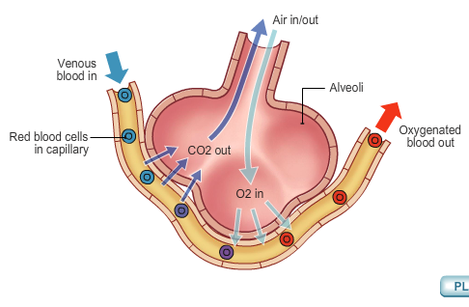

My Definition:

**gaseous exchange**

**analysis of movement**

Now that you have learnt about how the body responds and works in sport and exercise, describe and explain what is happening in the image provided to demonstrate your knowledge.

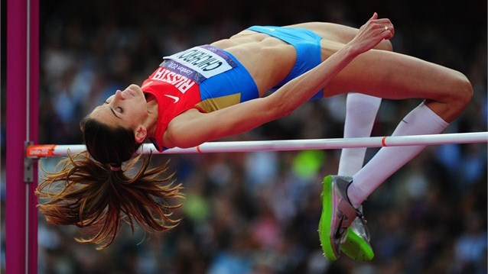

**MY ANALYSIS:**

**TEACHER ASSESSMENT**

|  |  |
| --- | --- |
| What went well / Strengths:  ✓  ✓  ✓ Literacy/Numeracy | Next Steps / Weaknesses:  ⮚  ⮚  ⮚ |
| Date: | Staff Signature: |

**IMPROVEMENT PHASE**

**STUDENT COMMENTS:**