Corn flour Goo
If you have online access visit:
https://www.stevespanglerscience.com/lab/experiments/non-newtonian-fluid/

No online access, no problem. Follow the instructions below.
All you need is some corn flour( from the supermarket) and water from the tap.
Please note : THIS IS A MESSY ACTIVITY- DO IT OUTSIDE IF YOU CAN
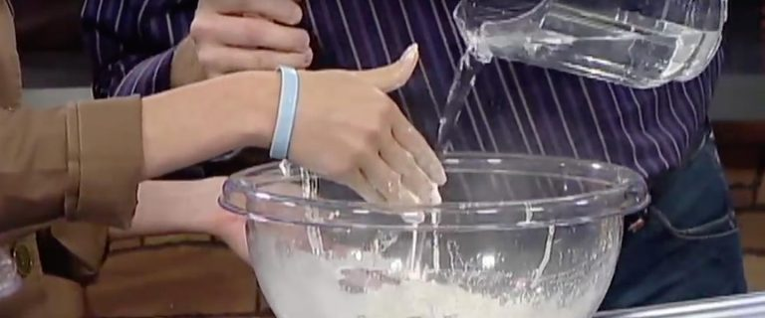

1
NOTE: Anyone working in the bowl needs to wash hands first. That keeps the goo much cleaner and more pleasant to study.
Pour the box of cornstarch into the mixing bowl and add one cup (237ml) of water. It’ll be tough to stir with a spoon. It’s just easier – and way more fun – to mix the cornstarch and water with clean, bare hands.
(Using colored water is an option. Just keep in mind that stained hands and clothes and floors may become a concern even with everything covered with a drop cloth.)

2
Continue adding water (and/or cornstarch if needed) in small amounts until you get a mixture that has a consistency similar to honey. It may take a little work to get it just right the first few times, but you’ll eventually end up mixing one box of cornstarch with 1 to 2 cups (237 to 473ml) of water. The nice thing about it is that you can’t make a mistake – but it sure is fun!.

3
Pour the mixture onto a tray, cookie sheet, or baking pan. Notice its unusual consistency as you pour it. Stir it on the tray with your fingers, first very slowly and then, as fast as you can. You may be surprised at what happens. Skim your fingers across the top of the glop. What do you notice?

4
Gather a handful of the glop and lift it off the tray. Roll the goo between your hands and make a ball. Hand the ball to someone and watch what happens to the ball.

5
Hold your hand flat over the pan palm-down and smack the liquid glop as hard as you can. Most helpers will duck for cover as you get ready to slap the liquid because they expect it will splash everywhere. Surprise! All of the glop stays in the pan… hopefully. (If a little mixture inadvertently splatters, clean it up, toss it into the trash, and add a bit more cornstarch to the batch.)
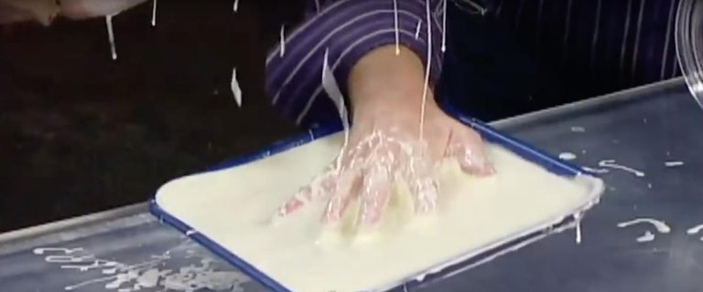

6
Smack the glop in the tray again but this time, lift your hand straight up from the table. Surprise – again! The tray and the glop come up off of the table with your hand. However, it will quickly fall back to the table so don’t go too high.
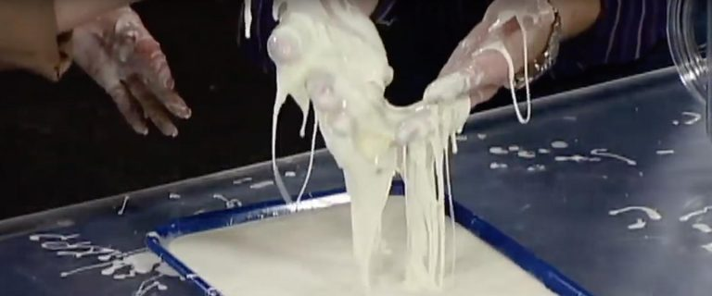

7
As you play with the glop, speculate as to why the “liquid” behaves as it does. What causes it to feel like something solid when it’s squeezed, yet flow like syrup when the pressure is released? When you’re finished with the activity, pour the glop into a large zipper-lock plastic bag to store it for later use. (Mixing and “researching” it with clean hands helps it store longer.)

