**Developing Skills for**

**Independent Life**

C:\Temporary\Content.IE5\HLXMQQJ0\MC900078626[1].wmf

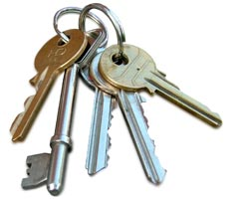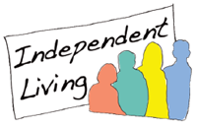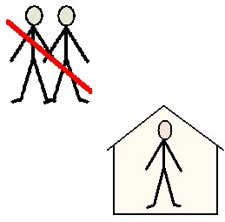





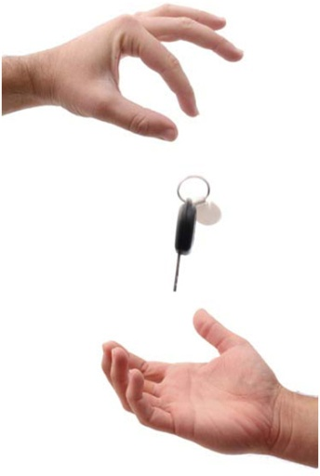

**NOCN Level 1**

**Developing Skills for**

**Independent Life**

**3 credits**

**(Mandatory/core Unit)**

**NOCN Unit Code: HD6/1/qq/007**

**Accredited Unit no: r/500/4704**

**By**

**(of Long Sutton Support Centre)**

**Date started unit:**

**Date finished unit:**

**1.1**

**What does ‘Independent Living’ mean?**

Use the tree mind map below to jot down your ideas about what ‘Independent Living’ means. There is not a right or wrong answer, just write what the words mean to you.

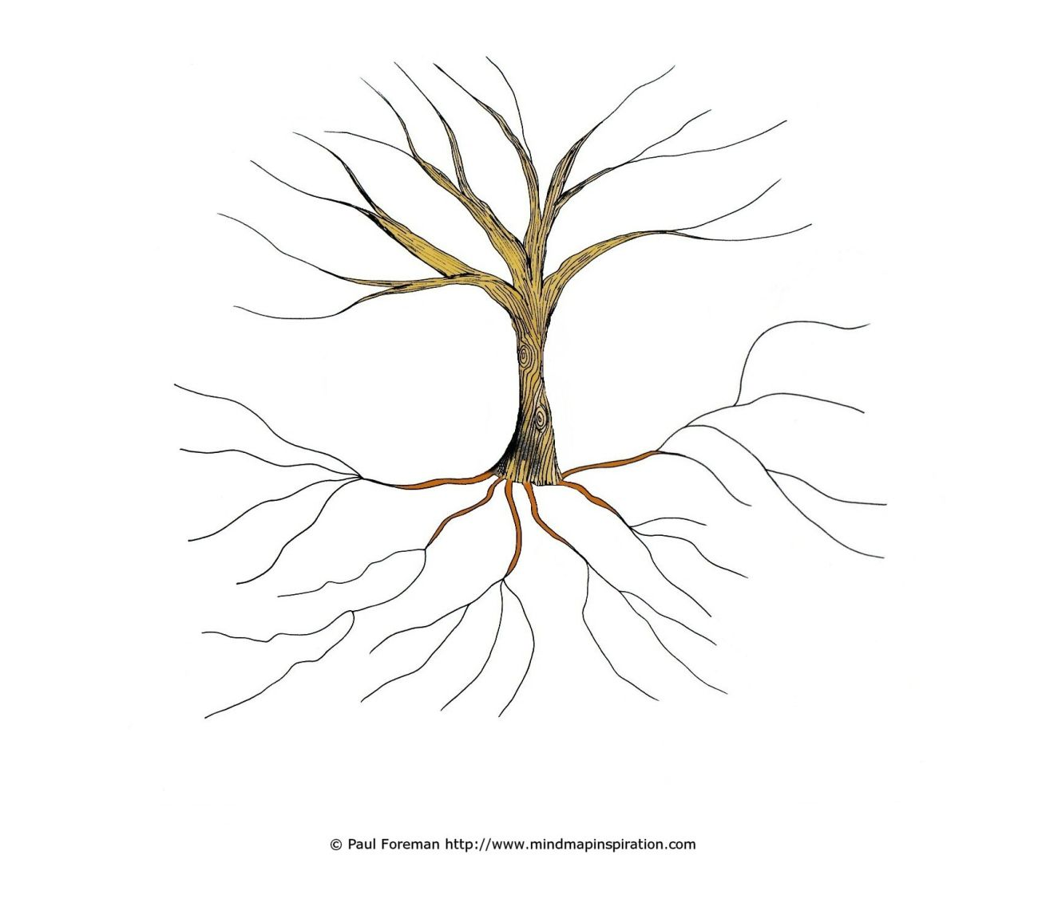

Now you’ve done some thinking, write 2 – 3 sentences that offer a definition of ‘Independent Living’.  
___________________________________________________________________________________________________________________________________________________________________________________

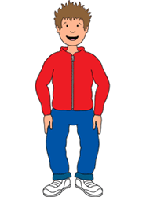Transition 2.1

Case Study

Use highlighter pens for the following activity.   
In **green**, highlight the POSITIVE aspects of Jack’s transition to independence.   
In **yellow**, highlight the NEGATIVE aspects…

Jack is 19 years old.

Jack went to a mainstream secondary school but didn’t feel like he fit in. He often got in fights with other boy his age. He missed a lot of school and as a result didn’t do very well in his GCSEs. Shortly after Jack left school his parents began to argue. Jack spent a lot of time at home watching tv with Mum and Dad fighting in the background. This made him angry and he spent a lot of time out of the house. He looked for a job but found employers wanted someone with qualifications. He also didn’t know how to prepare for a job interview. Eventually he got a Connexions advisor who helped him with his applications. When Jack was 18 and had finally found a job, he decided to leave home and live on his own.

For a few months Jack lived on friends’ sofas. Eventually however, his friends got tired of having him stay. This upset Jack and now he doesn’t see those friends anymore. He moved in with 2 people he worked with who had a flat and needed another roommate. They split the rent between the 3 of them.

Jack now lives in a flat with 2 friends. He works in a shop but doesn’t earn a lot of money. After paying his part of the rent, council tax and bills, he doesn’t have much money left at the end of the month. He likes being independent and being able to invite friends over, but he doesn’t like being poor and having to cook and clean. He doesn’t watch tv anymore because they can’t afford a tv licence and they got in trouble previously after not realising they needed a licence to have a tv in their flat.

Because he doesn’t earn much money, Jack has received financial help to help him re-do his GCSEs at the local college. He goes there on the bus. He is hoping that when he has done these exams, and maybe 1 or 2 other courses, that he will be able to go on to get a better paid job.

**What are some positive (i.e. good)** 2.1

**and negative (i.e. bad), things about the transition to independent life?**

***Use your own experience(s) to help you write your answers.***

|  |  |
| --- | --- |
| **Positive Points About Becoming Independent** | |
|  |  |
|  |  |
|  |  |

|  |  |
| --- | --- |
| **Negative Points About Becoming Independent** | |
|  |  |
|  |  |
|  |  |

2.2



**What about if you come from a different cultural background?**

|  |  |
| --- | --- |
| **If someone was from a different cultural background to you, what might be difficult for them as they began to live independently?** | **Why might this be difficult for them?** |
|  |  |
|  |  |
|  |  |
|  |  |

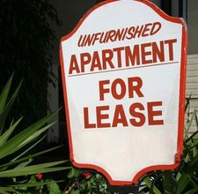3.1

**When you move out, you can choose to either**

**B _ _ or**

**R _ _ _ a property.**

**If you buy a property you put down a**

**d _ _ _ _ _ _ and then have a m _ _ _ _ _ _ which you pay every month. A mortgage is when the bank loan you the majority of the money to buy your house, you then pay a bit back every month. Mortgages last a long time, for example if you borrowed £100, 000 and paid back £600 a month, your mortgage would take over 13 years to pay back. If you chose a 20 year mortgage plan, your monthly payments would be less than in a 10 year mortgage, but it would obviously take longer to pay for your home. Mortgages also add interest to the money you owe so you have to pay back a bit more than you borrowed to start with.**

**If you rent a property you also have to put down a d _ _ _ _ _ _, although this will be far less than if you buy a property. Often landlords or estate agents ask for 1 month’s rent as a deposit, and then 1 month’s rent in advance. You then pay your rent every month. You will then have a lease agreement which is a written contract with your landlord (the owner of the property) or the estate agent (who often work on behalf of landlords). If you move out of the property and leave damage, such as a hole in the wall, the cost of repairing this is taken away from your deposit.**

**So if your deposit for a property was £500 and when you left there was a stain on the carpet and a broken curtain rail, work out how much of your deposit you would get back…**

**£500 deposit minus….**

**Cost of replacing carpet for one room = £200**

**+**

**Cost of repairing curtain rail = £70**

**=**

**Discuss with at least one other 3.1**

**C:\Documents and Settings\laura.collis\Local Settings\Temporary Internet Files\Content.IE5\5EM2U4VS\MC900282402[1].wmfperson, what responsibilities you might have if you were a tenant in a flat/house and had a tenancy agreement.**

**Record your discussion below…**

|  |  |
| --- | --- |
| **Key Responsibilities of Tenant** | **Why is this important?** |
|  |  |
|  |  |
|  |  |
|  |  |
|  |  |

**Now imagine you are the landlord of a 3.2**

**house/flat. You have a tenancy agreement with the person who rents your property.**

**Discuss and note down what responsibilities you would have to your tenant.**

|  |  |
| --- | --- |
| **Key Responsibilities of Landlord/Landlady** | **Why is this important?** |
|  |  |
|  |  |
|  |  |
|  |  |
|  |  |

**3.1**

FURNISHING A FLAT

*An unfurnished flat comes with:*

C:\Temporary\Content.IE5\YHTQ4WPY\MC900215168[1].wmfCooker

Carpets

Bathroom (sink, bath, shower, toilet)

*What you will need to find and pay for:*

Bed

C:\Temporary\Content.IE5\HLXMQQJ0\MC900030262[1].wmfSofa

Table

TV

Fridge/ freezer

Washing machine

Anything else you would like in your flat...microwave, cushions, plates, cutlery, glasses, pictures, rugs, bin, kettle…

**PC lesson- Produce either a power point or A4 poster showing how you could furnish a flat for under £1000.**

****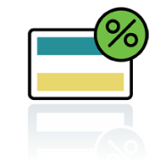 **Debit and Credit Cards**

**• What's The Difference Between Debit Cards And Credit Cards?** When you buy goods or get cash with a debit card the money goes from your bank account right away. With [**credit cards**](http://www.reviewcentre.com/products293.html) you receive a monthly bill. If you do not repay the amount owed in full on your credit card, or you take out cash, the charges can be high.

**• How Do Debit Cards Work?** [**Debit cards**](http://www.reviewcentre.com/products3568.html) are linked to your bank account. You can use them to buy goods or withdraw cash and the amount is taken out straight away. Debit cards can also be used to obtain ‘cashback’ from shops and supermarkets. When you buy goods you can also ask for money back from the cashier and the amount is deducted from your account right away, saving you the trouble of going to the bank. Most bank accounts offer debit cards and they also work as cheque guarantee cards. The card is a guarantee to retailers that your cheque will be 'honoured' by your bank up to a stated amount.

**• What Happens If I Do Not Have Enough Money In My Debit Account?** It depends on the type of debit card you have. With a '[Solo](http://www.reviewcentre.com/reviews102675.html)' or 'Electron' debit card the balance in your account is checked before each transaction. But if there is no money you won't be able pay or withdraw cash with the debit card without additional agreement. 'Switch', 'Visa' or 'Delta' cards means your account balance won't necessarily be checked and the payment may still go through although if you spend more than is in your account you will probably incur interest or excess charges which will depend on your overdraft agreement.

**• What's The PIN number?** Your PIN is the personal identification number on your card. When using a cash machine or paying for goods with a debit card you'll need to enter your pin. In the last few years [banks](http://www.reviewcentre.com/products2278.html) have introduced what are known as chip and pin cards in order to improve security. Under this system cardholders are required to enter their code when making a purchase. When buying goods you normally enter it into an electronic hand held device. In some cases you still may have to sign a receipt.

**• How Do Credit Cards Work?** Credit cards allow you to buy now and pay later. Hence, they are called 'credit' cards. Credit cards are not linked to [bank accounts](http://www.reviewcentre.com/products296.html). Like debit cards they can be used to buy goods in shops and over the phone and internet with the same information given out by you. You can also obtain cash by drawing money at bank's cash machines. Banks are always offering credit cards as they make a lot of money on them when you pay interest on your bill. You can also apply for one if you need one.

**• What Are The risks Of Using Credit Cards?** Think carefully before using one. If you do not repay your bill in full by the date shown you will be charged interest on the whole amount of the bill for that month. The rates of interest - the APR/Annual Percentage Rate - can often be extremely high. If you take cash out with a credit card you are charged daily interest from the moment you take out the money until the credit card bill is paid in full. This is an expensive way of borrowing cash. Some credit cards also have an annual fee. Use and misuse of credit cards is one of the main reasons for rising debt in the UK.

**• What Are The Advantages Of Credit Cards?** It should be noted that if you pay off your bill in full every month it does not matter how high the interest rate is on your card because you will not be paying it. A credit card therefore gives you greater spending flexibility. If you clear your bill each month, have no annual fee your card will not cost you. Some cards also offer loyalty bonus such as points, Air Miles or cashback. Paying for expensive items with credit cards also offers the advantage of added consumer protection. The Consumer Credit Act makes the card company liable along with the seller in case of breach of contract.

**Skills for living 4.1 Independently**

**Discuss with at least one other person, the skills that you would need to live independently.**

**Use the spidergram below to note down your answers.**

** 5.1** & **5.2** & **4.1**

Facing

Difficulties

If you make the move to living independently, what situations could be difficult for you? What problems could occur?

Think of what problems could occur with finances and money….





How could you best deal with such situations?



What skills would you need to deal with these problems?



**5.1** & **5.2** & **4.1**



Think of what problems or any issues that could arise if you lived with other people?







Can you think of any issues that could occur with your neighbours?







How could you best deal with such situations?



What skills would you need to deal with these problems?



**5.1** & **5.2** & **4.1**

What problems could happen with work and jobs?











How would you deal with these work related problems?



What skills would you need to deal with these problems?



Can you think of any other things that could cause you problems if you lived independently?



**C:\Temporary\Content.IE5\GE31LLQI\MC900028383[1].wmfC:\Program Files\Microsoft Office\MEDIA\CAGCAT10\j0234131.wmfC:\Temporary\Content.IE5\GE31LLQI\MC900241319[1].wmf**

How would you deal with these other problems?



What skills would you need?





**Diary/ Log**

Record when you have used independent skills at home, school or elsewhere.

**Activity: Date:**

**Activity: Date:**

**Activity: Date:**

**Activity: Date:**

**Activity: Date:**

**Activity: Date:**

**Activity: Date:**

**Activity: Date:**

**Activity: Date:**

**Activity: Date:**

**Activity: Date:**

 

The Money Quiz!

Are you a saver or a spender? This quiz is designed to find out how you manage your money!

**1. You are out shopping with one of your mates and you see an expensive pair of trainers that you really want but can't afford. Do you.....**

a. You want them now so you ask your parents/carers to lend you the money so you can buy them now and hopefully they won't ask for the money back.

b. You want them now so you ask your parents/carers to lend you the money and agree that you will pay them back a set amount each week.

c. You already have some money put away and you will save up for a couple of weeks to get the rest. When you have enough money you will go and buy them.

**2. You get £50 pounds for your birthday. Do you...**

a. Hit the shops straight away and spend it all.

b. Spend some of it and save some of it.

c. Put all of it in your bank/building society account until you know what you want to spend it on.

**3. Do you always know how much money you have, how much money you have spent and what on?**

a. No I haven't got a clue. When I get some money I tend to just spend it.

b. Yes, I've got a fair idea about what I spend my money on.

c. Yes. I keep myself organised and keep track of my spending.

**4. You've borrowed some money from a friend and don't think that you will be able to pay it back by the time you said you would. Do you...**

a. Not worry about it. Hopefully your friend will forget about it.

b. Speak to your friend and explain the situation telling them that you will pay them back but it might take a bit longer than you first thought.

c. Sit down and work out how much money you have and how much you owe. Speak to your friend and explain the situation telling them that you still intend to pay them back and suggest that you could maybe repay them in smaller instalments rather than one big lump.

**5. Your parents/carers have suggested that you have a look at opening a bank account so you can start to save and earn some interest on your money. Do you...**

a. Ignore the advice - money is for spending not for saving.

b. Have a think about it. You know it's a good idea and intend to do something about it - but not straight away.

c. Start doing some research and have a look at the different types of bank accounts available so you make sure that you choose the right bank account for you.

**6. You have a friend who is always borrowing money off you and never paying it back. This friend asks to borrow £5 to go to the cinema. Do you…**

a. Lend them the money. You can afford it and it doesn't matter if you get it back.

b. Lend them the money but explain it is the last time until they have paid some back.

c. Say no, they owe you too much already.

**Results**

**You answered mostly A's:**

You could probably do with a bit of support to help you to manage your finances better. Why not speak to your parent, carer or an organised friend and ask them to show you what's what. This will help you to make your money go further and stop you getting into debt.

**You answered mostly B's:**

You have a good understanding of managing your money but sometimes you need to be a bit more organised. Try setting yourself a weekly or monthly budget and sticking to it. You will then know how much money you have, what you spend it on and how much you can save.

**You answered mostly C's:**

Congratulations - It sounds like you really know what you are doing when it comes down to managing your money. You know how important it is to keep track of your spending and are responsible with your money.

Evidence File

Use the following 2 pages to show any photographs or drawings you have of yourself being independent or using independent skills.

**1.1, 2.1, 2.2, 3.1, 3.2**

**End of Unit Test Questions**

1. In one sentence, describe what ‘independent living’ means.
2. Identify **two** positive things about becoming independent.



1. Identify **two** reasons why becoming independent could be difficult for someone from a different cultural background.






1. If you are renting a property from someone, what might you be called? (Hint: it begins with a ‘T’)
2. If you rent a property from someone, what are **two** of your responsibilities?






1. If you are the landlord renting out a property, what are **two** of your responsibilities?



**4.1, 5.1, 5.2**

1. Name **five** skills a person would need to live independently.



1. Identify **three** different problems that you could face when living independently. For each problem, write how you would deal with the situation.

How would you deal with this?

* -
* -

* -

End of Unit