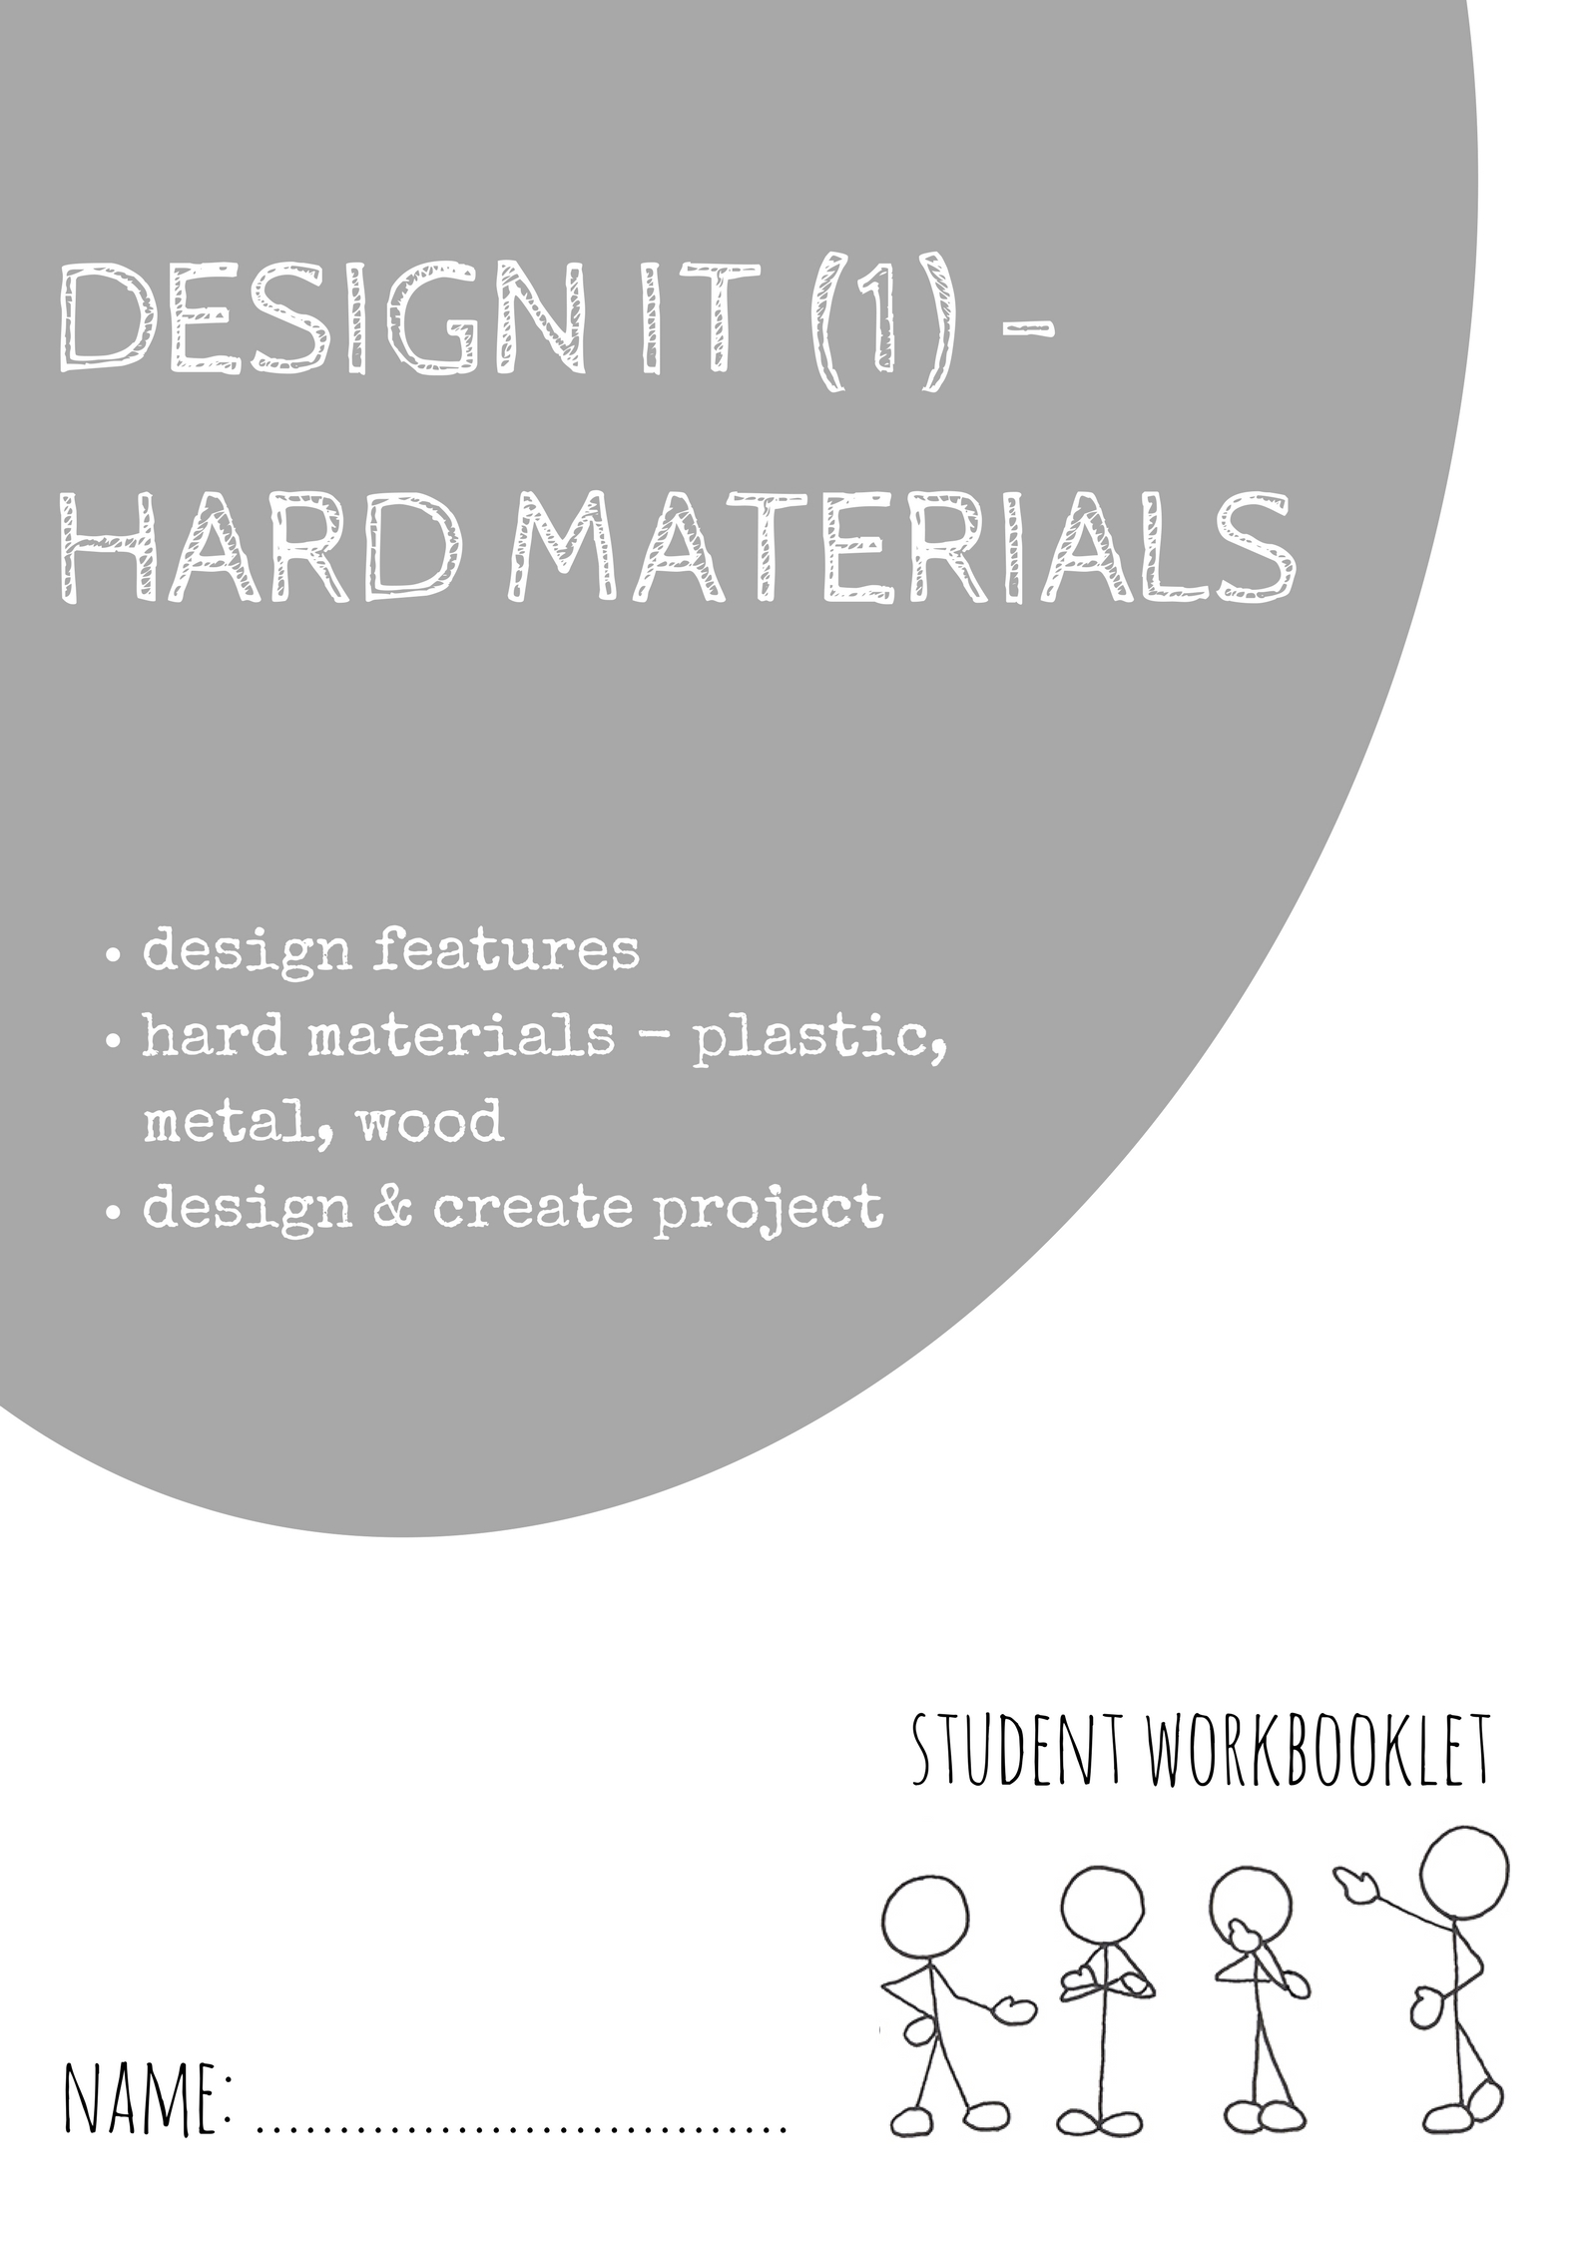
INSTRUCTIONS FOR THE TEACHER

These learning workbooklets are designed as building blocks within a theme for students to practice everyday skills and use them in several tasks. Where possible, we try to use relevant examples that include active learning and use resources available to most classroom settings

To support a student: -

- Encourage them to think first and give them examples that they will know
- Link ideas to things they are familiar with
- Help with reading the tasks aloud and writing their answers
- Help with physical tasks like cutting, pasting, drawing lines etc.
- Support with braille or sign language or non-verbal communication
- Listen to their answers and ask them questions to check understanding

A student could respond the way they find easiest and could choose from speaking, writing, signing or using pictures.

For this learning workbooklet it would often be useful to have a charged iPad, notebook, tablet or phone/camera to use for some of the tasks.

INSTRUCTIONS FOR THE STUDENT

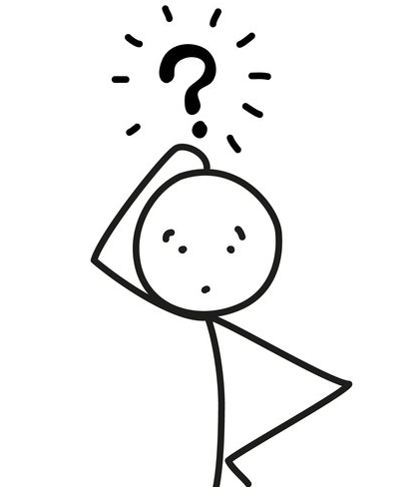
- Aim to complete the whole booklet and the learning checklist at the back
- Your teacher will explain how much you will be completing in a session
- Ask for help if you need it, especially with writing or understanding the task so you can complete it
- Think about how you use these skills every day
- The teacher can help you with reading/writing
- Remember, you can always practice a task before completing it.

INTRODUCTION

DESIGN IT (1) is all about seeing objects around us and working out how they were made, with what materials and what each object’s purpose is.

We use objects every day from a phone, computer, lights, TV, cars, bikes, cooking equipment or even the bed or sofa we sit on. Some of the objects are simple and easy to use, and other objects can have fancier or special features.

Sometimes an object may look ordinary but have little buttons or switches we don’t notice at first. DESIGN IT (1) is all about looking at the object carefully and what it has been designed to do.

Look around you and get familiar with all the different objects that may be in a classroom or room, and start to think about

- What are they made of?
- How old are they?
- What are they designed to do?
- Do they have any flash or hidden features?
- Are there similar products that you could buy or make?
DESIGN

Task 1a: Look around you and list or draw SIX objects made of hard materials (wood, plastic, metal) you can see that have been designed by someone. Beside the name of the object, put what the object is made from.

Object … | Made from …
1
2
3
4
5
6

Task 1b: Discuss what you think are features of each object.

Task 1c: Select one of the objects and draw it below. Try to improve one feature on it so it has been “re-designed” by you.
Task 2a: Look carefully at the photo below and circle THREE objects.

Task 2b: For ONE of the objects, find out:

Object:
1. What is it made from?
2. What would it mostly be used for?
3. Who uses it?
4. Are there different types?

Task 3a: Look carefully at the objects below and circle any that have been made from plastic.

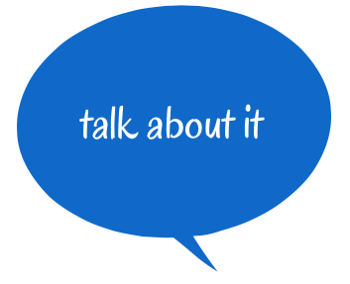
Task 3b: Discuss the purpose of TWO plastic objects in the picture.

Plastic object … | Purpose of object …
1
2

Task 3c: Discuss any design features on the plastic objects you can see. It could be a button, some trim, something attached to it etc.
Task 3d: Look carefully at the objects below and circle any objects that have been made from metal.

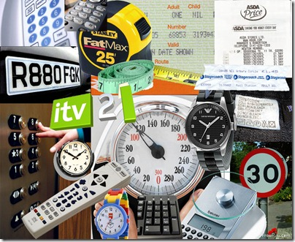

Task 3e: Discuss the purpose of TWO metal objects in the picture.
Metal object … | Purpose of object …
1
2

Task 3f: Discuss any design features on the metal objects you can see. It could be a button, some trim, something attached to it etc.
Task 4a: Look carefully around the room you are in now and create a design scavenger hunt to swap with someone else. Create clues to direct someone to THREE different objects.

Clues to find THREE objects … | Answer  (person doing hunt fills in)
1
2
3

Task 4b: Swap and do several other design scavenger hunts.
Task 4c: Create a photo collage or sketch the objects you chose for your design scavenger hunt as an answer sheet and attach to this page.

Task 4d: For each object discuss why you chose it, what its purpose is and if there any similar objects that have been made like each one.

 | Object 1 | Object 2 | Object 3
Why I chose each object
The object’s purpose
Similar designs of each object

Task 4e: Find a photo or sketch a similar design object to the one you chose for your scavenger hunt and attach it to this page.
Task 5a: You are to find out or research THREE different objects made from plastic, metal or wood that have been designed to help with COOKING.
THREE objects designed for COOKING | What does each object do in COOKING?
1
2
3

Task 5b: You are to add a picture or sketch below of each object chosen - you could use magazines, newspapers, internet etc.

Task 5c: You are to find out or research THREE different objects made from plastic, metal or wood that have been designed to help with TRANSPORT.
THREE objects designed for TRANSPORT | What does each object do for TRANSPORT?
1
2
3

Task 5d: You are to add a picture or sketch below of each object chosen - you could use magazines, newspapers, internet etc.

Task 5e: You are to find out or research THREE different objects made from plastic, metal or wood that have been designed to help with TRAVEL.
THREE objects designed for TRAVEL | What does each object do for  TRAVEL?
1
2
3

Task 5f: You are to add a picture or sketch below of each object chosen - you could use magazines, newspapers, internet etc.
Task 5g: You are to find out or research THREE different objects made from plastic, metal or wood that have been designed for BUILDING.
THREE objects designed for BUILDING | What does each object do in BUILDING?
1
2
3

Task 5h: You are to add a picture or sketch below of each object chosen - you could use magazines, newspapers, internet etc.

MATERIALS - PLASTIC

Task 6a: Find three different plastic pens and discuss the similarities and the differences between them.
Similarities | Differences

Task 6b: Select one and list TWO things you like about it and why?
Pen chosen:

Task 6c: What are TWO advantages of using plastic for a pen?

Task 7a: You are to design an everyday object using plastic. It could be used for cooking, eating, art, communication, technology, building, transport etc.

Object
What would you think about first?
What would it be used for?
What would you make it out of?
What would make it different?

Task 7b: Think about and discuss some more about your new plastic object.
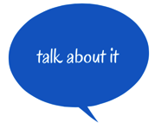
Object
What makes it a little different from what you can already buy?
Does it help anyone or solve problems?
How would it work?
How would you make it?

Task 7c: Draw a sketch of your new everyday plastic object and label the different features on it. Attach it to this page.

MATERIALS - METAL

Task 8a: Suggest a reason why metals are often used to make these objects:
Why metal is used for …
A car
A ring
Scissors
A table
House roofs

Task 8b: Look around the room you are in and list all the metal objects you can see. Highlight the everyday items, and underline (or circle) more designed metal objects.

Task 9a: Find out TWO good and TWO bad points of making something using metal? (Advantages and disadvantages).
Advantages of using metal | Disadvantages of using metal
1.
2.

Task 9b: Find a metal object in the room you are in and try to draw it to scale below. You should measure as much of it as you can, and then try to draw it smaller or larger in the box below.

MATERIAL - WOOD

Task 10: Survey THREE different people and ask them the questions below:

 | Person 1 | Person 2 | Person 3
What TWO wooden objects do you have at home?
Can you name a wooden object you have seen around school?
Have you ever made anything with wood?
Do you have any tools at home to use with wood?
What is a good thing about making something with wood?
What is a bad thing about wood?

Task 11a: Look at the wooden horse below and fill in the table.

Wooden horse
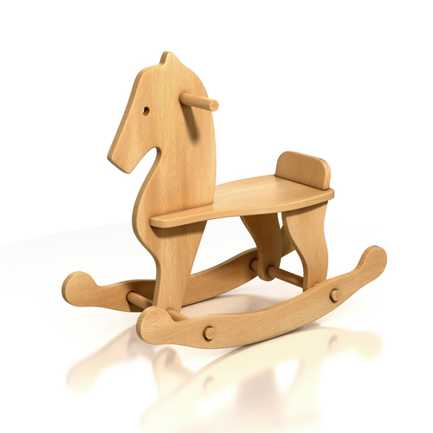
Why is it made
of wood?
What is one
design feature of the wooden horse?
How do you think it
was made?
What could you do to adapt it?
Task 11b: Look at the wooden bowl below and fill in the table.

Wooden bowl
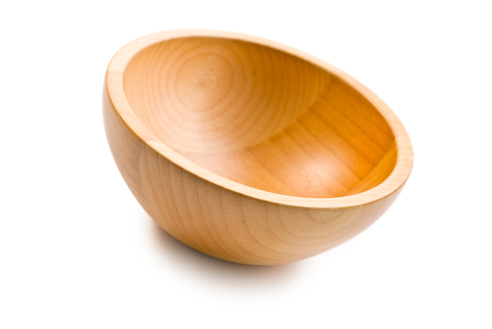
Why is it made
of wood?
What is one
design feature of the wooden bowl?
How do you think it
was made?
What could you do to adapt it?
Task 11c: Look at the wooden boat below and fill in the table.

Wooden boat
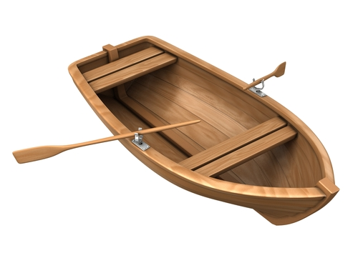
Why is it made
of wood?
What is one
design feature of the wooden boat?
How do you think it
was made?
What could you do to adapt it?

Task 11d: Look at the wooden violin below and fill in the table.

Wooden violin
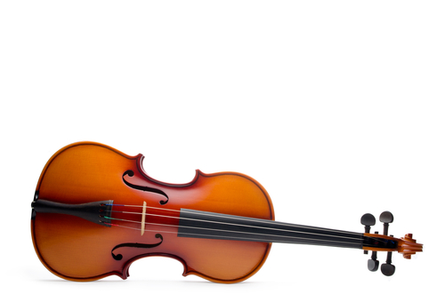
Why is it made
of wood?
What is one
design feature of the wooden violin?
How do you think it
was made?
What could you do to adapt it?

Task 12a: You have a set time of ………… mins to find as many wooden objects as you can. Either list or draw them below. Compare with someone else.

Task 12b: What other materials are used in the objects?

Plastic | Metal | Rubber
Liquid | Paper | Other:

Task 12c: Select ONE wooden object you found and describe the design of it to something else. Think about its shape, size, purpose, materials, how long it lasts, who will use it, where to buy it etc. Put ideas below:

DESIGN & CREATE

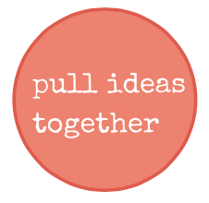
Task 15a: You are to select an item/idea you want to design/create and complete it as a project using hard materials. You are to fill in the design brief below and attach all your sketches, ideas, photos and costs as you work through the project.

DESIGN BRIEF AND OUTLINE
I will design a →
It will be used to →
My first ideas of what it will look like are →
The materials I could use are →
Pictures of similar designs/products → | Attach to this page …
The steps to creating my design may be →
Problems I may have to solve are →
People who could help me make this →
How long will this take?→
My notes as I work through my project →
Picture of my finished product →

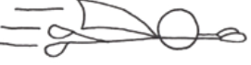

Well done on completing the Design It (1) workbooklet.
Your teacher will fill in the following.

Name: | Can do this skill | Needs practice
Design
Can identify basic design of objects
Can select objects with different functions
Can compare design elements of objects
Materials
Can identify use of plastic in designing objects
Can identify use of metal in designing objects
Can identify use of wood in designing objects
Design & Create
Can select and plan a design project
Can create and complete a new design
Literacy and Thinking Skills
Can discuss key ideas
Can research or think of new tasks/items
Comment:

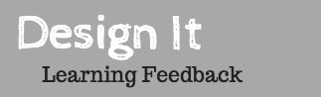

Think about how you worked in Design It (1).
Name: | Yes | Sometimes | Not really
About Me …
I have attempted all work to the best of my ability
I have learned key words about the topics
I feel I was positive and participated well
I could make more effort to:

About the topic …
I enjoyed this topic
I learned new ideas about this topic
I could make more effort to:

About the learning …
I was able to understand the instructions
I was able to complete the tasks
I could make more effort to:

Literacy, Numeracy and Thinking Skills
I was able to use key literacy skills
I was able to use key numeracy skills if needed
I was able to use key thinking skills
I could make more effort to:

