Food challenges KS3
For every challenge you can complete take a photograph of the results if you can!

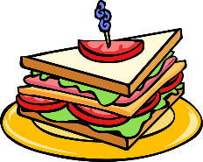
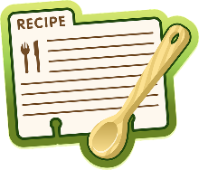
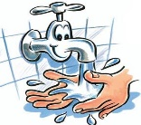
This Photo by Unknown Author is licensed under CC BY-SA
This Photo by Unknown Author is licensed under CC BY-NC
Make a list of 10 dishes you can make with eggs | Watch Ready Steady Cook on BBC 1 and write the ingredients they used | WASH UP and write step by step instructions or take a photo | Make cupcakes ( if ingredients are available) | Write a list of 5 hazards you could find in the kitchen.
Design a chocolate bar or smoothie wrapper and photograph | Cook a meal for your family and photograph | Research and write a fruit or veg from A-Z | Research food from 5 different countries | Watch Junior Bake off (you tube )
Draw pictures of food from plants/animals | Design your ultimate sandwich – draw or make and photograph | Find 5 pieces of equipment and write their use. | Think of 6 different cooking methods and foods you could cook. | Write a list or draw pictures of winter seasonal food (use google)
Evaluate one of your meals at home | Watch Inside the Factory and write some facts you learn | List some of your favourite dishes we have made at school together | Plan a meal taking into account the 5 sections on the Eatwell guide | Watch Secrets of the Supermarket and write what each episode is about.
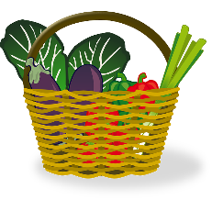
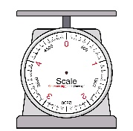
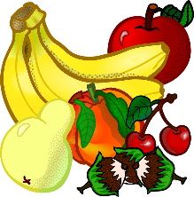
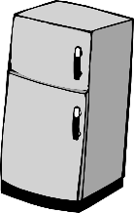
This Photo by Unknown Author is licensed under CC BY-SA

