What did the waiter say?
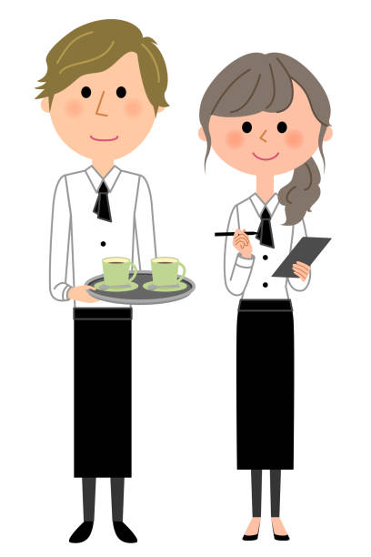
Hospitality is very important , in particular how you speak to your customers . Read the following and decide if it is or isn’t something they would say.
What do you want?
Thank you for your custom please come again.
Are you ready to order?
Alright mate!

Good evening Sir / Madam
Bye
Is your grub good?
Is everything ok with your meal?

