KS3 Food Technology – Home learning.
During this time, we are encouraging students to take part in home learning should they have access to the internet.Alternatively if no internet access your child can keep a food diary for at least a week which support out healthy eating/5 a day work.
This will be revision, quizzes and visual learning ( videos ) that will reinforce the work we have done in previous lessons.
1 – Search – Foodafactoflife 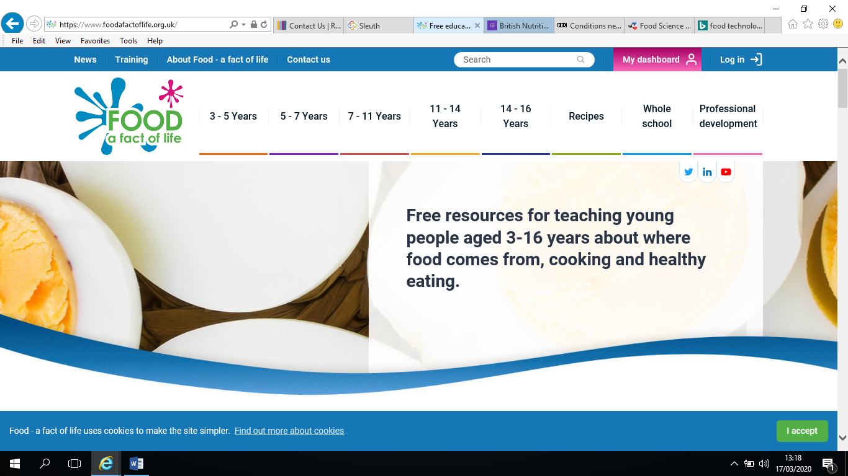
2 – In the search bar enter quiz where you will find an assortment of quizzes on different subjects. 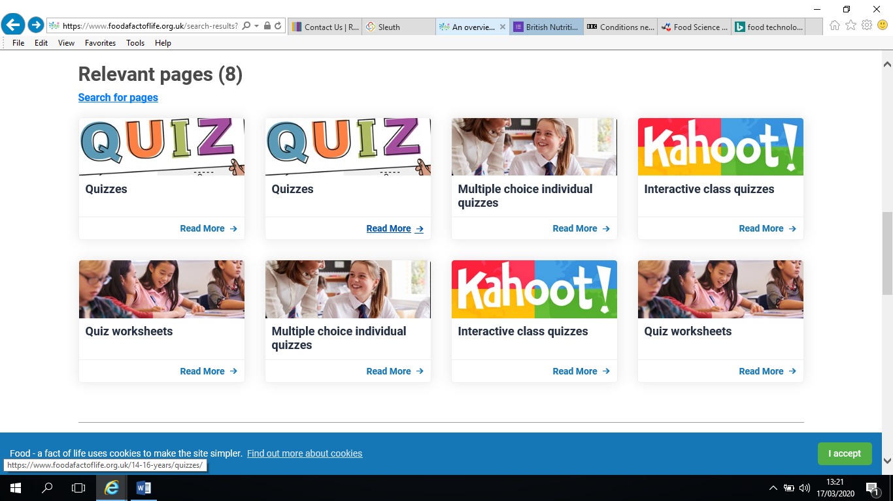

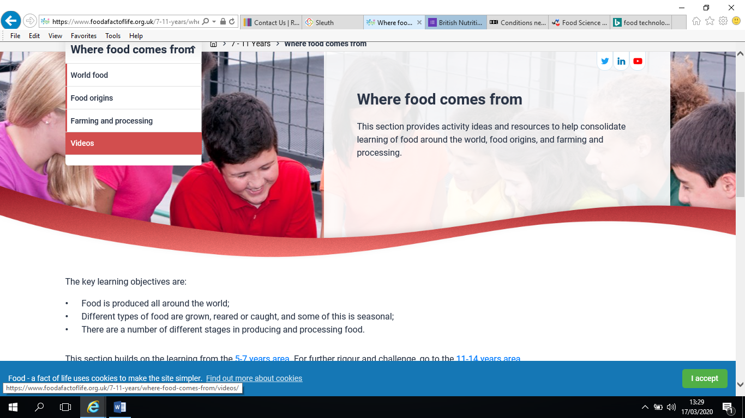
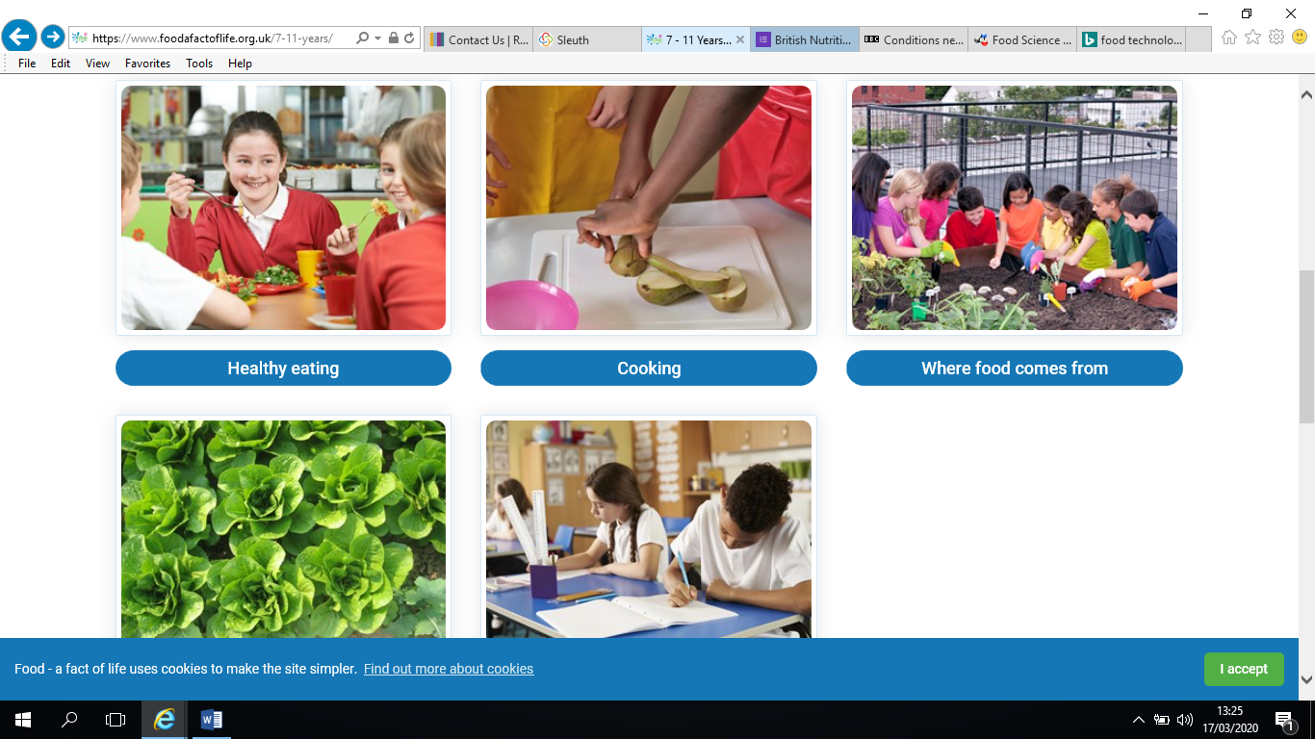
3 – Alernativly you can click on the subheading ‘ 7-11’ where you will find different subjects . Click on ‘ where does food come from ‘ and select ‘ videos’ to watch clips which supports our classroom work.

