**Muscles**

[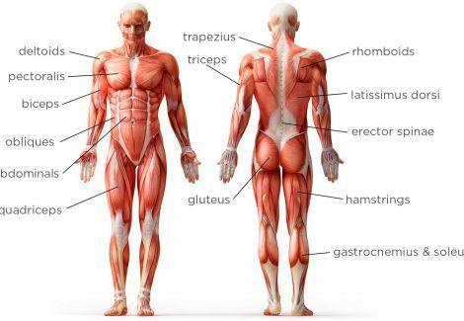](https://www.google.co.uk/url?sa=i&source=images&cd=&ved=2ahUKEwi5xsTvxIXbAhULlxQKHXeKCbEQjRx6BAgBEAU&url=https://www.pinterest.com/pin/481181541417823896/&psig=AOvVaw1D-KMIYfUu1ZoguoaZSEmU&ust=1526398791910705)