# **A blue circle with yellow text and blue text Description automatically generatedA blue circle with yellow text and blue text Description automatically generatedAttendance Matters**

**Parent Newsletter**

**Thursday 5th June 2025**

|  |  |  |  |  |  |  |  |  |  |  |  |  |  |  |  |
| --- | --- | --- | --- | --- | --- | --- | --- | --- | --- | --- | --- | --- | --- | --- | --- |
| Our attendance target for the academic year is **95%.** Look at the graph above to see how your child’s class is performing. The average attendance across the school the week before half-term was **92.1%.** This is below our whole school target and a slight decrease on the previous week.  Authorised absences were: **5.9%**  Unauthorised absences were: **2.0% - This figure is far too high.** All absences **must** be reported to the school office.  It is imperative that all absences from school are reported to the school office. This will help to reduce the percentage of unauthorised absences at the school. Failure to report your child’s absence from school could result in a prosecution from the educational welfare officer.  **School Dinners**  Nect week, we will be on Week 2 of the menu. Please check with your child that they like the menu option before they come to school.    **Sports Days**  Please the times of our sports days below:   |  |  |  | | --- | --- | --- | | Day | AM | PM | | Tuesday 10th June | Nursery (am) 9:15am | Nursery (pm) 13:30pm | | Wednesday 11th June | Reception – 9:15am  Year 1 – 10:45am | Year 2 – 13:30pm | | Thursday 12th June | Year 3/4 – 9:30am | Year 5/6 – 13:30pm | | Friday 13th June | Rising 3s (am) – 9:15am  Infant Hall | Rising 3s (pm) – 14:00pm  Infant Hall |   Please remember, that at all times, no parents are to cross the running track unless directed to do so by a member of staff. Anyone failing to comply with this rule will be asked to leave the track area.  The weather for next week is predicted to be changeable. Whilst I remain hopeful that all of the Sports Days will take place, should there be a need to cancel, we will make a decision as early as possible. However, please be patient as the weather can change quickly and is something that is completely out of our control.  All ice-cream money, £1.50 per pupil, needs to be sent into school by tomorrow, Friday 6th of June.  **SRB Consultation**  The Local Authority are proposing to develop specialist resource base provision for complex needs and autistic spectrum disorder (ASD) across a number of schools in the borough and our school has been identified as a potential option.  The consultation process represents an opportunity for people to learn about the proposal, ask questions and make comments that will be recorded and summarised in a consultation report. This report will be published on the Council’s website and will be considered when Cabinet decides the way forward.  The closing date for response is midnight on 13th July.  You can respond to the proposal by clicking on the link below or by visiting ‘Caerphilly Conversation’ online:  [https://forms.cloud.microsoft/Pages/ResponsePage.aspx?id=vGg9Ws-tLkaRgSm0tCsxTWBxFb8weV9MmP3gx2_HlSdUM0FERzhMQ0JDUDlPTlpWTUhPOEVSWlgzVy4u](https://eur02.safelinks.protection.outlook.com/?url=https%3A%2F%2Fforms.cloud.microsoft%2FPages%2FResponsePage.aspx%3Fid%3DvGg9Ws-tLkaRgSm0tCsxTWBxFb8weV9MmP3gx2_HlSdUM0FERzhMQ0JDUDlPTlpWTUhPOEVSWlgzVy4u&data=05%7C02%7CGeorgeP6%40sch.caerphilly.gov.uk%7Cf2f6e13c7d29418bdc5d08dda3845bb0%7C4f3f0e52b734416494091b601d147993%7C0%7C0%7C638846511044923677%7CUnknown%7CTWFpbGZsb3d8eyJFbXB0eU1hcGkiOnRydWUsIlYiOiIwLjAuMDAwMCIsIlAiOiJXaW4zMiIsIkFOIjoiTWFpbCIsIldUIjoyfQ%3D%3D%7C0%7C%7C%7C&sdata=n%2FkcTfCcjboquc0UfuepCqFGRa2IrMlcz0mhMNc34NM%3D&reserved=0) |

**SRE Lessons**

In the latter weeks of each year, the pupils complete learning surrounding SRE. The scheduling of this at the end of each year was agreed with our parent panel when this was introduced in 2021. The Welsh Government guidance can be found here:

[https://www.gov.wales/sites/default/files/publications/2022-01/curriculum-for-wales-relationships-sexuality-education-code.pdf](https://eur02.safelinks.protection.outlook.com/?url=https%3A%2F%2Fwww.gov.wales%2Fsites%2Fdefault%2Ffiles%2Fpublications%2F2022-01%2Fcurriculum-for-wales-relationships-sexuality-education-code.pdf&data=05%7C02%7CGeorgeP6%40sch.caerphilly.gov.uk%7C2fc16fe4cb534d0c918508dda40aa495%7C4f3f0e52b734416494091b601d147993%7C0%7C0%7C638847087799379525%7CUnknown%7CTWFpbGZsb3d8eyJFbXB0eU1hcGkiOnRydWUsIlYiOiIwLjAuMDAwMCIsIlAiOiJXaW4zMiIsIkFOIjoiTWFpbCIsIldUIjoyfQ%3D%3D%7C0%7C%7C%7C&sdata=RP%2B%2BEuf%2BEAI0CR6jJmJVIsNFxxe%2Fz3eukB6OGFZQCP4%3D&reserved=0)

If you would like to discuss the content or view the resources, please contact the school office.

**Girls Football Teams**

Huge congratulations to the two school football teams who participated in a tournament yesterday at Gaer Primary School in Newport. Both teams were outstanding both on and off the pitch. After some incredible games, both teams met in the final, playing out a 3 – 3 draw. Extra time was planned but the girls agreed it would be a good idea to share the trophy. Well done to everyone involved!

**Holidays**

Please be aware we have made a change to our attendance policy. No holidays will be authorised during the first two weeks in September.

**School Nursing Team**

The school nursing team will be visiting from June 18th – 20th to undertake the vision and growth measurements with reception pupils. Please see the link below for further information:

"The ABUHB School Nursing Team will soon be visiting school to test the vision and measure the growth of children in reception year. This is called the School Entry Review (SER). For more information about the SER and to view our privacy policy please visit: [https://abuhb.nhs.wales/hospitals/childrens-healthcare-services/school-nursing/school-entry-review/](https://eur02.safelinks.protection.outlook.com/?url=https%3A%2F%2Fabuhb.nhs.wales%2Fhospitals%2Fchildrens-healthcare-services%2Fschool-nursing%2Fschool-entry-review%2F&data=05%7C02%7CGeorgeP6%40sch.caerphilly.gov.uk%7Ca37c496765ed403f4d0608dd9394595e%7C4f3f0e52b734416494091b601d147993%7C0%7C0%7C638828987539225159%7CUnknown%7CTWFpbGZsb3d8eyJFbXB0eU1hcGkiOnRydWUsIlYiOiIwLjAuMDAwMCIsIlAiOiJXaW4zMiIsIkFOIjoiTWFpbCIsIldUIjoyfQ%3D%3D%7C0%7C%7C%7C&sdata=OhavLB3NcvqR2tfDaZvHDVdLwJh2PB7p%2Bc6Z0y4muX4%3D&reserved=0)

**Dates**

|  |  |  |
| --- | --- | --- |
| **Event** | **Date** | **Year Group** |
| Sports Day | Tuesday 10th June | Nursery |
| PGL Parent Meeting | Tuesday 10th June | Year 6 |
| Sports Day | Wednesday 11th June | Reception |
| Sports Day | Wednesday 11th June | Year 1 |
| Sports Day | Wednesday 11th June | Year 2 |
| Sports Day | Thursday 12th June | Year 3 / 4 |
| Sports Day | Thursday 12th June | Year 5 / 6 |
| Sports Day | Friday 13th June | Rising 3s |
| Reserve Sports Day | Friday 13th June | Various |
| Class Photographs | Monday 16th June | Nursery – Year 5 |
| PGL Residential | Wednesday 18th – Friday 20th June | Year 6 |
| Transition Day | Tuesday 24th June | Whole School |
| Rainbow Raffle | Friday 27th June | Whole School |
| PTA Summer Fayre | Friday 4th July | Whole School |
| School Reports | Monday 7th July | Whole School |
| Year 6 Leavers’ Assembly | Tuesday 15th July | Year 6 |
| Last Day of Term | Friday 18th July | Whole School |
| **INSET Day** | **Monday 21st July** | **Whole School** |

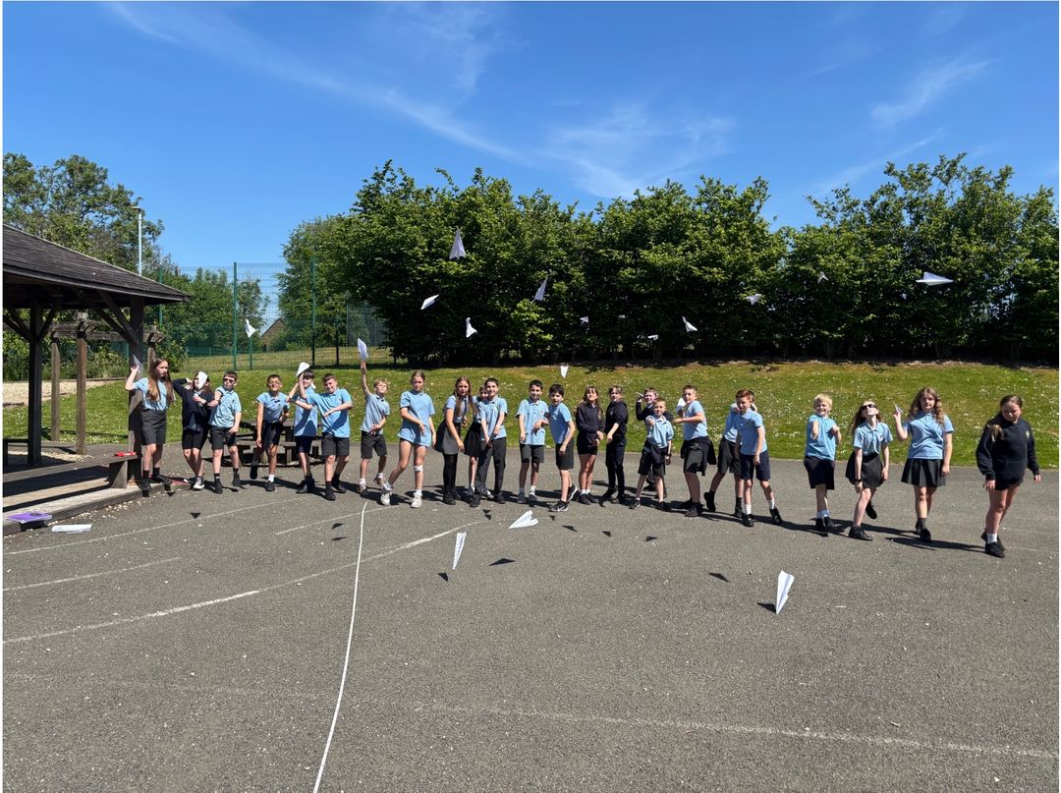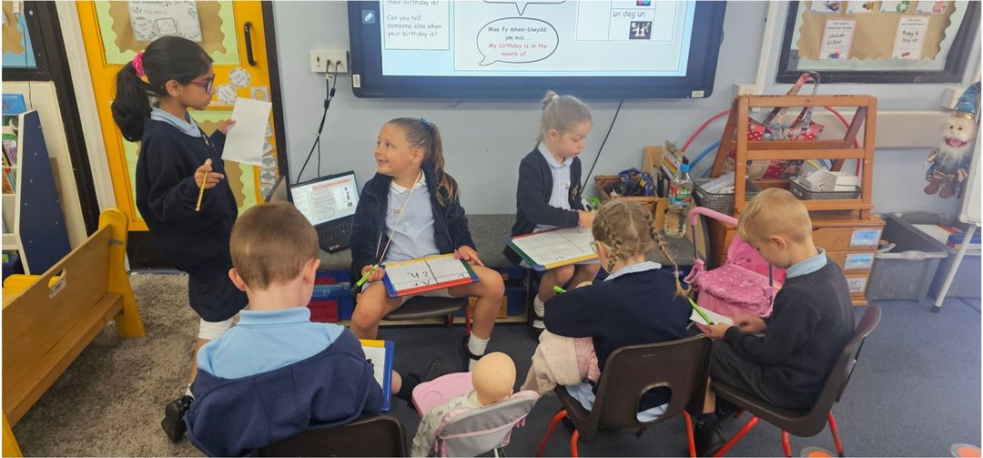

**Parent Newsletter**

|  |  |
| --- | --- |
| **Mr C George**  **Headteacher** | **Mrs S Windsor**  **Chair of Governors** |