
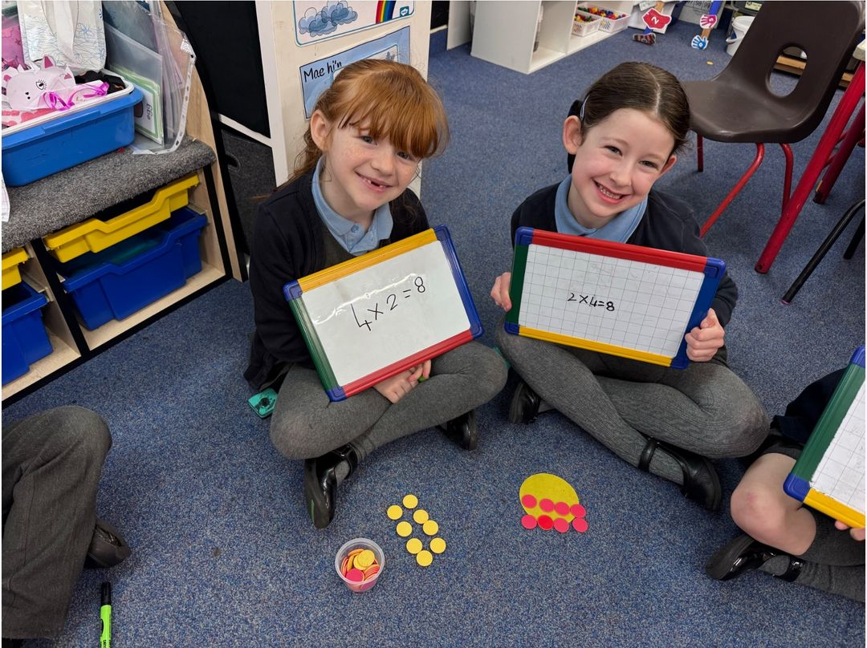
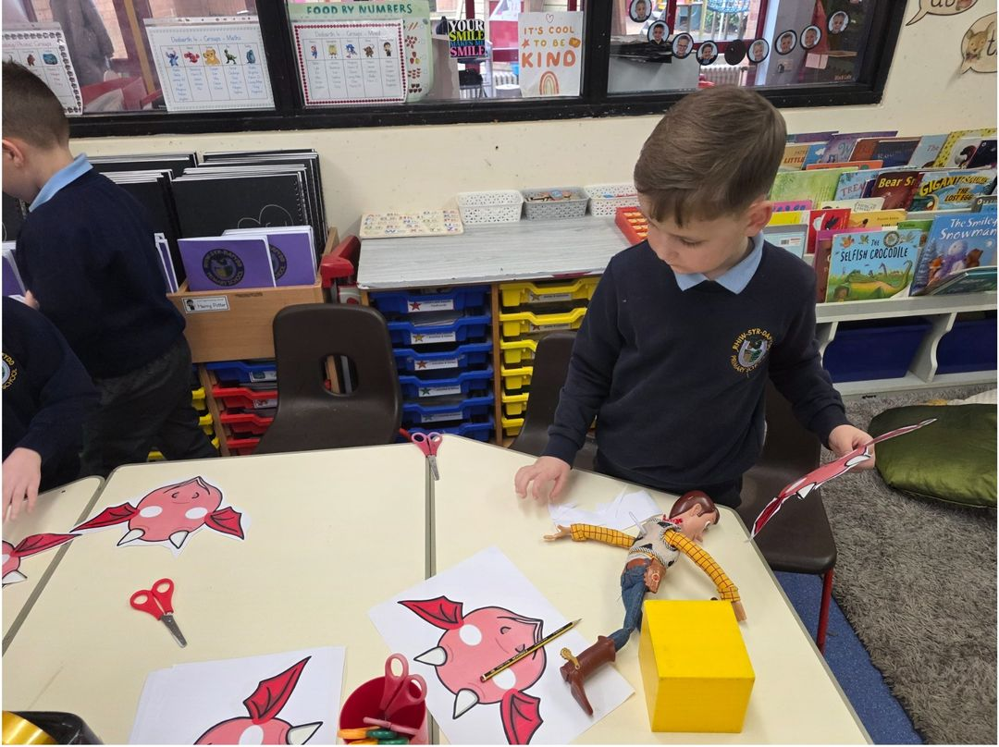


Attendance Matters

Parent Newsletter
  - Friday 27th February 2026

Our attendance target for the academic year is 95%. Look at the graph above to see how your child’s class is performing. The average attendance across the school the week before half term was 94.1%. This is slightly below our whole school target but an increase on the previous week!

Authorised absences were: 4.5%
Unauthorised absences were: 1.5% - All absences must be reported to the school office.

It is imperative that all absences from school are reported to the school office. This will help to reduce the percentage of unauthorised absences at the school. Failure to report your child’s absence from school could result in a prosecution from the educational welfare officer.
School Dinners
Next week, we will be on Week 3 of the menu. Please check with your child that they like the menu option before they come to school. Please see a change to the menu below:

Change of Menu
Please note there will be a change of menu on Monday 2nd March to celebrate St. David’s Day. The menu can be found on the picture opposite.


All Things Welsh!
The Friends of Rhiw Syr Dafydd are holding a special after-school event today (Friday 27th February) to celebrate all things Welsh in honour of St. David’s Day.
There will be a variety of items available to purchase during the event.
Please see the poster for full details.
We look forward to seeing you there and celebrating together!

Break Times
We have noticed an increasing number of children attempting to remain inside the school building during break and lunchtimes.
Please be reminded that, during these times, all children are expected to go outdoors. Children should only remain inside if they have been specifically requested to do so by a member of staff.
If a child needs to stay indoors during break or lunchtime for any reason, this must be supported by either:
- A completed risk assessment arranged with the school, or
- A letter from parents/carers explaining the reason for this request.
This procedure is in place to ensure the safety, wellbeing, and appropriate supervision of all pupils.
We appreciate your support in reinforcing this expectation with your child.
Dates
Event | Date | Year Group
School Eisteddfod Week | 23rd - 27th February | Whole School
Mother’s Day Stall (PTA) | Monday 9th March | Whole School
Parent Teacher Consultations | Tuesday 24th March | Whole School
Parent Teacher Consultations | Thursday 26th March | Whole School
Easter Holidays | Monday 30th March – Friday 10th April | Whole School
INSET Day | Friday 1st May | Whole School
Bank Holiday | Monday 4th May | Whole School
INSET Day | Friday 22nd May | Whole School
Half-Term | Monday 25th – Friday 29th May | Whole School
Summer Disco | Thursday 4th June | Year 1 – Year 6
Sports Day | Tuesday 9th June | Nursery
Sports Day | Wednesday 10th June | Reception
Sports Day | Wednesday 10th June | Year 1
Sports Day | Wednesday 10th June | Year 2
Sports Day | Thursday 11th June | Rising 3s
Sports Day | Thursday 11th June | Year 3
Sports Day | Thursday 11th June | Year 4
Sports Day | Friday 12th June | Year 5
Sports Day | Friday 12th June | Year 6
Father’s Day Stall (PTA) | Monday 15th June | Whole School
Rainbow Raffle (PTA) | Friday 26th June | Whole School
Summer Fayre (PTA) | Friday 10th July | Whole School
Leavers’ Assembly | Tuesday 14th July | Year 6
INSET Day | Monday 20th July | Whole School



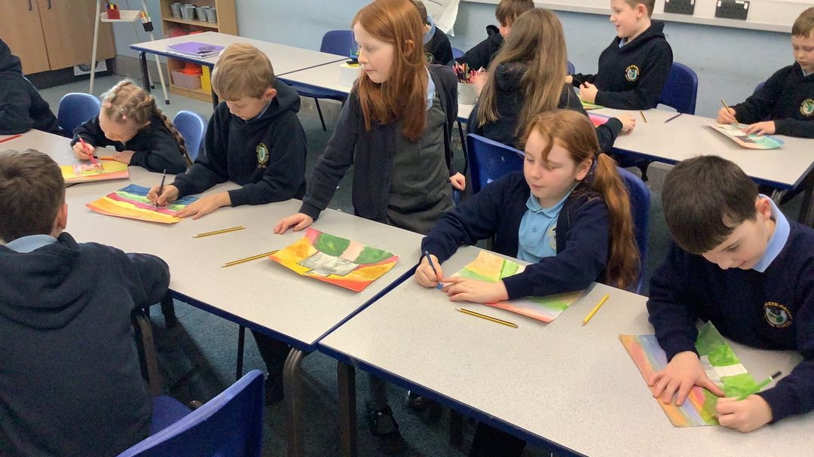

Parent Newsletter
- Mr C George  - Headteacher | - Mrs S Windsor  - Chair of Governors

