Class 5: Autumn Term 1 2020-21
Welcome Back!
Welcome back Class 5! It is so good to have you all back in school. This academic year will be full of exciting new challenges and I hope you are looking forward to it.
Mr Davies

Class 5 | Key Information
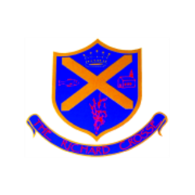  Uniform | Remember that a blazer is a compulsory part of the uniform and that your child should wear this at all times unless given permission otherwise. Please make sure all uniform is clearly labelled to avoid any loss. Bring a coat to school as well as your blazers.  For further information, please follow the link below.  https://www.richardcrosse.staffs.sch.uk/parents/uniform
Reading Diaries | Please ensure that your child’s reading diary is in school every day, as we aim to try and listen to them read, in school, at least once a week. The children are encouraged to read at least five times a week at home and will need their diary signing by an adult to let us know how they are getting on. The children are responsible for changing their own books, when necessary, but this will be checked on a regular basis. Please note that your child does not have to read a whole book a night, it is acceptable to read just a few pages, especially as the books get trickier. Every time you child reads, they will receive 1 dojo. If they read 5 times in a week, they will be entered into a competition – 5 times reader – with the possibility of winning a book of their choice.
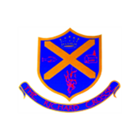  Spellings | Your child will be expected to learn 10 spellings at home each week. Please help your child to learn them. Spelling tests will take place on a Tuesday.  Spellings are both on the school website under the Class 5 Spellings tab and on Google Classroom.
PE Kit | Your child needs to bring a PE kit into school which is clearly labelled with their name. This must remain in school and will be returned at the end of each half term.  During the colder months, your child will need a tracksuit top and bottoms.  For further information, please follow the link below.  https://www.richardcrosse.staffs.sch.uk/parents/uniform
Homework | Homework will be set every Thursday and will need to be completed by Wednesday. Each week, homework will alternate between English and Mathematics. To avoid children taking worksheets home, we will be setting homework on Google Classroom. Your child has already been given an email address and password which will allow them access to complete their homework online.  From time to time,  If your child is in Year 6, they may receive additional work to support their learning.
Weekly blog | A weekly blog will be uploaded to our school website - https://www.richardcrosse.staffs.sch.uk/ - with pictures and a summary of the activities your child has participated in each week.  To find this blog please visit the above web address; click on the ‘Children’ tab located at the top of the page; select ‘Class 5’ from the drop down menu; and choose ‘Class 5 blog’.

