Class 1: Autumn Term 1 2019-20

Welcome Back!
Welcome to Class 1! We hope you have had a lovely summer break and are well and truly rested. A big welcome to our new Foundation Stage children and their families who are settling in really well. We are looking forward to a wonderful year in class 1 filled with lots of fun learning.

Class 1 | Key Information
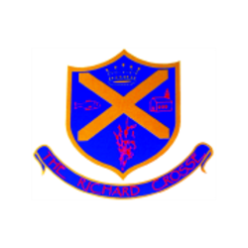  Uniform | Please make sure that your child has a waterproof coat, (which is named), on all but very warm days as it can be cold outside and the children in Class 1 go outside whatever the weather. Children will also need a pair of wellingtons, marked clearly with your child’s name, as they will be taking part in outdoor learning sessions.  For further information, please follow the link below.  https://www.richardcrosse.staffs.sch.uk/parents/uniform
PE kit | Your child’s PE kit will need to be in school every day, as we may need to change days at the last minute due to weather etc. Please ensure that all items are clearly labelled with their name. We will send kits home at the end of each half term so that they can be washed.  During the colder months, your child will need a tracksuit top and bottoms.  For further information, please follow the link below.  https://www.richardcrosse.staffs.sch.uk/parents/uniform
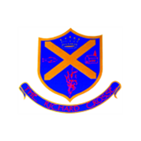  Phonics Reading | All reception children will receive a phonics sound book which is updated fortnightly with the new sounds that the children have learnt in phonics. It would be lovely if you could practise these sounds with your child.  Over the next few weeks, the children will be issued with a reading book. To start with, these books may be picture books but as your child’s confidence grows with their phonics, they will move onto books with words. All children progress at different speeds, so don’t panic if your child isn’t first!!
Curriculum | In the foundation stage, your child will be taught using a combination of independent activities and teacher-led activities. These activities will be designed to promote all of the seven areas of learning to ensure your child has a well-rounded education.  We start this half term with the topic, ‘Marvellous Me!’  Please see our curriculum overview for more information.
Homework | Please remember homework is optional in Early Years however, if your child wishes to complete our homework challenges that would be great.  Each half term your child will receive a homework challenge sheet with suggested activities relating to our current topic in class. The children can select one challenge a week to complete and bring in on Fridays to share with the class.  Please see our homework challenge sheet for more information.
Snack | We have snack time twice a day. During this time, we can have a drink of milk or water and a choice of fruit which is provided by the school. To enable us to provide additional snack options and purchase ingredients for regular cookery sessions with the children we ask parents for a contribution of £1.00 per week. Thank you.

