Class 1: Autumn Term 1 2021-22

Welcome Back!
Miss John and the team wish you all a warm welcome to Class 1! We hope you have had a lovely, restful summer break and are as excited for the year ahead as we all are! Welcome to all of our children and families who are new to Richard Crosse. We are looking forward to a wonderful year in Early Years Foundation stage full of laugher, smiles and lots of fun learning opportunities.

Class 1 | Key Information
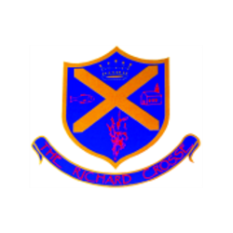  Uniform | Please make sure that your child has a waterproof coat, (which is named), on all but very warm days.  It can be quite cold outside and the children in Class 1 go outside, whatever the weather. During the warmer months of the year, children are encouraged to bring sun hats into school.  Your child will also need a pair of wellingtons, and protective clothing for our outdoor learning sessions. Please check our class blog for more information about the children will need these items in school. All items of clothing brought into school need to be marked clearly with your child’s name.  For further information, please follow the link below.  https://www.richardcrosse.staffs.sch.uk/parents/uniform
PE kit | Your child’s PE kit will need to be in school every day, as we may need to change days at the last minute due to weather etc. Please ensure that all items are clearly labelled with their name. We will send kits home at the end of each half term so that they can be washed.  During the colder months, your child will need a tracksuit top and bottoms. We will again notify you before we begin our P.E, sessions. Our first few P.E. sessions involve becoming familiar with the rules and routines of the lessons. After this, we will start to change for P.E.  For further information, please follow the link below.  https://www.richardcrosse.staffs.sch.uk/parents/uniform
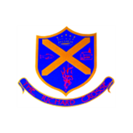  Phonics Reading | As we move further into the Autumn term, our Reception children will begin their monster phonics sessions. To support their learning in school, we will send home some monster phonics sound ‘flash cards’, for you to practice at home.  Before the end of the first half term, our Reception children will be given a school reading book. To start with, these books may be picture books but as your child’s confidence grows with their phonics, they will move onto books with words. All children progress at different speeds, so don’t panic if your child isn’t the first to receive a word book! The school reading scheme books are linked to our ‘Monster’ phonics scheme. Some of the words in the book will be coloured. This is to help the children recognise and read certain sounds.
Curriculum | In the foundation stage, your child will be taught using a combination of independent activities and teacher-led activities. These activities will be designed to promote all of the seven areas of learning to ensure your child has a well-rounded education.  We start this half term with the topic, ‘All About Me!’  Please see our curriculum overview for more information.
Homework | Please remember homework is optional in Early Years. From time to time your child may be sent home with a challenge to complete. More information about these tasks will be available on our weekly Class 1 blog.  Our Reception children will be issued with a school reading book on a weekly basis. Spending just 5 minutes every night reading with your children will help them to become more confident readers. Please write a comment or signature in your child’s reading diaries when you hear them read.
Snack | We have snack time twice a day. During this time, we can have a drink of milk or water and a choice of fruit which is provided by the school. To enable us to provide additional snack options and purchase ingredients for regular cookery sessions with the children we ask parents for a contribution of £1.00 per week. Thank you.

