Class 2: Autumn Term 2021-2022

Welcome Back!
Welcome to Class 2! Everyone at Richard Crosse would like to offer a warm welcome back to both yourself and your child. We hope you have had a lovely summer break and are well and truly rested. This term, your child can look forward to many exciting activities and experiences, to enhance their learning and love of school.

Class 2 | Key Information
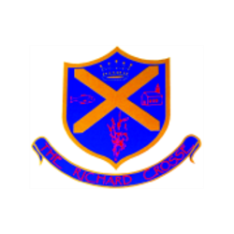  Uniform | School uniform in KS1 is the same as Foundation Stage, other than the children will now be required to wear a tie. Please ensure that your child has their tie on every morning. It would also be helpful if you could ensure that all of your child’s uniform is clearly labelled with their name. This makes it easier to return any lost items.  For further information, please follow the link below.  https://www.richardcrosse.staffs.sch.uk/parents/uniform
Reading Diaries | Please ensure that your child’s reading diary is in school every day, as we aim to try and listen to them read, in school, at least once a week. The children are encouraged to read at least five times a week at home and will need their diary signing by an adult to let us know how they are getting on. The children are responsible for changing their own books, when necessary, but this will be checked on a regular basis. Please note that your child does not have to read a whole book a night, it is acceptable to read just a few pages, especially as the books get trickier. Every time you child reads, they will receive 1 dojo. If they read 5 times in a week, they will be entered into a competition – 5 times reader – with the possibility of winning a book of their choice!
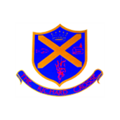  Spellings  Word tins | Year 1 children will be given 5 words to learn each week appropriate to what they have been learning in phonics from October half term. Year 2 will have 10 words to learn each week. We would love it if you could help your child to practise writing and reading these words. Spelling tests will take place on a Friday. New spellings will be put on Google Classroom each week  The children will be bringing home a word tin containing 5 common exception words appropriate to their year group, if you could help them to become confident with them it would be great! This doesn’t have to be done in a formal way, you could write/ say as many words that you can think of with that sound, in a minute and then challenge the children to beat your score.
PE Kit | We ask that on the days the children are doing PE, they come to school dressed in their PE kits rather than school uniform. Class 2’s PE lessons will be on a Thursday and Friday afternoon.  During the colder months, your child will need a tracksuit top and bottoms.  For further information, please follow the link below.  https://www.richardcrosse.staffs.sch.uk/parents/uniform
Homework  Times Tables | Homework will be sent home every Friday and will need to be handed in on a Wednesday. There will be English and maths activities set based upon what we have been doing in class. All activities will be put on Google classroom for you to access.  If your child is in Year 2, they may receive additional work to support their learning.  Year 1: We will be focusing upon counting forwards and backwards confidently.  Year 2: We will be learning the 5 times table, which will be tested weekly.

