Class 2

Welcome to Class 2!
Welcome to Class 2! Everyone at Richard Crosse would like to offer a warm welcome back to both yourself and your child. We hope you have had a lovely summer break and are well and truly rested. This year, your child can look forward to many exciting activities and experiences, to enhance their learning and love of school. Miss Derry is the class teacher, supported by Mrs Rich in the morning and Mrs Cox in an afternoon.
Class 2 | Key Information
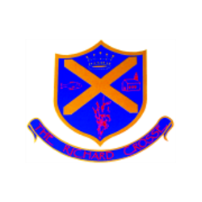  Uniform | School uniform in KS1 is the same as Foundation Stage, other than the children will now be required to wear a tie. Please ensure that your child has their tie on every morning. It would also be helpful if you could ensure that all of your child’s uniform is clearly labelled with their name. This makes it easier to return any lost items.  For further information, please follow the link below.  https://www.richardcrosse.staffs.sch.uk/parents/uniform
Reading Diaries | Please ensure that your child’s reading diary and book is in school every day, as we aim to try and listen to them read, in school, at least once a week. The children are encouraged to read at least five times a week at home and will need their diary signing by an adult to let us know how they are getting on. The children are responsible for changing their own books, when necessary, but this will be checked on a regular basis. Please note that your child does not have to read a whole book a night, it is acceptable to read just a few pages, especially as the books get trickier. Every time you child reads, they will receive 1 dojo. If they read 5 times in a week, they will be entered into a competition – 5 times reader – with the possibility of winning a book of their choice!
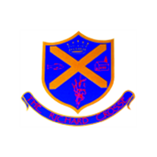  Spellings | The children will be given 10 common exception words to learn each week appropriate to their year group and what we have been learning about in phonics. I will send out the spellings to be learnt via Class Dojo. We would love it if you could help your child to practise writing and reading these words. Spelling tests will take place on a Friday.
PE Kit | Your child’s PE kit will need to be in school every day, as we may need to change days at the last minute due to weather etc. Please ensure that all items are clearly labelled with their name. We will send kits home each Friday so that they can be washed.  During the colder months, your child will need a tracksuit, top and bottoms.  For further information, please follow the link below.  https://www.richardcrosse.staffs.sch.uk/parents/uniform
Homework  Times Tables  Education City | Homework will be sent out every Friday via Google Classroom, the children should receive an e-mail to say that they have been set an assignment each week. The task will need to be completed for the following Wednesday.  If your child is in Year 2, they may receive additional work to support their learning.  Year 1: We will be learning our number bonds to 10. We will practise these in school on a Friday.  Year 2: We will be learning 5 times table, which will be tested on a Friday.  Children will be set activities to complete on Education City each week. They should have their login details stuck in the front of their reading diaries.
Class blog | Each week, if you log onto the school website (click on the link below)  https://www.richardcrosse.staffs.sch.uk/blog/category/class-2  you will find a summary of what your child has been learning in school that week. This may be accompanied by photographs, where appropriate. Please log on to enjoy reading about your child’s learning experiences.

