

# The Richard Crosse Christmas Fayre

**Human fruit machine**

**Santa’s Grotto £3.50 in**

**Knock Santa off the chimney, Santa race game**

**Hook a Bauble, Xmas Pairs**

**Knock Santa off the chimney, Santa race game**

**Hook A Bauble**

**Tombola,**

**Refreshments**

**Guess the Elf’s name, Pick your nose!**

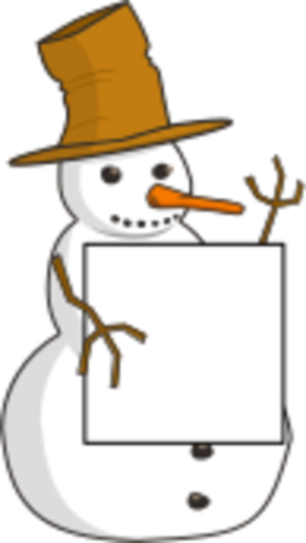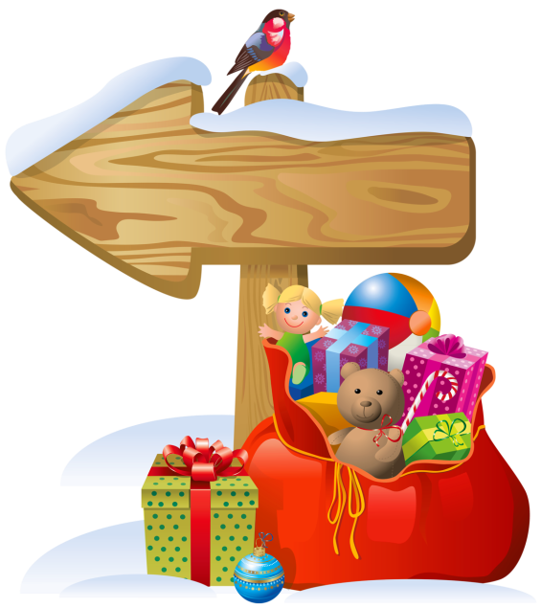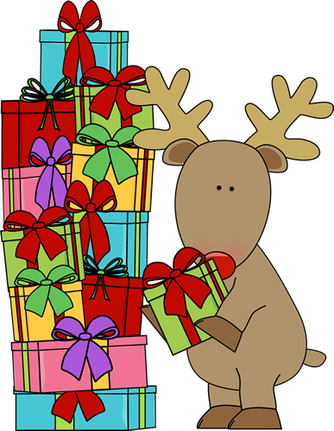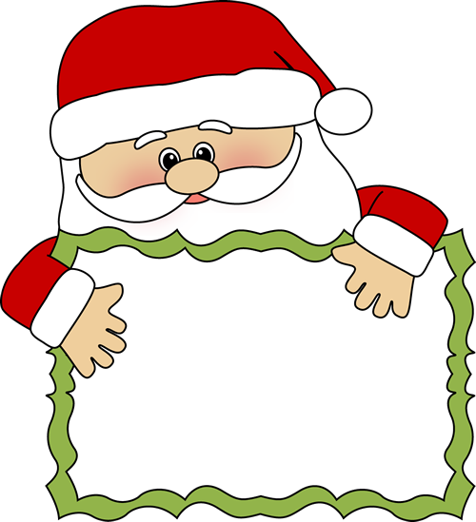

**We have a**

**number of**

**external stalls**

**selling handmade items such as hair bows, Xmas eve boxes, knitted goods, plus a teddy tombola, bath bombs, candles, body shop and temple spa beauty**

**Raffle, Parent gifts, Candy Cones**

**Lob a choc!**

***Raffle prizes: Festive Hamper, David Lloyd passes and many more***

**Friday 29th November**

**2:30pm - 4:30pm**

**Child Only Zone!**

**Come visit and buy your parent a gift for Christmas, gift wrapped by the PTA. Items for mum and dad from £2 to £4.50**

***Book your Grotto appointments online to avoid disappointment! (Details on how to book will be communicated via the school)***

**Children’s Christmas Crafts**

**Lob a Choc**

**pick your nose**