Key Stage  KS1 | ENGLISH | GEOG | HIST | RE | DT | ART | PE | PSHE | COMPUTING | SCIENCE | Trips
AUTUMN 1  22-23  7 WEEKS | Instructions  Traditional Tales:  Little Red Riding Hood  Traditional Nursery Rhymes | Our World  Plan Bee |  | What do Christians believe God is like? |  | Printing  Plan here  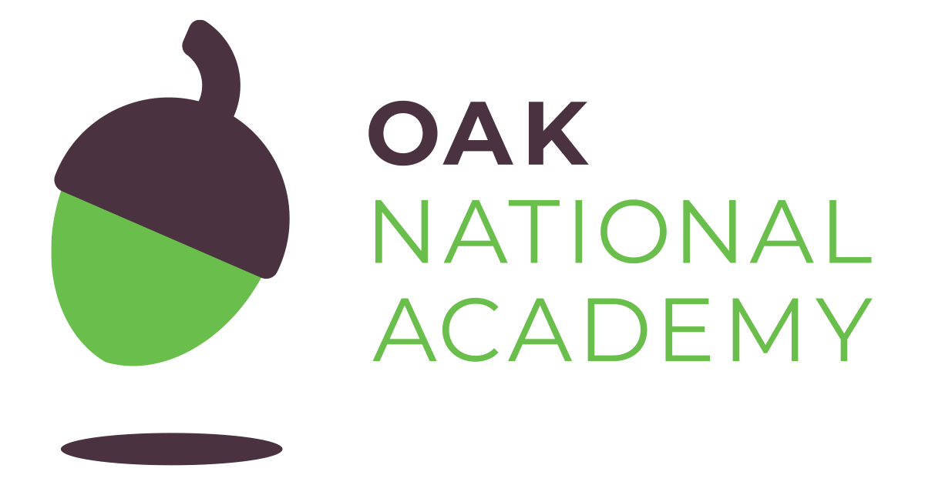 | Health related exercise  here  Handball | Being Mindful  Being Mindful  Votes for Schools  First Aid and CPR  First Aid and CPR  Votes for Schools  Bonus lesson - What is Friendship? | Computing systems and networks  Year 2 planning to be used but Year 1 if class needs. | Living things and their habitats  CPD opportunity for this unit  Here
AUTUMN 2  7 WEEKS | Our Trip to the Woods-recount- travel journals  Billy & the Beast  The Snowman  The lonely Christmas |  | Local History | What are festivals and why do we have them? | Textiles - Christmas decorations  Plan Bee |  | Improve agility  Improve balance |  |  |  | Village walks - His  SCHOOL PLAY
SPRING 1  7 WEEKS | The Way Back Home  Astro Girl/Man on the Moon-recount/  fact files  Alliteration poems | Weather Patterns |  | What do Muslims believe? |  | Clay | Gymnastics  Dance |  | Digital photography Year 2 | Animals including humans - food chains  CPD opportunity Here
SPRING 2  6 WEEKS | Nibbles the Book Monster  The Day the Crayons Quit-postcards/  Letters  The Sound Collector |  | Moon Landing  Black history lesson. Hidden figures | Salvation | Mechanics - Vehicles  Plan Bee |  | Invictus  orienteering |  |  | Animals including humans - basic needs, diet and exercise | National Space Centre – English/His
SUMMER 1  5 WEEKS | Lila and the secret of rain & Tales from Africa  Big Cats-non-chronological report  The Ugly Five | Safari  Plan Bee |  | How do Christians talk to God? |  | Colour  Plan Bee | Athletics  Improve throwing |  | Making Music  Year 2 planning to be used but Year 1 if class needs. | Seasonal changes  CPD opportunity Here | Twycross Zoo – English/Geog  KEY STAGE 1 SATS  PHONICS SCREENING
SUMMER 2  7 WEEKS | Tales of Peter Rabbit Beatrix Potter  Bold Women in Black History-  biography- Mary Seacole  The Owl & the Pussy Cat |  | Florence Nighingtale  Plan Bee | How do I make a difference in the world? | Picnic |  | Improving catching  Striking and fielding |  |  | Working Scientifically investigations and application  CPD opportunity Here | Schools come together to make and eat picnics - DT

