Class 4: Welcome letter 2021-22
Welcome Back!
Welcome back Class 4! I hope that you are all looking forward to the year ahead. This year will be full of exciting challenges, learning and lots of opportunities for fun.
Mrs Gully

Class 4 | Key Information
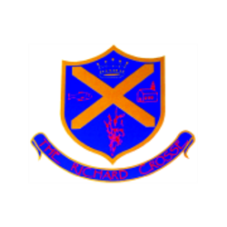  Uniform | Remember that a blazer is a compulsory part of the uniform and that your child should wear this at all times unless given permission otherwise. Please make sure all uniform is clearly labelled to avoid any loss. Bring a coat to school as well as your blazers.  For further information, please follow the link below.  https://www.richardcrosse.staffs.sch.uk/parents/uniform
Reading Diaries | Please ensure that your child’s reading diary is in school every day, as we aim to try and listen to them read, in school, at least once a week. The children are encouraged to read at least five times a week at home and will need their diary signing by an adult to let us know how they are getting on. The children are responsible for changing their own books, when necessary, but this will be checked on a regular basis. Please note that your child does not have to read a whole book a night, it is acceptable to read just a few pages, especially as the books get trickier. Every time you child reads, they will receive 1 dojo. If they read 5 times in a week and their diary is signed by an adult, they will be entered into a competition – 5 times reader – with the possibility of winning a book of their choice.
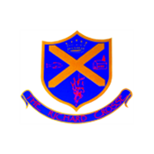  Spellings | Your child will be expected to learn 10 spellings at home each week. Please help your child to learn them. Spelling tests will take place on a Thursday.  Spellings are on Google Classroom and can be practiced through SpellingShed https://www.spellingshed.com/en-gb/
PE Kit | We ask that on the days that pupils are doing PE, they come to school in their PE kits instead of their school uniform. Class 4 will be doing PE on a Tuesday and a Friday.  PE kit should consist of a plain white T-shirt, black shorts, black jogging trousers, a black sweatshirt and trainers.  For further information, please follow the link below.  https://www.richardcrosse.staffs.sch.uk/parents/uniform
Homework | Homework will be set every Friday and will need to be completed by Wednesday. Each week, homework will alternate between English and Mathematics. The majority of pupils’ homework will be set on Google Classroom. Your child has already been given an email address and password which will allow them access to complete their homework online.
Weekly blog | A weekly blog will be uploaded to our school website - https://www.richardcrosse.staffs.sch.uk/ - with pictures and a summary of the activities your child has participated in each week.  To find this blog, please visit the above web address; click on the ‘Children’ tab located at the top of the page; select ‘Class 4’ from the drop down menu; and choose ‘Class 4 blog’.

