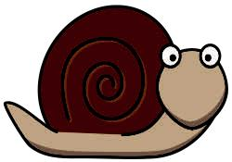
The snail wants to see more of the world.

Imagine you are the Snail in the story and you could choose a place to visit with the Whale. Where would you go? Draw a picture of where you would go next.

Draw and write about 4 different things the snail sees on her new travels.
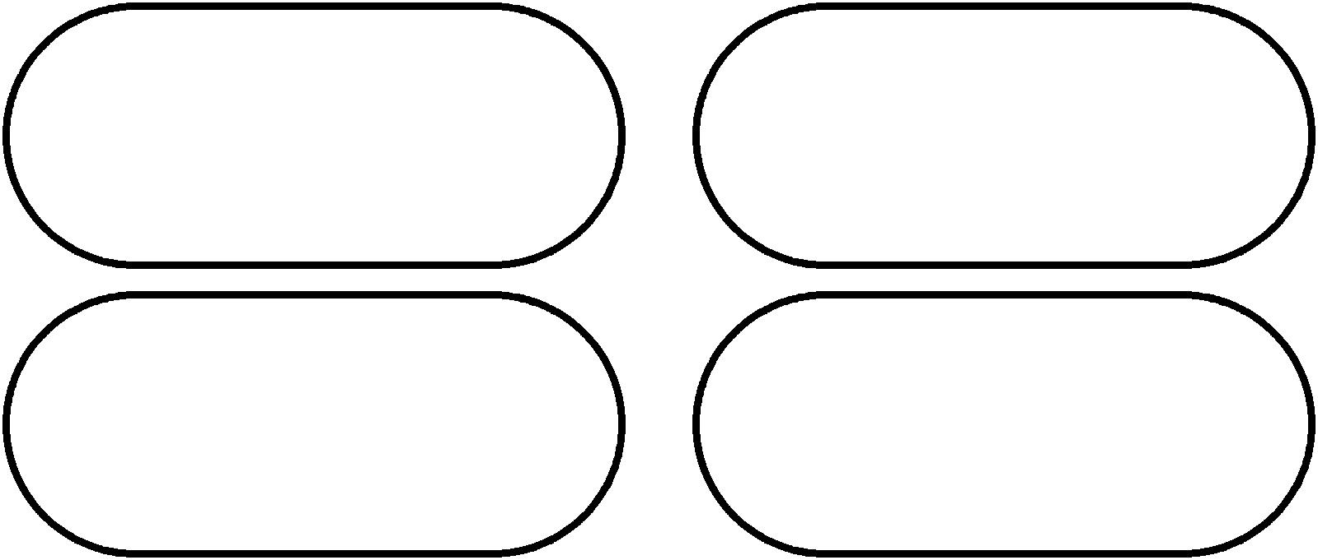

What is the snail like?
Look at the pictures and the words in the book. Can you find words to
describe the snail?
