Class 2 2023/2024
Welcome Back!
Welcome back Class 2! I hope you are feeling excited about the new academic year.
This year will be full of lots of opportunities to learn and have fun.
Miss Derry is your class teacher supported by Mrs Partingotn and Miss Fullwood.

Class 2 | Key Information
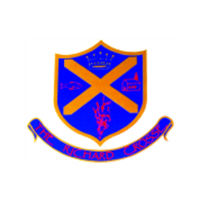  Uniform | Remember that ties are a compulsory part of the uniform and that your child should wear them at all times unless given permission otherwise. Please make sure all uniform is clearly labelled to avoid any loss. Please ensure that your child always has a waterproof coat in school.  For further information, please follow the link below.  https://www.richardcrosse.staffs.sch.uk/parents/uniform
Water bottles | We strongly recommend your child brings in a water bottle which is clearly labelled with their name. Water bottles will be kept in the classroom and need to be taken home each evening to be refilled. Staying hydrated will raise the children’s alertness and focus.
Reading Diaries | Please ensure that your child’s reading diary and book is in school every day, as we aim to try and listen to them read, in school, at least once a week. The children are encouraged to read at least five times a week at home and will need their diary signing by an adult to let us know how they are getting on. Please note that your child does not have to read a whole book a night, it is acceptable to read just a few pages, especially as the books get longer. Every time your child reads, they will receive 1 dojo. If they read 5 times in a week, they will be entered into a competition – 5 times reader – with the possibility of winning a book of their choice!
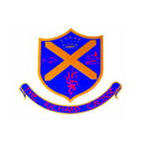  Spellings | The children will be given 10 words to learn each week appropriate to their year group and what we have been learning about in phonics. I will send out the spellings to be learnt via Google Classroom. The children will also have Monster Phonics Spelling books with the words in too. These will need to be in school everyday. We would love it if you could help your child to practise writing and reading these words. Spelling tests will take place on a Friday.
PE Kit | The children will need to come to school in their PE kits on a Wednesday and Friday. Please ensure that they are wearing the correct school kit.  During the colder months, your child will need a tracksuit, top and bottoms.  For further information, please follow the link below.  https://www.richardcrosse.staffs.sch.uk/parents/uniform
Homework | The children will be expected to learn their spellings and read at home.
Class Blog | Each week, if you log onto the school website (click on the link below) you will find a summary of what your child has been learning in school. This may be accompanied by photographs, where appropriate. Please log on to enjoy reading about your child’s learning experiences.  https://www.richardcrosse.staffs.sch.uk/blog/category/class-2

