Class 3: Autumn Term 1 2020-21
Welcome Back!
Welcome back Class 4! I hope you are feeling excited about the new academic year.
This year will be full of lots of opportunities to learn and have fun.
Miss Hylton is your class teacher supported by Mrs Cox and Mrs Mycock in the mornings.

Class 3 | Key Information
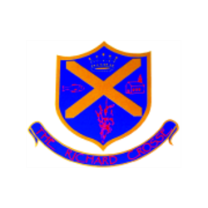  Uniform | Remember that a blazer and tie are compulsory parts of the uniform and that your child should wear them at all times unless given permission otherwise. Please make sure all uniform is clearly labelled to avoid any loss. Bring a coat to school as well as your blazers.  For further information, please follow the link below.  https://www.richardcrosse.staffs.sch.uk/parents/uniform
Water bottles | It is compulsory for your child to bring in a water bottle which is labelled clearly with their name. Water bottles will be kept in the classroom for easy usage. Please ensure your child has a water bottle as it will raise their alertness and focus.
Reading Diaries | Please aim to read 5 times a week. Diaries to be in school every day. Books will be changed when completed and checked on a regular basis. Your child is encouraged to fill in their own diaries on their own in school and a parent signature is require for reading at home. If your child reads 5 times a week, they will receive 1 dojo and will be entered into a weekly competition - 5 times reader – with a possibility of winning a book of their choice.
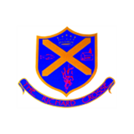  Spellings | Your child will be expected to learn 5 spellings at home each week whilst being taught 5 in school. Please help your child to learn them. Spelling tests will take place on a Thursday. You will find the spellings on your child’s class page on our school website and also the Google Classroom homepage. Your child has already been given an email address and password which will allow them access to see their spellings. Click on the link below to find them.  https://www.richardcrosse.staffs.sch.uk/children/class-3/class-3-spellings
PE Kit | Swimming lessons will not take place until advised that it is safe to do so. Your child needs to bring a PE kit into school which is clearly labelled with their name. This must remain in school and will be returned at the end of each half term.  During the colder months, your child will need a tracksuit top and bottoms.  https://www.richardcrosse.staffs.sch.uk/parents/uniform
Homework | Homework will be set every Thursday and will need to be completed by Wednesday. Each week, homework will alternate between English and Mathematics. To avoid children taking worksheets home, we will be setting homework on Education City.
Class Blog | Each week, if you log onto the school website (click on the link below) you will find a summary of what your child has been learning in school that week. This may be accompanied by photographs, where appropriate. Please log on to enjoy reading about your child’s learning experiences.  https://www.richardcrosse.staffs.sch.uk/blog/category/class-3

