Class 3 2023-24
Welcome Back!
Welcome back Class 3! I hope you are feeling excited about the new academic year.
This year will be full of lots of opportunities to learn and have fun.
Miss Hylton is your class teacher supported by Mrs Cox and Mrs Compton.

Class 3 | Key Information
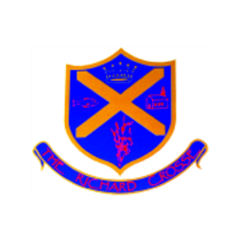  Uniform | Remember that a blazer and tie are compulsory parts of the uniform and that your child should wear them at all times unless given permission otherwise. Please make sure all uniform is clearly labelled to avoid any loss. Please ensure that your child always has a waterproof coat in school as well as their blazers.  For further information, please follow the link below.  https://www.richardcrosse.staffs.sch.uk/parents/uniform
Water bottles | We strongly recommend your child brings in a water bottle which is clearly labelled with their name. Water bottles will be kept in the classroom and need to be taken home each evening to be refilled.  Staying hydrated will raise the children’s alertness and focus.
Reading Diaries | The children are encouraged to read at least five times a week at home and will need their diary signed by an adult to let us know how they are getting on. Your child is encouraged to fill in their own diary and a parent signature is required for reading at home. If your child reads 5 times a week, they will receive 1 dojo and will be entered into a weekly competition - 5 times reader – with the possibility of winning a book of their choice. Note that your child does not have to read a whole book a night, it is acceptable to read just a few pages, especially as the books get trickier.
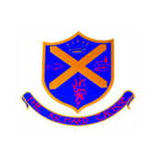  Spellings | Your child will learn 10 weekly spellings at school. Please support them in learning these. Spelling tests will take place on a Thursday. You will find the spellings on your child’s Google Classroom homepage. Also, please use Spelling Shed to practise your weekly spellings. Please click on the link below to log into Spelling Shed.  https://www.edshed.com/en-gb/login
PE Kit | Class 3’s PE days are Wednesday and Friday. On PE days, we ask children to come to school wearing their PE kit.This should consist of a plain white t-shirt, plain back shorts, plain jogging trousers, black sweatshirt and trainers.  https://www.richardcrosse.staffs.sch.uk/parents/uniform
Homework | Your children will be expected to learn their spellings, read at home and learn their timetables.  Each week there will be a specific times table which the children need to learn. Please use Times Tables Rock Stars (TTRS) to learn these. Please click on the link below to log into TTRS.  https://play.ttrockstars.com/
Class Blog | Each week, if you log onto the school website (click on the link below) you will find a summary of what your child has been learning in school. This may be accompanied by photographs, where appropriate. Please log on to enjoy reading about your child’s learning experiences.  https://www.richardcrosse.staffs.sch.uk/blog/category/class-3

