2. Include some dairy
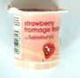 | 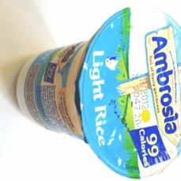 | 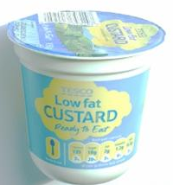
Fruit yoghurt | Rice pudding | Custard | Cheese portion | Yoghurt tube
Why eat a healthy packed lunch?
New School Food Standards were introduced in January 2015 to ensure that all pupils are getting balanced and healthy food in school.
3. Include some fruit or vegetables
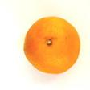 |  |  | 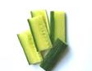
Satsuma | Grapes | Banana | Cucumber | Carrot batons
 |  | 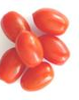
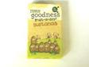

Raisins | Tinned fruit salad | Cherry tomatoes | Dried apricots | Plum
We have used these standards to create our packed lunch guide and help families with ideas. A healthy packed lunch can help children to:
- Have enough energy to concentrate and learn in the afternoon
- Keep calm and be prepared to do their best
- Get important nutrients to keep their bodies healthy
What should a packed lunch include?

Use the following ideas to help plan a healthy lunch for your child.
1. Include a savoury main (with some salad)
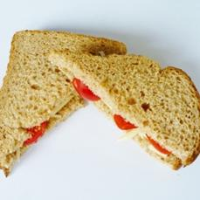 | 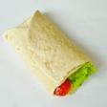 |  | 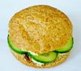 | 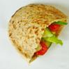
Cheese & tomato sandwich | Tuna and salad wrap | Cream cheese and lettuce bagel | Hummus and cucumber roll | Chicken salad pitta bread
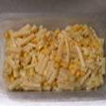 |  | 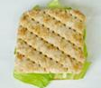 | 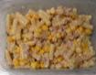 | 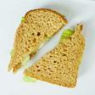
Cheese and sweetcorn pasta | Chicken and pepper noodles | Sardine and lettuce thin | Tuna and sweetcorn pasta | Egg, pepper and lettuce sandwich
4. Include an extra low fat/low sugar snack, if needed
 | 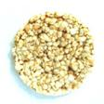
Plain breadsticks | Plain rice cakes | Fruit scone | Crackers | Plain biscuit

