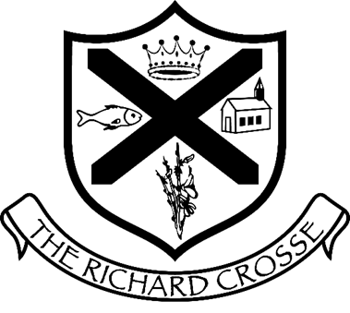
Christmas Fayre

Raffle - £1 a strip
Prizes
David Lloyd family pass
Hoar Cross Hall spa day for one
Family photo session with 3 digital images
Photo shoot with 1 print
Knitted Mr & Mrs Claus
Prosecco and Chocolates
Festive Hamper
Jo Malone gift set
The White Company gift set
Temple Spa gift set

