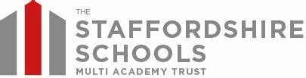
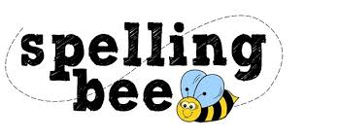

Year 5& 6 Autumn Term 2022

develop | hindrance
achieve | communicate
amateur | bruise
excellent | lightning
competition | strength
determined | shoulder
familiar | surprise
environment | muscle
mischievous | symbol
frequently | although
vehicle | sufficient
curiosity | through
prejudice | nuisance
identity | weight
vegetable | occupy
individual | occur
rhyme | opportunity
recognise | parliament
according | persuade

Please practise these spellings if you would like to enter the TSSMAT Spelling Bee. Your class teacher will be running heats in your classroom.
The finals will take place on WC 5th December 2022
Good luck!

