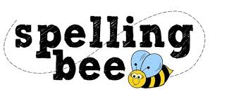

Year 5 and 6 Spring Term

accommodate | separate
dictionary | leisure
exaggerate | straight
recognise | programme
existence | pronunciation
explanation | marvellous
physical | queue
foreign | recommend
forty | necessary
prejudice | restaurant
government | neighbour
guarantee | rhythm
harass | sacrifice
privilege | signature
immediate | stomach
profession | temperature
interfere | twelfth
interrupt | favourite
language | soldier

Please practise these spellings if you would like to enter the TSSMAT Spelling Bee. Your class teacher will be running heats in your classroom.
The finals will take place on WC 17th March 2023.
Good luck!

