Class 1: Spring Term 2019-20

Welcome Back!
Welcome back Class 1! Everyone at Richard Crosse wishes you a very happy and prosperous New Year! We hope you have had a lovely Christmas break and are well and truly rested. This term, you can look forward to many exciting activities and experiences, to enhance your learning and love of school.

Class 1 | Key Information
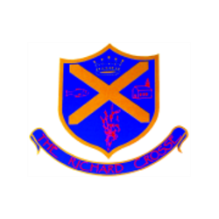  Uniform | Please make sure that your child has a waterproof coat, (which is named), on all but very warm days as it can be cold outside and the children in Class 1 go outside whatever the weather. Children will also need a pair of wellingtons, marked clearly with your child’s name, as they will be taking part in outdoor learning sessions.  For further information, please follow the link below.  https://www.richardcrosse.staffs.sch.uk/parents/uniform
PE kit | Your child’s PE kit will need to be in school every day, as we may need to change days at the last minute due to weather etc. Please ensure that all items are clearly labelled with their name. We will send kits home at the end of each half term so that they can be washed.  During the colder months, your child will need a tracksuit top and bottoms.  For further information, please follow the link below.  https://www.richardcrosse.staffs.sch.uk/parents/uniform
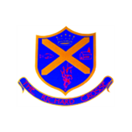  Phonics Reading | We have now come to end of Phase 2 phonics and the children in Reception have become skilled in identifying single sound letters. The children will now be issued with a phonics sound book. This will enable them to continue to practice and develop their skills at home. This book, will be updated with new sounds, as we start to learn the slightly trickier, Phase 3 sounds.  The children in Reception, will continue to read with an adult once a week and have their home, school book changed. The children will also be completing weekly group reading sessions, with a member of staff.  During this term, our Reception children will also be given a word tin. This will be a clear plastic tub that will contain 6 words for them to learn. These will be practiced and read on a weekly basis. Once your child is able to identify and read the words, they will be moved on to the next set. Once your child reaches set 10, they will practice writing them in a book, before continuing on to the next 10 sets.
Curriculum | In the foundation stage, your child will be taught using a combination of independent activities and teacher-led activities. These activities will be designed to promote all of the seven areas of learning to ensure your child has a well-rounded education.  Over the next term our topics will include, ‘Food, glorious food, Transport and Traditional Tales’.  Please see our curriculum overview for more information.
Homework | Please remember homework is optional in Early Years however, if your child wishes to complete our homework challenges that would be great.  Each half term your child will receive a homework challenge sheet with suggested activities relating to our current topic in class. The children can select one challenge a week to complete and bring in on Fridays to share with the class.  Please see our homework challenge sheet for more information.
Snack | We have snack time twice a day. During this time, we can have a drink of milk or water and a choice of fruit which is provided by the school. To enable us to provide additional snack options and purchase ingredients for regular cookery sessions with the children we ask parents for a contribution of £1.00 per week. Thank you.

