Class 3: Spring Term 2020
Welcome Back!
Welcome back Class 3! Everyone at Richard Crosse wishes you a very happy and prosperous New Year. We hope you have had a brilliant festive break and are well and truly rested.
This term you can look forward to many exciting activities and experiences which will enhance your learning.
Mrs Vincent Scuotto

Class 3 | Key Information
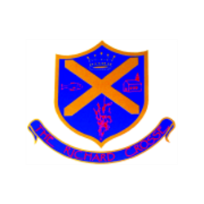  Uniform | Remember that a blazer is a compulsory part of the uniform and that your child should wear this at all times unless given permission otherwise. Please make sure all uniform is clearly labelled to avoid any loss. Please bring a coat to school as well as your blazers. Please also make sure their coat is labelled with your child’s name.  For further information, please follow the link below.  https://richardcrosse.staffs.sch.uk/parents/uniform
Reading Diaries | Please ensure that your child’s reading diary is in school every day, as we aim to try and listen to them read, in school, at least once a week. The children are encouraged to read at least five times a week at home and will need their diary signing by an adult to let us know how they are getting on. The children are responsible for changing their own books, when necessary, but this will be checked on a regular basis. Please note that your child does not have to read a whole book a night, it is acceptable to read just a few pages, especially as the books get trickier. Every time you child reads, they will receive 1 dojo. If they read 5 times in a week, they will be entered into a competition – 5 times reader – with the possibility of winning a book of their choice
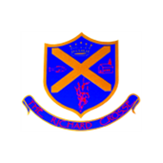  Spellings | Your child will be expected to learn 5 spellings at home each week whilst being taught 5 in school. Please help your child to learn them. Spelling tests will take place on a Friday.  Your child will be tested on words in their word tins every Wednesday. These spellings will include appropriate common exception words. However, this may be subject to change so please ensure that your child brings their word tin into school every day.
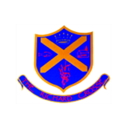  PE kit | Your child needs to bring a PE kit into school which is clearly labelled with their name. This must remain in school and will be returned at the end of each half term.  During the colder months your child will need a tracksuit top and bottoms.  https://richardcrosse.staffs.sch.uk/parents/uniform
Homework | Homework will be sent home every Friday and will need to be handed in on a Wednesday. Each week, homework will alternate between English and Mathematics.

Our Curriculum this term...
English | We have lots of exciting writing opportunities planned this term, starting with the topic of persuasive leaflets. Our class will have opportunities to scrutinise various leaflets to identify the features. This topic will link to the Geography topic of Our Village, where the children will create a leaflet persuading people to visit King’s Bromley. As well as this, Class 3 will cover a range of topics such as story writing and non-fiction writing including newspaper reports and non-chronological reports.
Maths  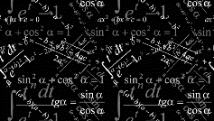 | One of our focus points this term will be Big Maths. The children will undertake their tests every Monday and be supported through their needs during the week. Other key topics this term include multiplication, division, money and statistics, length, perimeter and fractions. Year 3s will be practising their times tables in preparation to pass the statutory check at the end of the year. It is really important that the children practise all their times tables. This can be done by using which we encourage the Rockstar Times tables children to use at home as much as possible.
History  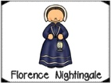 | We have a really exciting history topic this term, which is the Anglo-Saxons and Scots. The children will learn about who the Anglo-Saxons were and where they came from. They will identify the challenges facing the settlers when arriving in Britain. We plan to take the children on a trip to Tatton park to immerse them in what life was like in Anglo-Saxon times.
Geography  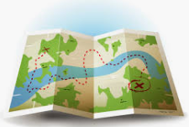 | This term we are learning all about our village, King’s Bromley. We will identify and locate human and physical features using maps. In addition to comparing and contrasting two local areas, looking specifically at amenities and landmarks. This topic will end with gathering data about what makes the ‘ideal village’ in order to illustrate their village on a map with the appropriate amenities and landmarks.
Art | In art, we will be exploring different techniques using different sketching techniques using a range of mediums. As well as this, the class will measure proportion using the grid method to accurately sketch a drawing of a local building. The children will create their final piece by sketching our local church where they will add depth by using different shading techniques.
Science | This term, we will be looking at skeletons. The children will identify and name some bones in the human body. Also, Class 3 will understand the function of muscles and the relationship with bones.
PE | This term in PE, we are focusing on dance, gym, fitness and football which will be led by Miss Hylton and Mr Challinor.
Religious Education/Science | Our RE topic is ‘What can we learn from a mosque’. The children will be focusing closely on the key features of a Mosque and investigating what they reveal about Muslim beliefs, especially beliefs about prayer, (salah).

