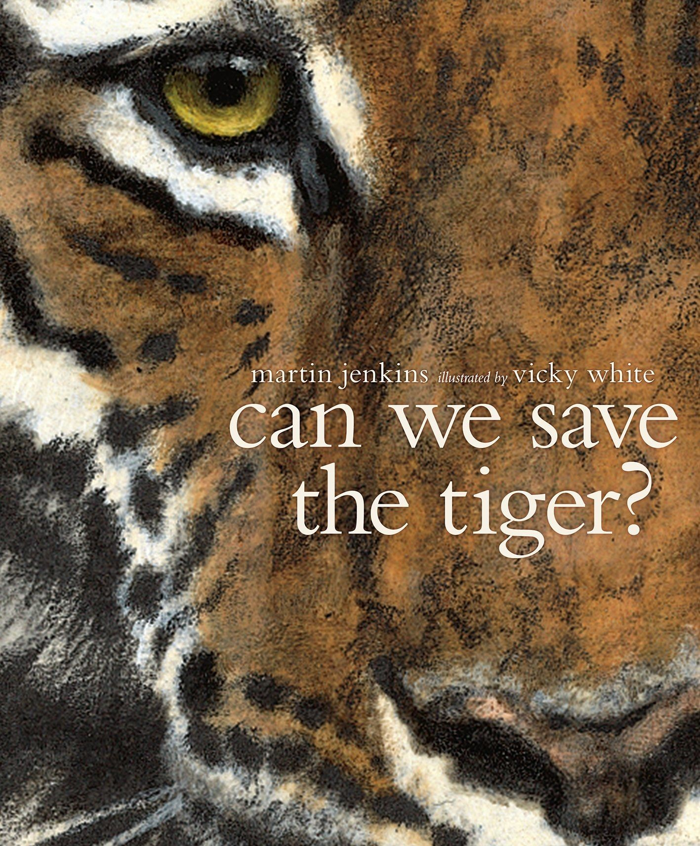
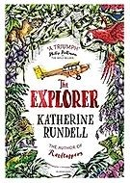
Climate and Habitats:KS2 Knowledge Mat
©
Focus Education UK Ltd.

Subject Specific Vocabulary |  | Sticky Knowledge about Climates and Habitats  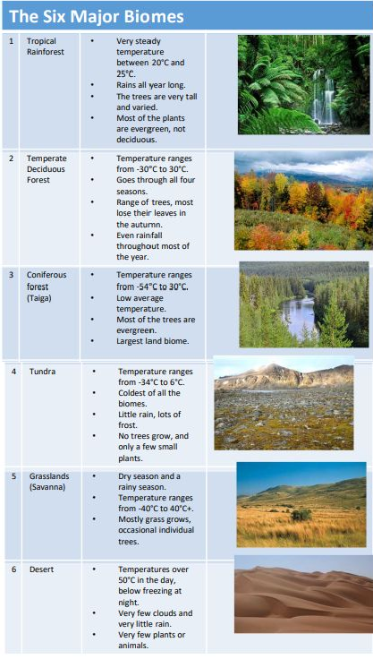
Climate | Climate is the average measurements of temperature, wind, humidity, snow, and rain in a place over the course of years
Vegetation | Plant life as a whole within a certain. area
Biome | A biome is a large region of Earth that has a certain climate and certain types of living things
Eco-System | A community of living and non-living things that work together
Deciduous | A tree that sheds its leaves in the autumn
Dormant | When a plant or animal is in a deep, long sleep
Equator | The imaginary line that runs around the middle of the earth
Fauna | The animals that normally live in a particular biome
Flora | The plants that normally grow in a particular biome
Temperate | Mild weather, further away from the equator.
Tropics | Any place on earth near the equator
Deforestation | Cutting down trees

