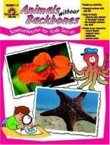
UKS2 Animal Classification Knowledge Mat
Subject Specific Vocabulary |  | Interesting Books | Sticky Knowledge about Classification of animals
micro-organi sm | Micro-organisms are tiny. They are so small they can only be seen with a microscope. | 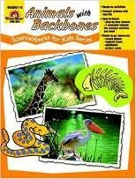
 |  |  | - The largest vertebrate is the blue whale, which can grow to 25m long and weighs 140,000kg.
vertebrates | A vertebrate animal is one that has a backbone.
invertebrates | An invertebrate animal does not have a backbone and 97% of creatures belong to this group. |  | - The smallest vertebrate is thought to be a tiny frog called the Paedophryne amauensis. It only grows to about 8mm in length.
species | This is the grouping together of similar types of plants, animals and other organisms that can reproduce with each other.
 |  |  | - Vertebrates tend to be much more intelligent than invertebrates.
fungi | Fungi are a classification or group of living organisms. This means they are not animals, plants, or bacteria.
- Vertebrate animals can be either warm or cold-blooded. A
cold-blooded animal cannot maintain a constant body temperature. The temperature of their body is determined by the outside surroundings.
monera | The whole organism is made up of just one cell. This cell is more basic than cells of other organisms.
 |  | Important facts to know by the end of the classification of animals topic:
bacteria | Bacteria are tiny little organisms that are everywhere around us. |  | - An invertebrate is an animal that does not have a backbone. 97% of all animal species are invertebrates.
- Be able to classify living things into broad groups according to observable characteristics and based on similarities and differences.
- Know how living things have been classified.
- Give reasons for classifying plants and animals based on specific characteristics.
protista | Protists are not animals, plants, fungi, or bacteria. Many protists are so small that people can see them only through a microscope.
 |  |  | - Frogs can breathe through their skin.
algae | Algae is a single or multi-cellular organism that has no roots, stems or leaves and is often found in water.
 |  |  | - There are a wide variety of interesting ocean animals that are invertebrates. These include sponges, corals, jellyfish, anemones, and starfish.
Carl Linnaeus | Carl Linnaeus is famous for his work in Taxonomy, the science of identifying, naming and classifying organisms (plants, animals, bacteria, fungi etc.).
© Focus Education UK Ltd.

