Class 2: Spring Term 2020

Welcome Back!
Welcome back Class 2! Everyone at Richard Crosse wishes you a very happy and prosperous New Year! We hope you have had a lovely Christmas break and are well and truly rested. This term, you can look forward to many exciting activities and experiences, to enhance your learning and love of school.

Class 2 | Key Information
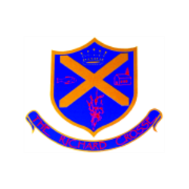  Uniform | School uniform in KS1 is the same as Foundation Stage, other than the children will now be required to wear a tie. Please ensure that your child has their tie on every morning. It would also be helpful if you could ensure that all of your child’s uniform is clearly labelled with their name. This makes it easier to return any lost items.  For further information, please follow the link below.  https://www.richardcrosse.staffs.sch.uk/parents/uniform
Reading Diaries | Please ensure that your child’s reading diary is in school every day, as we aim to try and listen to them read, in school, at least once a week. The children are encouraged to read at least five times a week at home and will need their diary signing by an adult to let us know how they are getting on. The children are responsible for changing their own books, when necessary, but this will be checked on a regular basis. Please note that your child does not have to read a whole book a night, it is acceptable to read just a few pages, especially as the books get trickier. Every time you child reads, they will receive 1 dojo. If they read 5 times in a week, they will be entered into a competition – 5 times reader – with the possibility of winning a book of their choice!
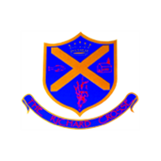  Spellings  Word tins | The children will be given 5 common exception words to learn each week appropriate to their year group. We would love it if you could help your child to practise writing and reading these words. Spelling tests will take place on a Friday.  The children will be bringing home a word tin containing 5 sounds that we have been focusing upon during our phonics sessions. These sounds are important when helping the children learn to spell independently, so if you could help them to become confident with them it would be great! This doesn’t have to be done in a formal way, you could write/ say as many words that you can think of with that sound, in a minute and then challenge the children to beat your score.
PE Kit | Your child’s PE kit will need to be in school every day, as we may need to change days at the last minute due to weather etc. Please ensure that all items are clearly labelled with their name. We will send kits home at the end of each half term so that they can be washed.  During the colder months, your child will need a tracksuit top and bottoms.  For further information, please follow the link below.  https://www.richardcrosse.staffs.sch.uk/parents/uniform
Homework  Times Tables | Homework will be sent home every Friday and will need to be handed in on a Wednesday. We will be focusing upon handwriting in Year 1 and joining and comprehension in Year 2.  If your child is in Year 2, they will receive additional work to support their learning.  Year 1: We will be learning our number bonds to 10. We will practise these in school on a Friday.  Year 2: We will be learning the 3 times table, which will be tested on a Thursday.

Our Curriculum this half term...
English | As part of our English lessons this half term we will start by planning and writing a recount about our Christmas holidays. We will then complete a unit on animal acrostic poems, where our work is going to be entered into a competition. It is our intention to write an information piece and a narrative piece of work based on our topic of London.
Maths  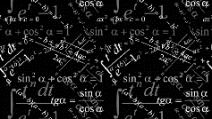 | The children will have a daily maths session, where we will focus upon different areas of mathematical knowledge.  Year 1: addition and subtraction to 20, place value within 50, length and height and weight and volume.  Year 2: multiplication and division, statistics, time, fractions and properties of shape.  The children will also have an Activ Maths session (where they learn a concept through PE) and a Big Maths session (looking at fluency and basic mathematical knowledge) per week.
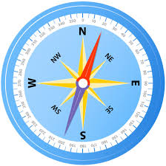  Geography | Our Geography topic this half term will be called ‘Where do we live?’ The children will be learning about the 7 continents of the world. They will discover how the UK is split into 4 countries and that each country has a capital city. We will think about the human and physical features of each country and learn more about the village that we live in.  NC – name, locate and identify the characteristics of the four countries and capital cities of the United Kingdom and its surrounding seas.  NC – use world maps, atlases and globes to identify the United Kingdom and its countries.
D&T | Our focus will be on construction. We will be investigating different types of playground and having a look at how we could design our own to make it exactly how we would want. The children will have a go at designing, making and evaluating their own piece of playground equipment.  NC – design purposeful, functional, appealing products for themselves and other users based on design criteria.  NC – select from and use a range of tools and equipment to perform practical tasks.  NC – explore and evaluate a range of existing products.  NC – evaluate their ideas and products against design criteria  NC – build structures, exploring how they can be made stronger, stiffer and more stable.
Computing | For this session we will focus on becoming computer scientists. The children will begin to understand what algorithms are, how to create and debug simple programs and how to recognise common uses of information technology beyond school.  NC – understand what algorithms are; how they are implemented as programs on digital devices; and that programs execute by following precise and unambiguous instructions.  NC – create and debug simple programs.
PE | This term, PE will be taught on a Thursday and a Friday. Our PE topics will be focusing upon gymnastics and Boccia skills with Mr Challinor and dance and movement skills for their other session.  NC – master basic movements including running, jumping, throwing and catching, as well as developing balance, agility and co-ordination, and begin to apply these in a range of activities.  NC – participate in team games, developing simple tactics for attacking and defending.  NC – perform dances using simple movement patterns.
Religious Education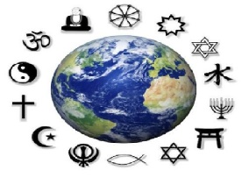 | Judaism.  We will be investigating what Judaism is and what Jews believe. We will find out about the Torah and how it teaches Jews about helping each other.
Science  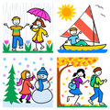 | Plants.  We will be learning about different plants and trees. The children will conduct various experiments to discover the ideal growing conditions for a plant. They will also learn about the different parts of a plant and the names of various plants and trees.  NC – Observe and describe how seeds and bulbs grow into mature plants.  NC – find out and describe how plants need water, light and a suitable temperature to stay and grow healthy.  NC – identify a name of common, wild and garden plants including deciduous and evergreen trees.  NC – identify and describe the basic structure of a variety of common flowering plants including trees.
Art  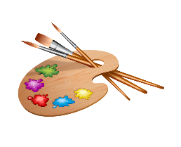 | Sparks and flames.  We will be using chalk and collage to create flames. We will be using a variety of different materials to create 3D scenes and pictures.  NC – to develop a wide range of art and design techniques in using colour, pattern, texture, line, shape, form and space.  NC – to use a range of materials creatively to design and make products.  NC – to use drawing, painting and sculpture to develop and share their ideas, experiences and imagination.
History  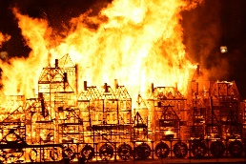 | The Great Fire of London.  We will be learning about when and where the Great Fire of London started and the events that led up to it. We will think about the reasons why the fire spread so quickly and will learn who Samuel Pepys was.  NC – pupils should be taught events beyond living memory that are significant nationally or globally.

