13.01.20 | 20.01.20 | 27.01.20 | 03.02.20 | 10.02.20 | 10.02.20
door | child | gold | break | father | move
behind | old | great | past | hour | should
both | even | last | bath | could | busy
everybody | fast | path | eye | clothes | Mrs
after | plant | sugar | many | Mr | mind
pass | sure | any | money | kind | only
improve | whole | half | find | most | every
who | again | because | climb | told | beautiful
water | poor | wild | hold | pretty | would
floor | children | cold | steak | class | people
Group 1 – the dates indicate the week beginning not the exact date of the test as it may vary.

Group 2
Week One | Week Two | Week Three | Week Four | Week Five | Week Six
accident | accidentally | actual | actually | address | although
answer | appear | arrive | believe | bicycle | breath
breathe | build | busy | business | calendar | caught
centre | century | certain | circle | complete | consider
continue | decide | describe | different | difficult | disappear
early | earth | eight | eighth | enough | exercise
experience | experiment | extreme | famous | favourite | February
forward | forwards | fruit | grammar | group | guard
guide | heard | heart | height | history | imagine
increase | important | interest | island | knowledge | learn

Group 3

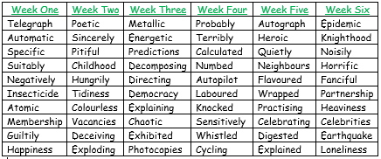
Group 4

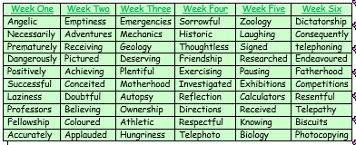
Group 5

