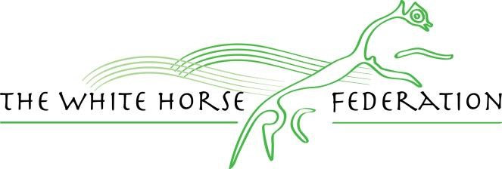
Rodbourne Cheney Primary School

English Policy

Key Document details:
Author: Sarah Harris
Version No.: 2 Approver: Lisa Davies
Date Ratified: September 2023 Next review: September 2024

Rodbourne Cheney Primary School English Policy

Philosophy
At Rodbourne Cheney Primary School we believe that:
Helping children to develop a lifelong love of reading is the most powerful thing to meet their potential. The study of English through a quality text-based approach develops children’s abilities to listen, speak, read and write for a wide range of purposes, using language to learn and communicate ideas, views and feelings. It enables children to express themselves creatively and imaginatively, as they become enthusiastic and critical readers of stories, poetry, drama, non-fiction and media texts. Children gain an understanding of how language works by looking at its patterns, structures and origins. Children use their knowledge, skills and understanding in speaking and writing across a range of different genres and situations.
We aim to promote lifelong skills in English.

Principles
At Rodbourne Cheney Primary School we aim to:
- put a love of reading at the heart of our curriculum.
- use a quality text-based approach to engender a love of reading and to provide quality modelling;
- ensure that the skills of reading and writing are linked through the use of a quality text;
- enable children to speak clearly and audibly in ways which take account of their listeners;
- encourage children to listen with concentration in order to be able to identify the main points of what they have heard;
- enable children to adapt their speech to a wide range of circumstances and demands;
- develop children’s abilities to reflect on their own and others’ contributions and the language used;
- enable children to evaluate their own and others’ contributions through a range of drama activities;
- develop confident, independent readers through an appropriate focus on word, sentence and text-level knowledge;
- encourage children to become enthusiastic and reflective readers through contact with challenging and lengthy texts;
- help children enjoy writing and recognize its value;
- enable children to write with accuracy and meaning in narrative and non-fiction;
- increase the children’s ability to use planning, drafting and editing to improve their work.

The Teaching of English
At Rodbourne Cheney Primary School our principal aim is to develop children’s knowledge, skills, and understanding in English. We do this through a lesson four times a week that has a high proportion of whole-class and group teaching. As well as these lessons, children also experience a reading lesson four times a week and spelling lessons in Years 2-6. Children have the opportunity to experience a wide range of texts and use a range of resources such as dictionaries and thesauruses to support their work. In EYFS and Year 1, English is taught using focussed activities throughout the day including guided reading. We always plan and encourage children to use and apply their learning in other areas of the curriculum.

Early Years Foundation Stage
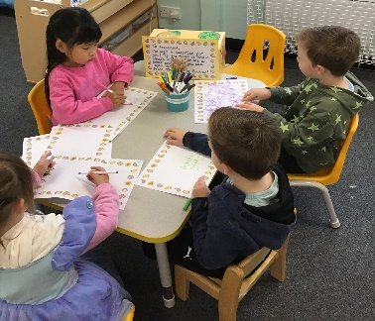
We teach English as an integral part of the day. As the Reception class is a part of the Early Years Foundation Stage, we relate the literacy aspects of the children’s work to the objectives set out in the Foundation Stage curriculum, which underpin the curriculum planning for children aged 3-5. We give all children the opportunity to talk and communicate in a widening range of situations, to respond to adults and to each other, to listen carefully and to practise and extend their range of vocabulary and communication skills. Large imaginative play areas and small worlds provide a nucleus for speaking and listening in the Foundation Stage and children have the opportunity to explore and learn about words and text in a range of situations and through structured play. In order to support this, children listen to daily stories and nursery rhymes as a part of our quality text-based curriculum. They also have access to a wide range of books which children are encouraged to explore and appreciate. Little Wandle activities are sent home regularly to reinforce class teaching. Writing is promoted in EYFS and children’s learning progresses from writing words to then writing simple sentences using their phonic knowledge.

Year 1
In Year 1, the children have English lesson four times a week, guided reading sessions and twice daily phonics session. Spellings from Little Wandle are sent home to be learned and tested the following week. Children also have regular phonics screening assessments. Throughout EYFS and KS1, reading material is closely banded and children work through the reading scheme. Children are encouraged to read at home daily and read with an adult weekly in school. Cursive handwriting is practised regularly. English lessons are carefully structured to include a focus on Spoken Language. Writing is taught through immersion in text, oral rehearsal, shared tasks, independent tasks and assessment. There is a focus on the writing process as a
journey, progressing from planning and drafting, editing and then creating a final piece of writing. English skills are used and reinforced across the curriculum.

Year 2
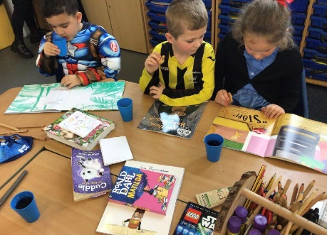
In Year 2, the children have an English lesson and guided reading session four times a week. Cursive handwriting is practised regularly. Children follow the Spelling Shed scheme. Spellings are sent home and children are tested weekly. Throughout EYFS and KS1, reading material is banded and children work through the reading scheme. Children are encouraged to read at home daily and read with an adult every fortnight in school. English lessons are carefully structured to include a focus on Spoken Language. Writing is taught through immersion in text, oral rehearsal, shared tasks, independent tasks and assessment. There is a focus on the writing process as a journey, progressing from planning, writing, editing and revising. English skills are used and reinforced across the curriculum. Where children require phonics intervention in Year 2, this is done through the Little Wandle scheme.

KS2
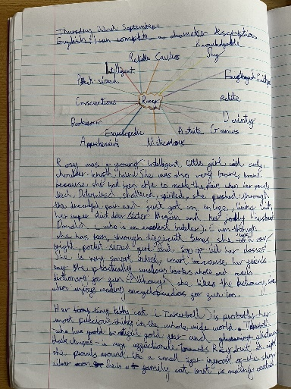
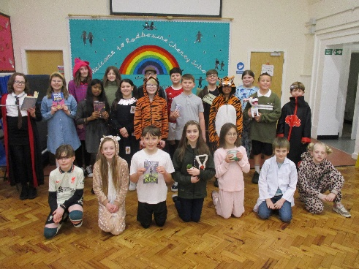
All children in KS2 have an English lesson and guided reading session four times a week. The school follows a cursive handwriting scheme. Children follow the Spelling Shed Scheme. These spellings are also sent home to be practised and children are tested weekly. Once they have become free readers, KS2, children are able to choose their own reading books and their choices and are supported in this in Years 5 and 6 through the Accelerated Reader program. Where children are not working at Age Related Expectations, teachers will support children in finding books which challenge them in an appropriate way. Writing is taught through immersion in text, oral rehearsal, shared tasks, independent tasks and assessment. There is a focus on the writing process as a journey, progressing from planning and drafting, editing and then creating a final piece of writing. Links are always made between English skills and the use of them in the curriculum and cross-curricular planning is done whenever possible.

Contribution of English to teaching in other curriculum areas
The skills that children develop in English are linked to, and applied in, every subject of our curriculum. The children’s skills in reading, writing, speaking and listening enable them to communicate and express themselves in all areas of their work in school. There are many resources for English and also cross-curricular resources to support the teaching of English.

Mathematics
English contributes significantly to the teaching of mathematics in our school. Children in EYFS develop their understanding of number, pattern, shape and space, problem solving and reasoning by talking about these areas with adults and other children. Children in EYFS and KS1 meet stories and rhymes that rely on counting and sequencing and begin to read and interpret problems. In KS2, children are encouraged to read and interpret problems in order to identify the mathematics involved. They reason, explain and present their work to others and they communicate mathematically through the developing use of precise mathematical language.

Computing
Computing can improve the quality of teaching, learning and management in schools and so help raise standards. The use of Computing enables children to use and apply their developing skills in literacy in a variety of ways. Younger children use resources such as Beebots which help develop language. They also need to explain logical reasoning to predict the behaviour of simple programs. Older children use the Internet when searching for information and in order to do this successfully, they must have secure English skills. They will also share information and work in a range of different ways which again relies on a secure understanding of both reading, writing and spelling. Children use the planning and proofing tools in a word processor when checking their draft work. There are a variety of programmes on the system that children and staff can access to support learning. We encourage all children to use Computing as a resource for learning, whenever they feel it is appropriate. All children take part in discussions about how they can use technology safely and respectfully and by having secure speaking and listening skills, children are able to share their ideas and concerns.

Personal, social and health education (PSHE) and Science
English contributes to the teaching of personal, social and health education and Science. We encourage younger children to take part in class and group discussions on topical issues. In their science work they talk about things that improve their health and are required to ask simple questions. Older children research and debate topical problems and events. In their science learning, older children are required to ask relevant questions and use different types of scientific enquiries to answer them and to provide both oral and written explanations of their findings. They discuss lifestyle choices and meet and talk with many visitors who work within the school community. Planned activities within the classroom encourage children to work together and respect each other’s views.

Spiritual, moral, social and cultural development
The teaching of English develops skills through which our children can give critical responses to the moral questions they meet in their work. Their understanding and appreciation of a range of texts brings them into contact with their own literary heritage and texts from other cultures. The organisation of lessons allows children to work together and gives them the chance to discuss their ideas and opinions.

Teaching English to children with special educational needs
At our school we teach English to all children, whatever their ability.
English forms part of the school curriculum policy to provide a broad and balanced education to all children. Through our English teaching, we provide learning opportunities that enable all pupils to make progress. We do this by setting suitable learning challenges and responding to each child’s different needs. Assessment against the National Curriculum allows us to consider each child’s attainment and progress. When progress falls significantly outside the expected range, the child may have special educational needs. Our assessment (alongside the SENDCo) process looks at a range of factors – classroom organisation, teaching materials, teaching style and adaptive learning – so that we can take some additional or different action to enable the child to learn more effectively. This ensures that our teaching is matched to the child’s needs. Interventions are planned when a teacher has assessed that a child has a particular need. We support Speech and Language, Fine and Gross Motor skill, Reading and Spelling needs with specific programmes undertaken by adults in the school and with home support. These are monitored by the SENDCo. We enable pupils to have access to the full range of activities involved in learning English. Where children are to participate in activities outside the classroom, for example, a theatre trip, we carry out a risk assessment prior to the activity, to ensure that the activity is safe and appropriate for all pupils.
Teachers provide help with communication and English through:
- using texts that children can read and understand;
- using visual and written materials in different formats;
- using ICT, other technological aids and taped materials;
- using alternative communication, such as signs and symbols;
- using translators.

Performance
Teachers constantly assess children’s work in English. They use assessments to measure progress against the key objectives and to help them plan for the next unit of work. In Reception, each child is assessed in reading and writing according to EYFS and the National Curriculum. In KS1 and KS2, children are assessed against the National Curriculum. Every 3 weeks, teachers assess the children in reading and writing and this information is entered on the school agreed format for the Senior Leadership Team to access and analyse. This data is used to set curricular and year group targets as well as for the teacher to use for class planning and support. A report is sent to parents at the end of the year with future targets for English identified. The next teacher uses these final term assessments as the basis for planning next year’s work. Assessments are made using children’s work, teacher assessments, end of Key Stage SATs, optional SATs and termly reading assessments. These assessments are passed onto colleagues or a new school using a Pupil Record Sheet.

Resources
There is a range of resources to support the teaching of English across the school. All classrooms have dictionaries and thesauruses. All classrooms have a selection of fiction and non-fiction texts. Children have access to the Internet through their classroom PCs, laptops and iPads. The library contains a range of books to support children’s understanding of a wide range of non-fiction topics. It also has fiction books which children can read for pleasure.

Monitoring and Review
Monitoring of the standards of the children’s work and of the quality of teaching in English is the responsibility of the coordinator and Senior Leadership Team. The work of the coordinator also involves supporting colleagues in the teaching of English, being informed about current developments in the subject, and providing a strategic lead and direction for the subject in the school. The coordinator attends meetings with Governors and ensures they are up-to-date with the necessary information.

