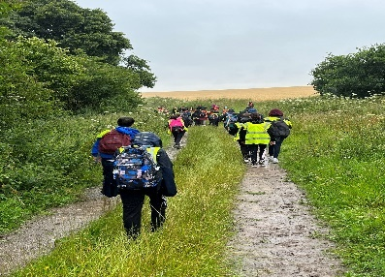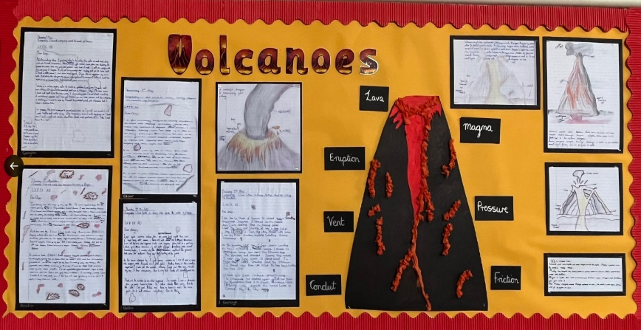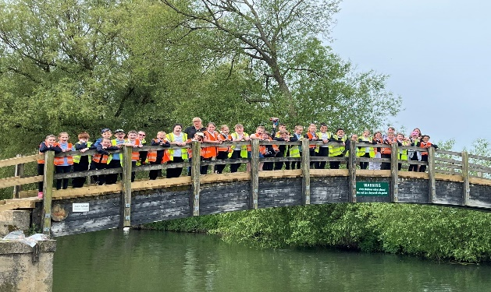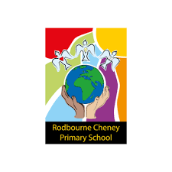

**Key areas for development:**

To ensure children are exposed to and making progress in learning key geographic vocabulary.

**Impact: What are the outcomes and strengths?**

The activities offered and the teaching approaches adopted provide pupils with opportunities to develop their knowledge and understanding of many countries and places around the world. Children are encouraged to develop their skills in geographical enquiries, carrying out research and fieldwork and presenting their findings. The school’s values-based approach embeds deeper understanding of environmental problems at a local, regional and global level whilst focusses on diversity and inclusion means that children build on their knowledge of other cultures and societies around the world.

Trips and educational visits play a vital role in promoting the school’s geography curriculum. They provide students with hands-on, experiential learning opportunities that help deepen their understanding of geographical concepts and theories taught in the classroom. For example, recent trips to natural environments including rivers, forests, and coastlines have allowed students to observe geographical processes like weathering, erosion, and water cycles. By seeing these processes in action, students have better grasped the dynamics of the Earth’s physical systems. Furthermore, Geography fieldwork has enabled students to develop skills in data collection, observation, recording, and analysis. Children are experts in using tools like maps, compasses, weather instruments, and geographical information systems (GIS) during such trips.

**Geography Intent, Implementation and Impact Statement**

**Implementation: How do we do it at Rodbourne?**

We use a variety of teaching and learning styles in our geography lessons. Our principal aim is to equip pupils with knowledge about diverse places, people, resources and natural and human environments. We achieve this through whole-class teaching, while at other times we engage the children in a more open-ended enquiry style research activity.

In each key stage, we provide the children with opportunities to visit sites of geographical interest as well as using the school grounds and local area to carry out fieldwork. When possible we hold whole school geography themed days such as our ‘country taster days’, which help to hook and engage the children in their new geography topic.

Themed immersion lessons ensure that our children are enthused by geography and vocabulary starters at the beginning of each lesson mean that children learn more and remember more as we revise and build on past learning.

**Intent: What do we want children to learn?**

In conjunction with the 2014 National Curriculum, we aim to offer a high-quality geography education. We want to ensure that our geography curriculum is fascinating, inspiring and able to provoke a sense of curiosity amongst our pupils in order to enable them to learn about the natural and human worlds.

Through teaching of geography at Rodbourne Cheney Primary School, we aim to ensure that all pupils:

• Develop contextual knowledge of the location of globally significant places.

• Understand the processes that give rise to key physical and human geographical features of the world.

• Collect, analyse and communicate with a range of data gathered through experiences of fieldwork that deepen their understanding of geographical processes.

• Interpret a range of sources of geographical information

• Communicate geographical information in a variety of ways.