**In our whole school curriculum, we have five ambitions for our curriculum intent and these are at the core of what we do across the school. We call these our Golden Threads. It is important that these threads are embedded in our whole school curriculum, and are also a common dominator in all that we do.**

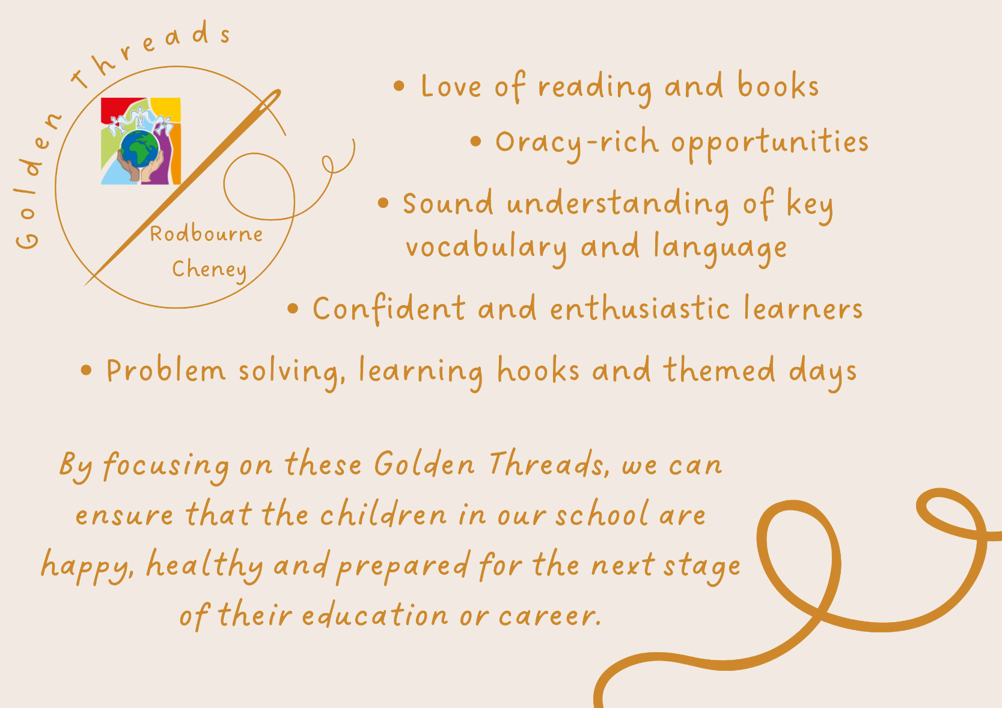

|  |
| --- |
| **School context:**  Our FSM is higher than national and Swindon averages.  Our children are from predominantly white, working-class families.  **Our demographic survey shows:**  42% of our children from financially stretched or low-income families.  57% of our families live in the in the most 30% of deprived postcodes in the UK.  **Our Acorn study shows that:**  There is a higher proportion of single parents than the base.  Financial profile shows more families making ends meet/ struggling than the base.  Number 1 Dominant Acorn Group titled ‘Limited Budgets’. 23% of our families fall into this category compared to 5% base.  20% of our demographic have an income less than 20K (the lowest grade measured).  **We have to ensure our children leave our school having had a high-quality, ambitious and well-planned curriculum. This means that all of our children, no matter what their starting points are, will achieve their best not only at our school, but in their future education setting, and then in working and adult life.** |

|  |  |  |  |  |
| --- | --- | --- | --- | --- |
| Whole School | | | History | |
|  | Whole School Golden Thread | Why this is important? | Golden thread in my subject | Impact of this Golden thread in my subject |
| 1. | Love of reading and books | We know that we need to develop the children’s reading, language and oracy to ensure they have the best possible outcomes. Reading and language is a crucial aspect to learning. Studies have proven that reading and language acquisition are key to all elements of learning, and later life.  It is essential that we encourage children to love books, teach them to be able readers and ensure they have a good understanding of vocabulary and language. | Children are given the chance to learn about historical events through reading and listening to stories from Early Years all the way through to KS2. Each class will study a book linked to their history topic and they will become fully immersed in this book. Each classroom has history books on display and children are encouraged to use them to carry out their own research. A range of history themed books are also available in class reading corners for children to access and take home to read and further their love of reading. | -Our children enjoy reading and share a love of reading.  -Our children learn new language through our book-based curriculum.  -Our children are able to comprehend and share their understanding of what they have read.  -Our children are confident readers.  -Our children can further their skills as historians by using books to carry out their own research. |
| 2. | Oracy-rich opportunities | Research shows that oracy is key to high performers. Research also shows that children, especially boys, benefit from drama and oracy opportunities to plan and gain increased understanding. It is essential that oracy opportunities are across all subjects and all phases. | Our children use and have opportunities for speaking and listening in all lessons whether this be discussing a new historical concept or using sources and their reasoning skills to explain their ideas about history. During history lessons our teachers plan in time for Drama based activities. These immerse the children into their class text. | -Our children are confident speakers and listeners.  -Children are able to share what they want to say through their learnt vocabulary.  - Our children are able to confidently express their knowledge and understanding of historical concepts. |
| 3. | Sound understanding of key vocabulary and language | Research has proven that children from lower socio-economic backgrounds have a word gap, and also have less vocabulary than their peers. To ensure cultural capital of our children, we need to enable our children to have sound understanding of vocabulary. | Vocabulary in our school is everywhere – each classroom shows vocabulary on history topic displays and these key terms are discussed and used throughout a topic. In EYFS use of language relating to time is used in daily routines and conversations with children for example, ‘yesterday', ‘old', ‘past', ‘now' and ‘then'. Every history lesson in KS2 begins with a vocabulary starter where children have the chance to recap and define key historical vocabulary. In KS1 the children discuss key vocabulary from previous lessons at the beginning of each lesson.  Teachers prepare knowledge organisers for each history topic. These include key vocabulary and definitions of terminology based on the topic being studied. These knowledge organisers are shared with parents so they can discuss key vocabulary with their children at home. | - Our children are confident and able to talk about what they have learnt in history using subject specific vocabulary.  -Children gain strong history knowledge and understanding and have an extensive base of historical vocabulary.  -Children remember key historical vocabulary for longer and leave or school with a developed knowledge of historical vocabulary. |
| 4. | Confident and enthusiastic learners | Being confident will help our children with their learning; not being afraid to make mistakes or to give things a go. They will be confident with their friends and this will help them achieve in their next stage of life. This links to the children having good self-esteem, which will encourage RCPS children to try new things and find their passion, which will allow them to develop a sense of identity and build confidence in facing whatever comes their way.  It’s important that our children are enthusiastic learners, who want to know and remember more. If our children are excited and enthused about their learning, they will be actively engaged and in turn display excellent learning behaviours which also maximises learning. | Our children have plenty of opportunities to work independently, with an adult or in small groups to build confidence and self-esteem in history. Children are given the opportunity to share their learning in a number of ways to ensure that every child has the chance to develop their confidence in becoming a historian. At the end of each topic children create their own knowledge organisers as a celebration of what they have learnt. This gives them the opportunity to reflect on their learning and see how their knowledge is improving over time.  Our children learn about aspects of local, British and Ancient history.  This wider awareness leads to the children having some knowledge of historical development in the wider world. We believe that by allowing the children to understand the importance and enjoyment of History through different opportunities, they will become enthused learners in History. Lessons are well planned and engaging and teachers use hooks and historical resources wherever possible to promote enthusiasm and a love of learning for history. | -Children are confident in sharing and talking about what they have learnt in history.  -Our children know that it is okay to make mistakes and can use learnt strategies to try again.  -Children feel a sense of pride in their achievements in their history learning.  -Our children are enthusiastic and passionate history learners, who have a sense of curiosity of the world, its history and people of the past.  -Children have a passion for and commitment to the subject and a real sense of curiosity to find out about the history of the world and the impact it has had on our lives today. |
| 5. | Problem solving, learning hooks and themed days. | By solving problems, our children will be happy, confident and independent learners. They will be able to make sense of, and understand, the world around them. They can make connections and they can apply this to other areas of life through new experiences.  Enrichment of learning is key! This gives our children cultural capital to their learning, and also means that they will enjoy their learning more. If children enjoy their learning, they will be more engaged and actively participate in lessons and experiences. | In History at our school, we give children opportunities to develop their skills of enquiry, investigation and analysis. They learn about significant events in local, British and Ancient history and use these skills to ask and answer questions about key historical events. Children look at how events of the past have influenced our lives today and use their problem-solving skills to find solutions to key historical questions.  Teachers plan in hook days to immerse the children into their history learning at the start of each topic. This also helps to ensure our children are getting their best start and all children have the same starting point.  Class trips linked to history learning are also organised in order to enrich learning. | -Our children are confident to face problems and challenges daily.  -Children are able to apply their oracy and language skills into problem solving.  -Our children all have the same starting point in their learning.  -Our children are engaged and immersed in their learning to ensure they make progress and have great learning attitudes. |

***By focusing on these Golden Threads, we can ensure that the children in our school are happy, healthy and prepared for the next stage of their education or career.***