**In our whole school curriculum, we have five ambitions for our curriculum intent and these are at the core of what we do across the school. We call these our Golden Threads. It is important that these threads are embedded in our whole school curriculum, and are also a common denominator in all that we do.**

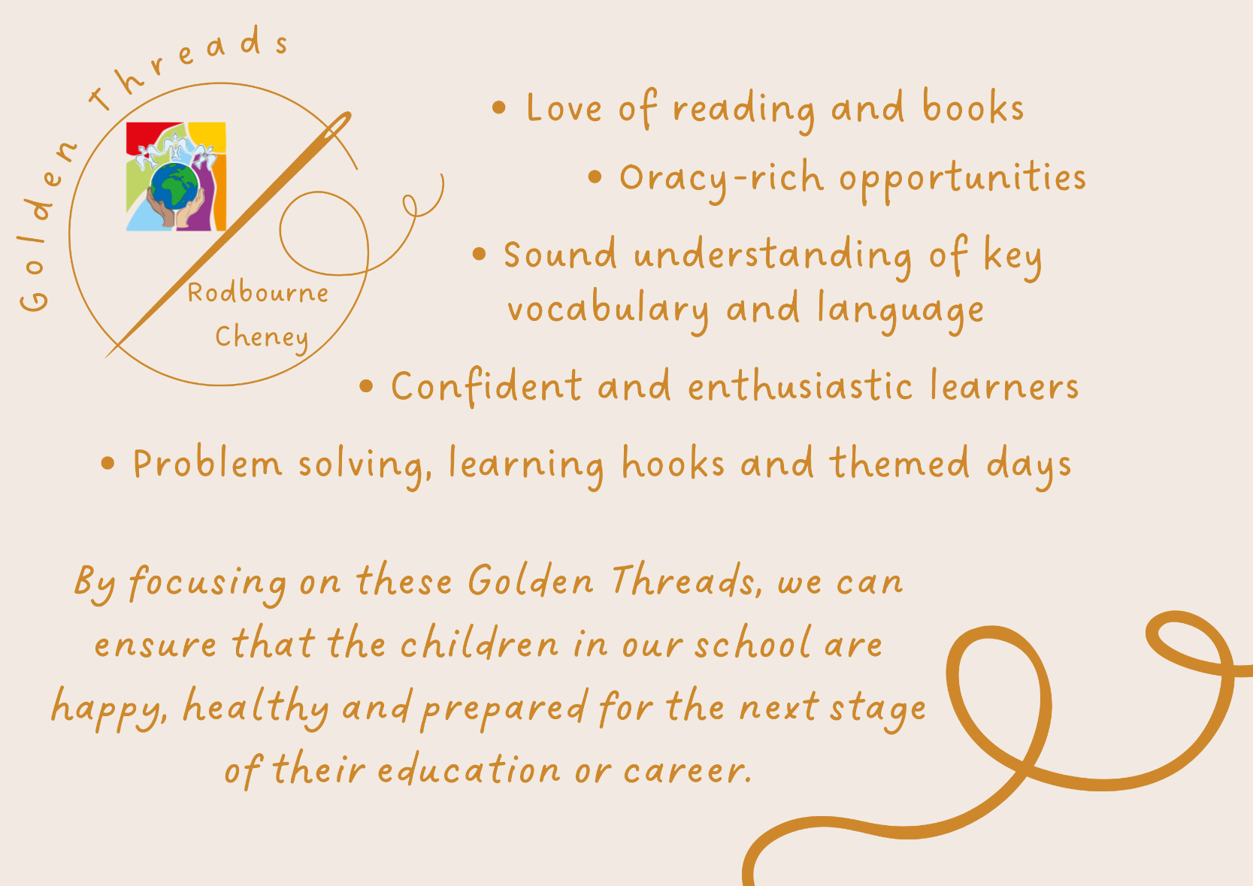

|  |
| --- |
| **School context:**  Our FSM is higher than national and Swindon averages.  Our children are from predominantly white, working-class families.  **Our demographic survey shows:**  42% of our children from financially stretched or low-income families.  57% of our families live in the in the most 30% of deprived postcodes in the UK.  **Our Acorn study shows that:**  There is a higher proportion of single parents than the base.  Financial profile shows more families making ends meet/ struggling than the base.  Number 1 Dominant Acorn Group titled ‘Limited Budgets’. 23% of our families fall into this category compared to 5% base.  20% of our demographic have an income less than 20K (the lowest grade measured).  **We have to ensure our children leave our school having had a high-quality, ambitious and well-planned curriculum. This means that all of our children, no matter what their starting points are, will achieve their best not only at our school, but in their future education setting, and then in working and adult life.** |

|  |  |  |  |  |
| --- | --- | --- | --- | --- |
| Whole School | | | Mathematics | |
|  | Whole School Golden Thread | Why this is important? | Golden thread in my subject | Impact of this Golden thread in my subject |
| 1. | Love of reading and books | We know that we need to develop the children’s reading, language and oracy to ensure they have the best possible outcomes. Reading and language is a crucial aspect to learning. Studies have proven that reading and language acquisition are key to all elements of learning, and later life.  It is essential that we encourage children to love books, teach them to be able readers and ensure they have a good understanding of vocabulary and language. | Each class has one narrative to read with their class about number and place value.  Reading is embedded within each lesson when reasoning and deepening learning. | Children understand that maths is part of their everyday life and that maths is not only recorded in digits but also words.  Children make connections with maths in other texts that they read and in the world around them. |
| 2. | Oracy-rich opportunities | Research shows that oracy is key to high performers. Research also shows that children, especially boys, benefit from drama and oracy opportunities to plan and gain increased understanding. It is essential that oracy opportunities are across all subjects and all phases. | Oracy is a key part of the ‘Teach it!’ section of our maths lessons. Each lesson begins with an oracy counting task. This allows the children to orally rehearse key number facts such as number bonds, multiplication tables, counting, etc. to support and review previous learning.  Partner-talk is used throughout the lessons to allow the practice of using mathematical vocabulary, STEM sentences and generalised statements to deepen understanding.  Number fluency is heavily supported by oracy of number. | Oracy increases the understanding of maths and can make links to other mathematical learning enabling the children to be confident communicators.  Oracy increases the children’s ability to recall key number facts.  Oracy enhances the children’s understanding through STEM sentences and Generalised Statements which support their verbal explanation when reasoning. |
| 3. | Sound understanding of key vocabulary and language | Research has proven that children from lower socio-economic backgrounds have a word gap, and also have less vocabulary than their peers. To ensure cultural capital of our children, we need to enable our children to have sound understanding of vocabulary. | Throughout the ‘Teach it!’ section of the lesson, children are given opportunities to discuss the maths learning to answer questions such as ‘What do you notice?’ ‘Do you agree or disagree?’ This gives them the opportunity to rehearse their answers using key vocabulary, mathematical language, stem sentences and generalised statements.  Children are encouraged to speak in whole sentences throughout the lesson to ensure the use of mathematical language and vocabulary.  Children orally rehearse stem sentences, generalised statements and key vocabulary with talk partners and as a whole class. | Vocabulary and mathematical language increase the children’s knowledge and understanding of words and allows them to explain their understanding and reasoning using specific vocabulary. |
| 4. | Confident and enthusiastic learners | Being confident will help our children with their learning; not being afraid to make mistakes or to give things a go. They will be confident with their friends and this will help them achieve in their next stage of life. This links to the children having good self-esteem, which will encourage RCPS children to try new things and find their passion, which will allow them to develop a sense of identity and build confidence in facing whatever comes their way.  It’s important that our children are enthusiastic learners, who want to know and remember more. If our children are excited and enthused about their learning, they will be actively engaged and in turn display excellent learning behaviours which also maximises learning. | As part of the ‘Teach it!’ section of the lesson, and through the ‘Secure it!’ task children get the opportunity to understand that mistakes can be made. Children are given the opportunity to explain their own reasoning. This is beneficial at times when children have made their own mistakes and through explaining are given the chance to identify their errors or select another child to explain their reasoning.  Partner talking gives the children the opportunity to discuss their answers and enables them to participate the learning before sharing with the whole class.  Fun and enthusiasm is demonstrated by teachers when teaching which rubs off on the children. | Discussing and reviewing errors in their mathematical learning enhances their ability to explain their understanding with greater confidence.  Addressing misconceptions and learning from each other during the ‘Teach it!’ section of the lesson enhances confidence about speaking to the whole class.  Enthusiasm enhances the interest and keenness of the children to participate in maths lessons. |
| 5. | Problem solving, learning hooks and themed days. | By solving problems, our children will be happy, confident and independent learners. They will be able to make sense of, and understand, the world around them. They can make connections and they can apply this to other areas of life through new experiences.  Enrichment of learning is key! This gives our children cultural capital to their learning, and also means that they will enjoy their learning more. If children enjoy their learning, they will be more engaged and actively participate in lessons and experiences. | Hooks that relate their learning to real life examples gives the children an understanding of how maths relates to the real world and their future learning.  Maths lessons dedicated to solving problems gives children the opportunity to enhance their confidence and learning.  Number fluency supports the children’s ability to recall key facts that supports their understanding and ability to solve problems. | Real life examples excite the children, and they can see clearly how maths fits into their everyday life.  Children are more resilient when exploring problems independently. |

***By focusing on these Golden Threads, we can ensure that the children in our school are happy, healthy and prepared for the next stage of their education or career.***